**MOBILE COMPUTING**

**(19CS312)**

**LIST OF EXPERIMENTS**

# Semester Plan

|  |  |  |
| --- | --- | --- |
| ***Week*** | ***Experiment*** | ***Name of the experiment*** |
| **1** | **1** | Obtaining the required tools |
| **2** | **2** | Activities; Capstone Project Announcement |
| **3** | **3** | Intents; Capstone Project Discussion |
| **4** | **4** | View Groups; Capstone Project Discussion |
| **5** |  | Review- 1: Assigned Project with topics 2,3,4 |
| **6** | **5** | Action Bar |
| **7** | **6** | Dialog Boxes |
| **8** |  | Review-2: Assigned Project with topics 5,6 |
| **9** |  | Received Modifications review in the app |
| **10** | **7** | Fragments |
| **11** | **8** | Notification Panes |
| **12** |  | Review-3: Assigned Project with topics 7,8 |
| **13** |  | Received Modifications review in the app |
| **14** | **9** | Firebase and Deployment |
| **15** | **10** | Project update with topic 9 |
| **16** |  | Project update with topic 9 |
| ***17*** |

***Exp – 1: Obtaining the required tools***

1. Installation of the latest Android Studio into machines
2. Understanding the developer’s Workflow basics
3. Understanding the Anatomy of an Android App
4. Exploring the interface of the studio

***Exp - 2: Activities***

1. Selecting an empty activity to display the welcome message in AVD.
2. Observing the activity lifecycle with Toast and Log.
3. Create a basic activity with themes and styles for deployment in an emulator and your own device.

***Exp – 3: Intents***

1. Linking activities with intents (Explicit & Implicit)
2. Returning results from an Intent
3. Passing Data using an intent object ***Exp - 4: View Groups***
4. Linear layout
5. Absolute Layout
6. Table Layout
7. Relative Layout
8. Frame layout
9. Scroll Layout

***Exp - 5: Action Bar***

***Exp - 6: Dialog Boxes***

1. Display a Dialog window
2. A progress Dialog ***Exp -7: Fragments***
3. Basics of working with fragments
4. Understanding the lifecycle of fragments within the activities
5. Adding Fragments dynamically
6. Interaction between fragments

***Exp -8: Notification Panes***

1. Displaying notifications
2. Expandable Notifications

***Exp - 9: Firebase and Deployment:*** Installation and setup of firebase to android project ***Exp-10:***

***Across the Week’s running Project***: Identify a problem in the department to design an application

## Experiment-1: Obtaining the required tools

**a. Aim: Install Android Studio in Windows Machine Description:**

The official Integrated Development Environment (IDE) for developing Android Apps is Android Studio, which Google supports. Java was replaced by kotlin on May 7, 2019, as a preferred language for developing Android Apps. But still, Java is being used for developing Android Apps. Android Studio 3.6.1 has the following features.

Gradle-based build support.

UI components can be created by drag and drop features in the layout editor.

Common Android designs and components can be created by Template-based wizards. Built-in support for Google Cloud Platform enabling integration with Firebase Cloud Messaging (Earlier 'Google Cloud Messaging') and Google App Engine.

Lint tools to catch performance, usefulness, version compatibility, and other problems.

***System Requirements***

Before downloading and installing Android Studio, the following requirements are essential.

Operating System Version - Microsoft Windows 7/8/10 (32-bit or 64-bit).

Random Access Memory (RAM) - Minimum 4 GB RAM and 8 GB RAM recommended.

Free Disk Space - Minimum 2 GB and 4 GB recommended.

Minimum Required JDK Version - Java Development Kit (JDK) 8.

Minimum Screen Resolution - 1280 * 800.resolution

## Download and Install Android Studio

Step 1

To download the Android Studio, visit the official [Android Studio](https://developer.android.com/studio/) website in your web browser.

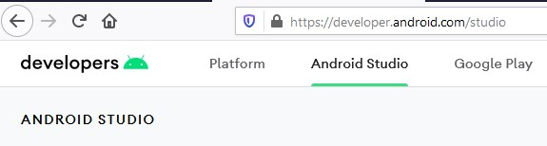

Step 2

Click on the "Download Android Studio" option.

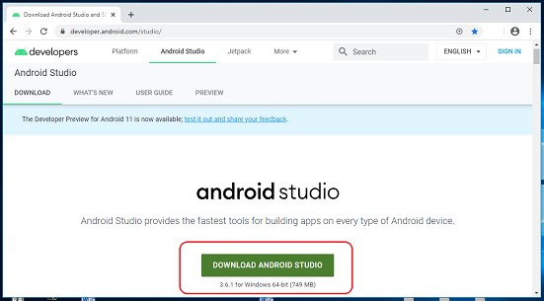

Step 3

Double click on the downloaded "Android Studio-ide.exe" file.

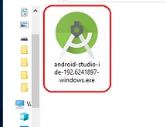

Step 4

"Android Studio Setup" will appear on the screen and click "Next" to proceed.

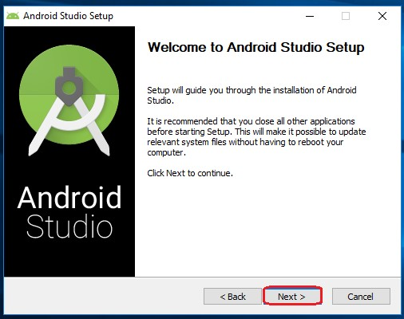

Step 5

Select the components that you want to install and click on the "Next" button.

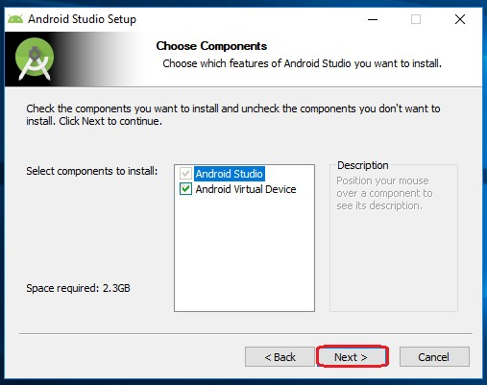

Step 6

Now, browse the location where you want to install the Android Studio and click "Next" to proceed.

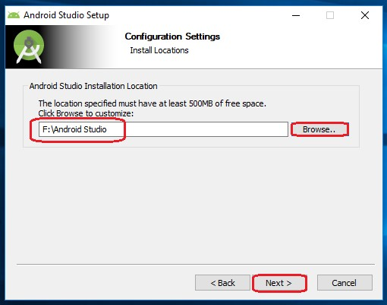

Step 7

Choose a start menu folder for the "Android Studio" shortcut and click the "Install" button to proceed.

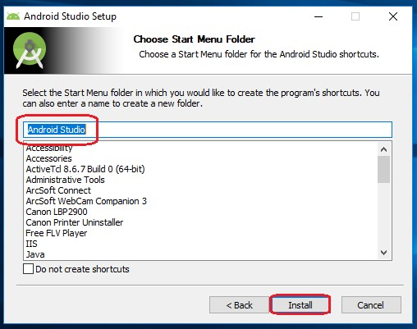

Step 8

After the successful completion of the installation, click on the "Next" button.

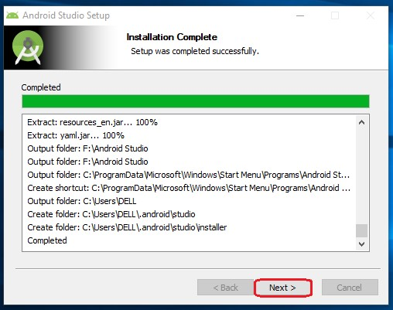

Step 9

Click on the "Finish" button to proceed.

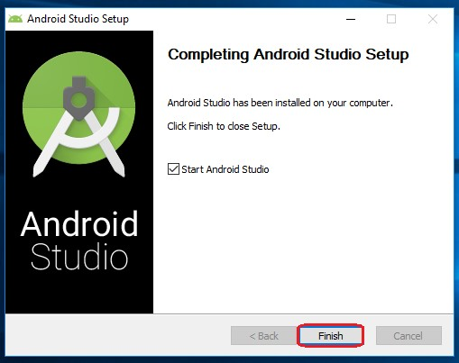

Now, your Android studio welcome screen will appear on the screen.



Android Studio Setup Configuration

Step 10

"Android Studio Setup Wizard" will appear on the screen with the welcome wizard. Click on the "Next" button.

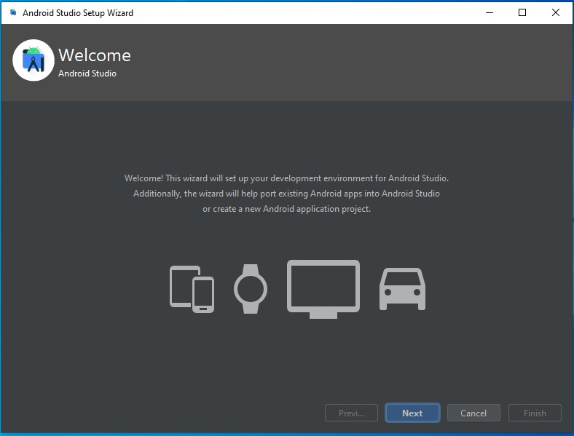

Step 11

Select (check) the "Standard" option if you are a beginner and do not have any idea about Android Studio. It will install the most common settings and options for you. Click "Next" to proceed.

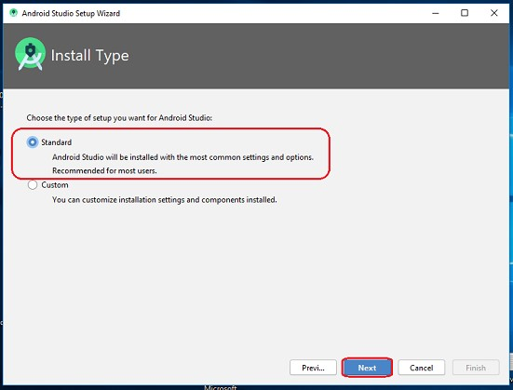

Step 12

Now, select the user interface theme as you want. (I prefer Dark theme (Dracula) that is most liked by the coders). Then, click on the "Next" button.

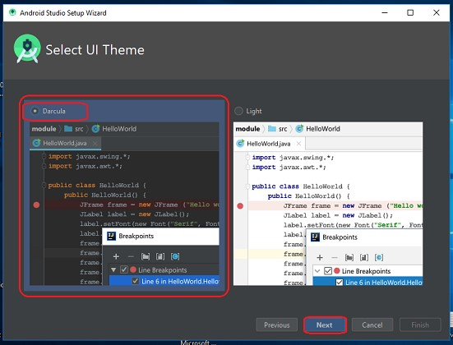

Step 13

Now, click on the "Finish" button to download all the SDK components.

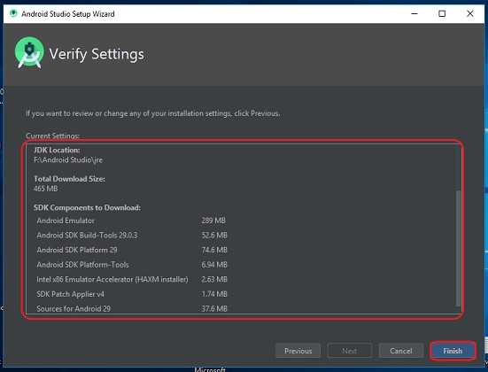

And, the downloading and installation process of components gets started.

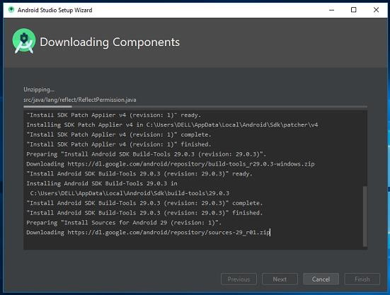

Step 14

After downloading all the necessary components, click on the "Finish" button.

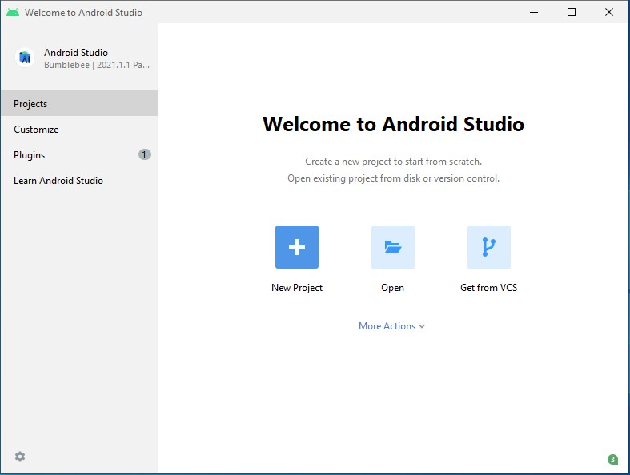

Congrats, your Android Studio has been successfully installed in your system and you can start a new Android studio project.

***Conclusion***

By following the above steps, you can download and install Android Studio in Windows 10.

## b) Understanding the Developers Workflow basics

The workflow to develop an app for Android is conceptually the same as other app platforms. However, to efficiently build a well-designed app for Android, you need some specialized tools. The following list provides an overview of the process to build an Android app and includes links to some Android Studio tools you should use during each phase of development.

### 1. Set up your workspace

This is the phase you probably already finished: Install Android Studio and create a project.

### 2. Write your app

Now you can get to work. Android Studio includes a variety of tools and intelligence to help you work faster, write quality code, design a UI, and create resources for different device types.

### 3. Build and run

During this phase, you build your project into a debuggable APK package that you can install and run on the emulator or an Androidpowered device.

You can also begin customizing your build. For example, you can create build variants that produce different versions of your app from the same project and shrink your code and resources to make your app smaller.

### 4. Debug, profile, and test

This is the iterative phase in which you continue writing your app but with a focus on eliminating bugs and optimizing app performance.\

### 5. Publish

When you're ready to release your app to users, there are just a few more things to consider, such as versioning your app, building an Android App Bundle, and signing it with a key.

## c) The Android Project View

To see the actual file structure of the project including all files hidden from the Android view, select **Project** from the dropdown at the top of the **Project** window. When you select **Project** view, you can see a lot more files and directories. The most important of which are the following:

***module-name*/**

## build/

Contains build outputs. **libs/**

Contains private libraries. **src/**

Contains all code and resource files for the module in the following subdirectories: **androidTest/**

Contains code for instrumentation tests that run on an Android device.

## main/

Contains the "main" sourceset files: the Android code and resources shared by all build variants (files for other build variants reside in sibling directories, such as src/debug/ for the debug build type).

## AndroidManifest.xml

Describes the nature of the application and each of its components.

## java/

Contains Java code sources. **jni/**

Contains native code using the Java Native Interface (JNI). For more information.

## gen/

Contains the Java files generated by Android Studio, such as your R.java file and interfaces created from AIDL files.

## res/

Contains application resources, such as drawable files, layout files, and UI string. **assets/**

Contains file that should be compiled into an .apk file as-is. You can navigate this directory in the same way as a typical file system using URIs and read files as a stream of bytes using the AssetManager . For example, this is a good location for textures and game data.

**test/**

Contains code for local tests that run on your host JVM.

**build.gradle (module)**

This defines the module-specific build configurations.

## build.gradle (project)

This defines your build configuration that apply to all modules. This file is integral to the project, so you should maintain them in revision control with all other source code.

**Experiment -2:**

**a) How to create and run an Android Project & Activities.**

To create your new Android project, follow these steps:

Install the latest version of [Android Studio.](https://developer.android.com/studio/)

In the **Welcome to Android Studio** window, click **Create New Project**.

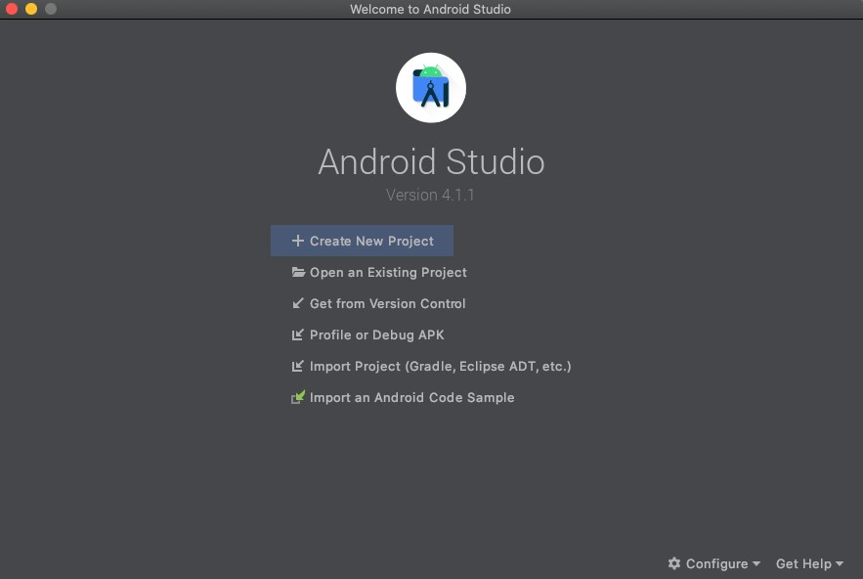

Figure 1. Android Studio welcome screen.

If you have a project already opened, select **File > New > New Project**.

In the Select a Project Template window, select Empty Activity and click Next.

In the Configure your project window, complete the following:

Enter "My First App" in the Name field.

Enter "com.example.myfirstapp" in the Package name field.

If you'd like to place the project in a different folder, change its Save location.

Select either **Java** or **Kotlin** from the **Language** drop-down menu.

Select the lowest version of Android you want your app to support in the **Minimum SDK** field. If your app will require legacy library support, mark the Use legacy android.support libraries checkbox.

Leave the other options as they are.

Click Finish.

After some processing time, the Android Studio main window appears.

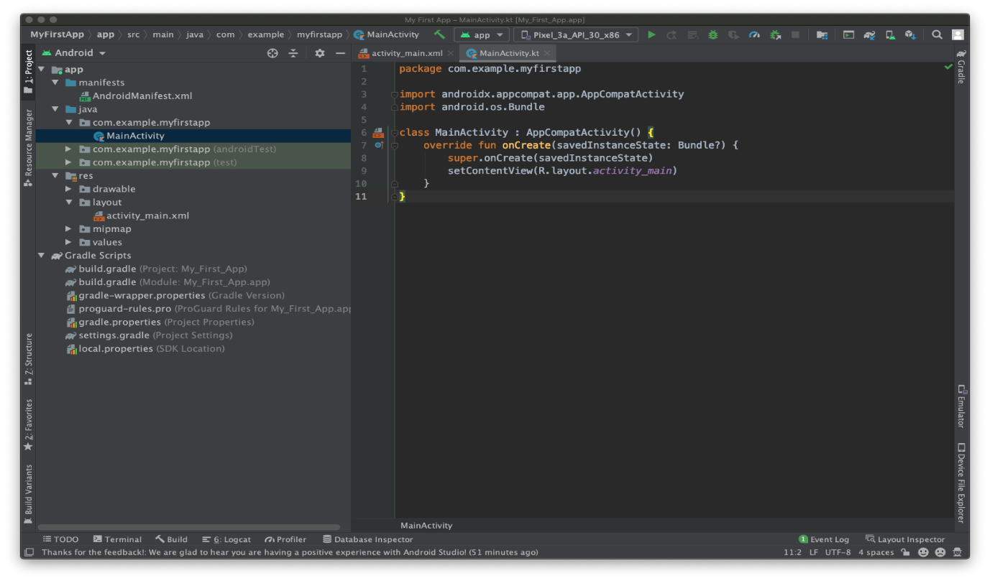

Figure 2. Android Studio main window.

Now take a moment to review the most important files.

First, be sure the Project window is open (select View > Tool Windows > Project) and the Android view is selected from the drop-down list at the top of that window. You can then see the following files:

app > java > com.example.myfirstapp > MainActivity

This is the main activity. It's the entry point for your app. When you build and run your app, the system launches an instance of this [Activity](https://developer.android.com/reference/android/app/Activity) and loads its layout. app > res > layout > activity_main.xml

This XML file defines the layout for the activity's user interface (UI). It contains a [TextView](https://developer.android.com/reference/android/widget/TextView) element with the text "Hello, World!" app > manifests > AndroidManifest.xml

The [manifest file](https://developer.android.com/guide/topics/manifest/manifest-intro) describes the fundamental characteristics of the app and defines each of its components.

Gradle Scripts > build.gradle

There are two files with this name: one for the project, "Project: My_First_App," and one for the app module, "Module: My_First_App.app." Each module has its own build.gradle file, but this project currently has just one module. Use each module's build.gradle file to control how the [Gradle plugin](https://developer.android.com/studio/releases/gradle-plugin) builds your app. For more information about this file, see [Configure your build.](https://developer.android.com/studio/build#module-level)

Run on a real device

Set up your device as follows:

Connect your device to your development machine with a USB cable. If you developed on Windows, you might need to [install the appropriate USB driver](https://developer.android.com/studio/run/oem-usb) for your device.

Perform the following steps to enable USB debugging in the Developer options window:

Open the Settings app.

If your device uses Android v8.0 or higher, select System. Otherwise, proceed to the next step.

Scroll to the bottom and select About phone.

Scroll to the bottom and tap Build number seven times.

Return to the previous screen, scroll to the bottom, and tap Developer options.

In the Developer options window, scroll down to find and enable USB debugging.

Run the app on your device as follows:

In Android Studio, select your app from the run/debug configurations drop-down menu in the toolbar.

In the toolbar, select the device that you want to run your app on from the target device dropdown menu.

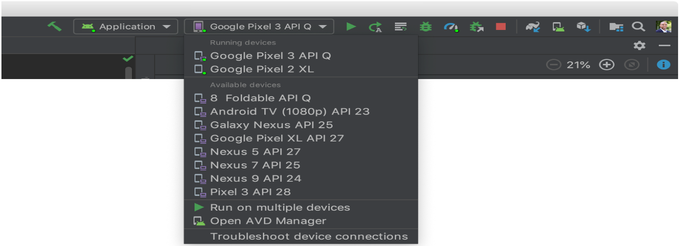

Figure. Target device drop-down menu

Click Run .

Android Studio installs your app on your connected device and starts it. You now see "Hello, World!" displayed in the app on your device.

Run on an emulator

Run the app on an emulator as follows:

In Android Studio, [create an Android Virtual Device (AVD)](https://developer.android.com/studio/run/managing-avds#createavd) that the emulator can use to install and run your app.

In the toolbar, select your app from the run/debug configurations drop-down menu.

From the target device drop-down menu, select the AVD that you want to run your app on.

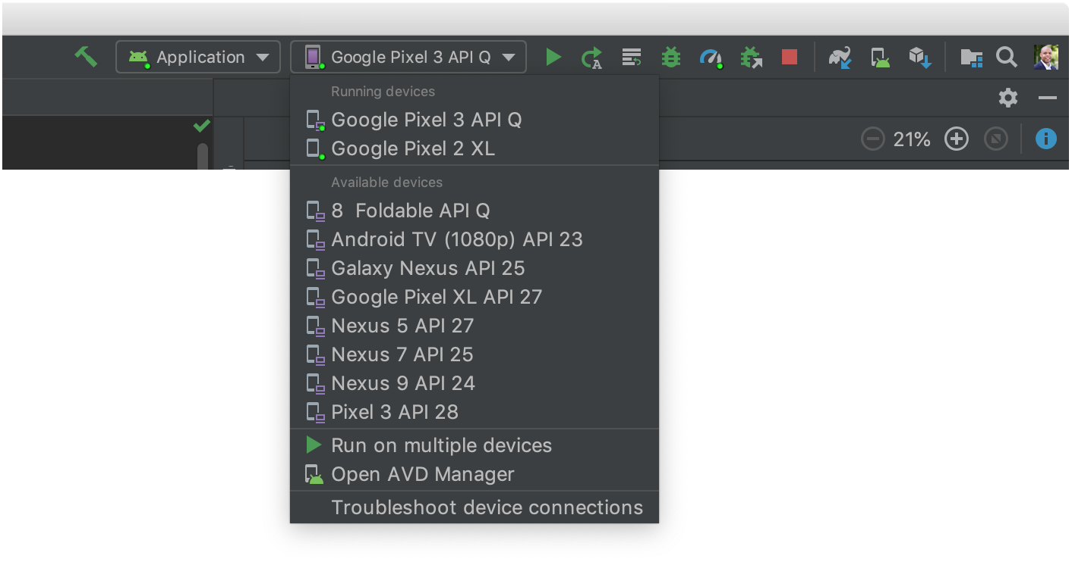

Figure 2. Target device drop-down menu

Click Run .

Android Studio installs the app on the AVD and starts the emulator. You now see "Hello, World!" displayed in the app.

**a) AIM: Selecting an empty activity to display the welcome message in AVD.**

In this task, you will create an app that displays "Hello World" to verify that Android studio is correctly installed, and to learn the basics of developing with Android Studio.

## Create the app project

Open Android Studio if it is not already opened.

In the main **Welcome to Android Studio** window, click **Start a new Android Studio project**.

In the **Create Android Project** window, enter **Hello World** for the **Application name**.

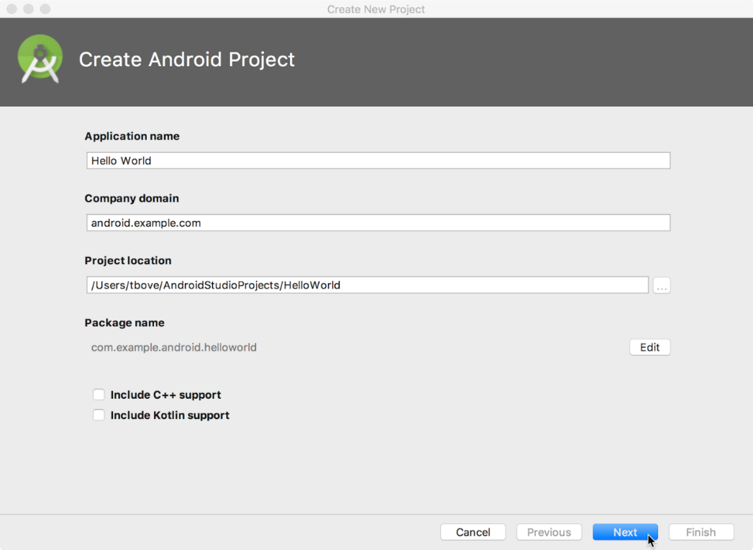

Verify that the default **Project location** is where you want to store your Hello World app and other Android Studio projects, or change it to your preferred directory.

Accept the default **android.example.com** for **Company Domain**, or create a unique company domain.

If you are not planning to publish your app, you can accept the default. Be aware that changing the package name of your app later is extra work.

Leave unchecked the options to **Include C++ support** and **Include Kotlin support**, and click **Next**.

On the **Target Android Devices** screen, **Phone and Tablet** should be selected. Ensure that **API 15: Android 4.0.3 IceCreamSandwich** is set as the Minimum SDK; if it is not, use the popup menu to set it.

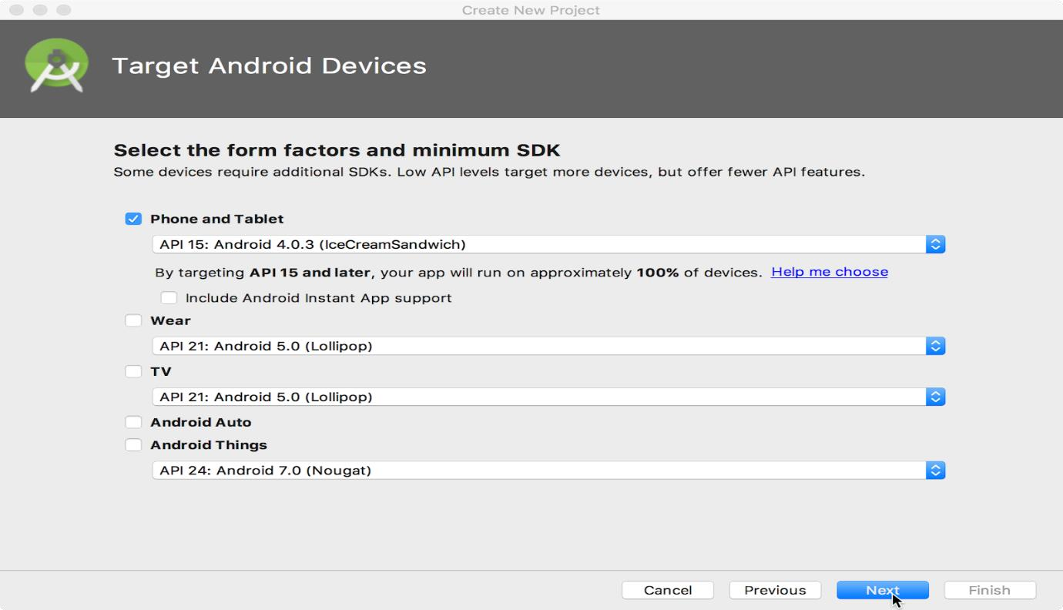

These are the settings used by the examples in the lessons for this course. As of this writing, these settings make your Hello World app compatible with 97% of Android devices active on the Google Play Store.

Leave unchecked the **Include Instant App support** and all other options. Then click **Next**. If your project requires additional components for your chosen target SDK, Android Studio will install them automatically.

The **Add an Activity** window appears. An [Activity](https://developer.android.com/reference/android/app/Activity.html) is a single, focused thing that the user can do. It is a crucial component of any Android app. An Activity typically has a layout associated with it that defines how UI elements appear on a screen. Android Studio provides Activity templates to help you get started. For the Hello World project, choose **Empty Activity** as shown below, and click **Next**.

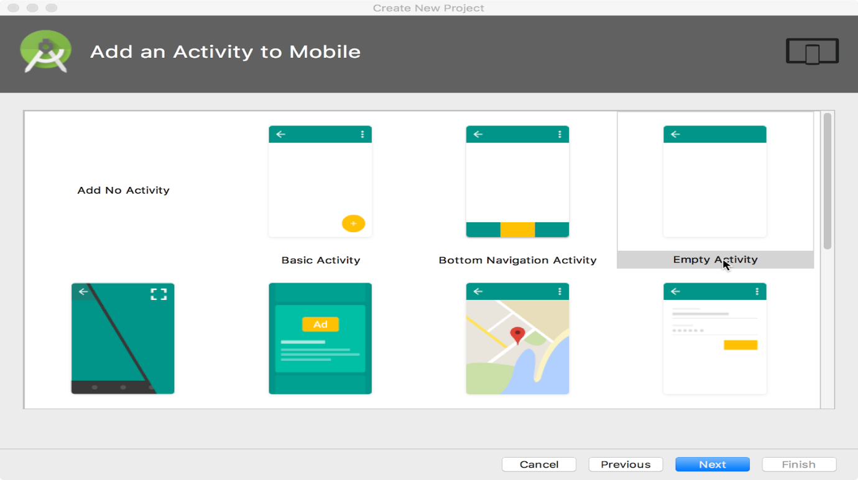

The **Configure Activity** screen appears (which differs depending on which template you chose in the previous step). By default, the empty Activity provided by the template is named MainActivity. You can change this if you want, but this lesson uses MainActivity.

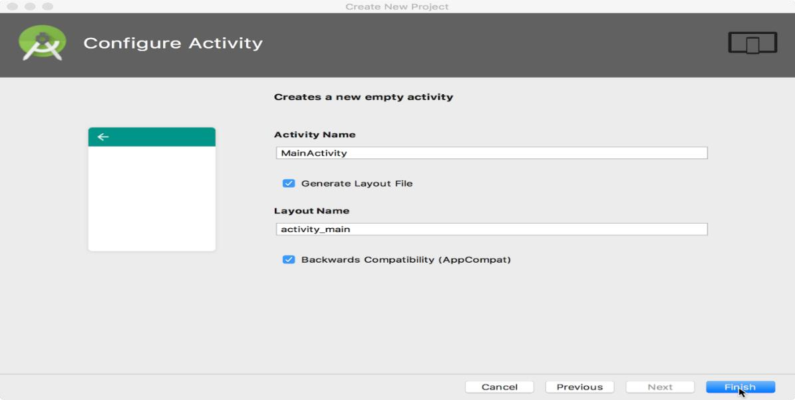

Make sure that the **Generate Layout file** option is checked. The layout name by default is activity_main. You can change this if you want, but this lesson uses activity_main. Make sure that the **Backwards Compatibility (App Compat)** option is checked. This ensures that your app will be backwards-compatible with previous versions of Android.

Click **Finish**.

Android Studio creates a folder for your projects and builds the project with [Gradle](https://gradle.org/) (this may take a few moments).

The Android Studio editor appears. Follow these steps:

Click the **activity_main.xml** tab to see the layout editor.

Click the layout editor **Design** tab, if not already selected, to show a graphical rendition of the layout as shown below.

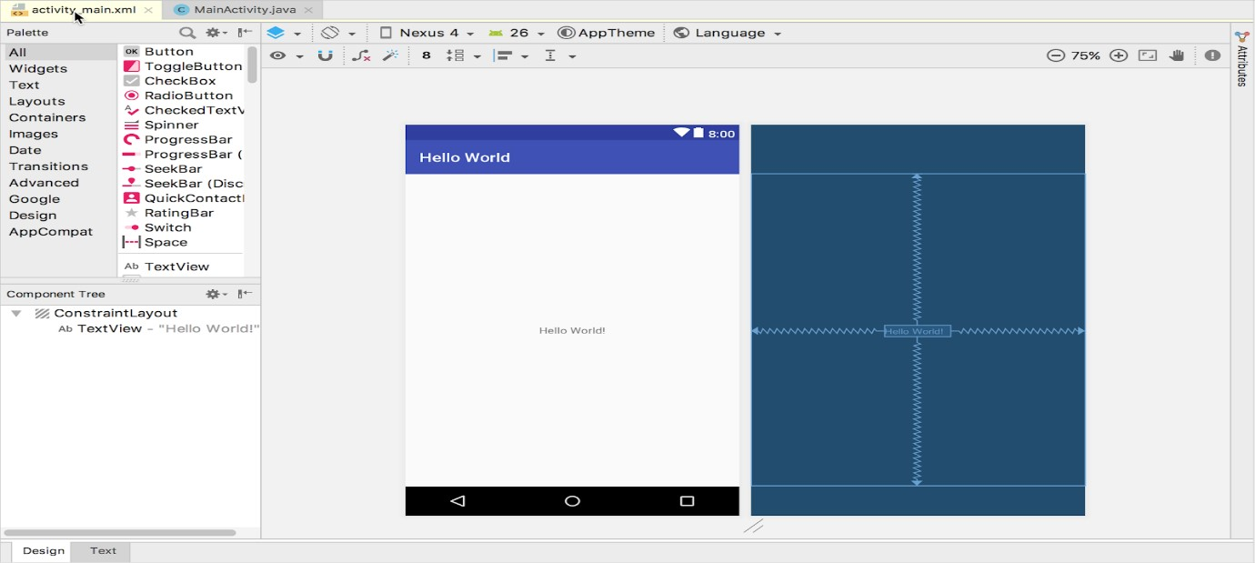

Click the **MainActivity.java** tab to see the code editor as shown below.

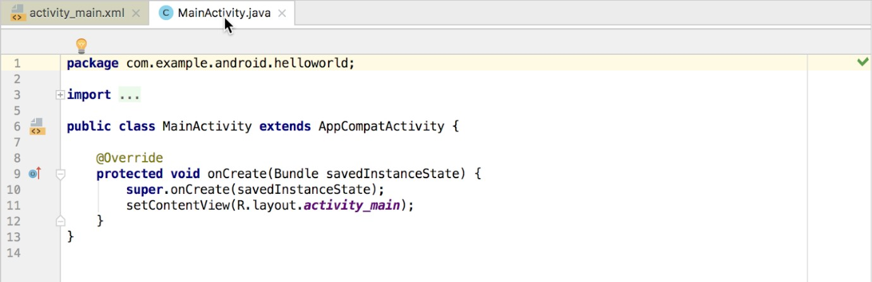

Run the app on your device as follows:

In Android Studio, select your app from the run/debug configurations drop-down menu in the toolbar.

In the toolbar, select the device that you want to run your app on from the target device dropdown menu.



Figure. Target device drop-down menu

Click Run .

Android Studio installs your app on your connected device and starts it. You now see "Hello, World!" displayed in the app on your device.

Run on an emulator

Run the app on an emulator as follows:

In Android Studio, create an Android Virtual Device (AVD) that the emulator can use to install and run your app.

In the toolbar, select your app from the run/debug configurations drop-down menu.

From the target device drop-down menu, select the AVD that you want to run your app on.

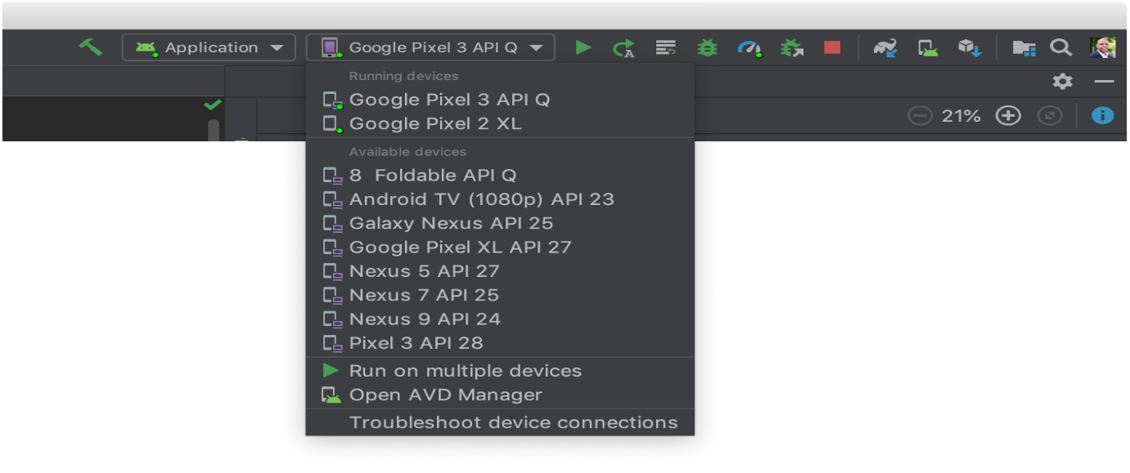

Figure 2. Target device drop-down menu

Click Run .

Android Studio installs the app on the AVD and starts the emulator. You now see "Hello, World!" displayed in the app.

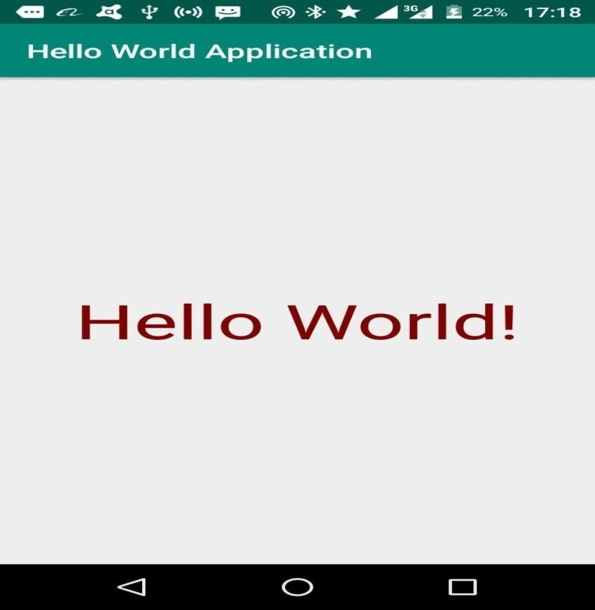

**b) AIM: Create a basic activity with themes and styles for deployment in an emulator and your own device.**

DESCRIPTION:

A style is a collection of attributes that specify the appearance for a single View.

A style can specify attributes such as font color, font size, background color, and much more. A theme is a collection of attributes that's applied to an entire app, activity, or view hierarchy— not just an individual view.

When you apply a theme, every view in the app or activity applies each of the theme's attributes that it supports.

Themes can also apply styles to non-view elements, such as the status bar and window background.

Styles and themes are declared in a style resource file in res/values/, usually named styles.xml Themes and styles have the same basic structure—a key-value pair which maps attributes to resources

Styles and themes are meant to work together.

For example: When the device goes into night mode, your app can switch from its "light" theme to its "dark" theme, changing the values for all those resource names.

CREATING AND APPLYING A STYLE

To create a new style or theme, open your project's res/values/styles.xml file.

For each style you want to create, follow these steps:

Add a <style> element with a name that uniquely identifies the style.

Add an <item> element for each style attribute you want to define.

The name in each item specifies an attribute you would otherwise use as an XML attribute in your layout.

The value in the <item> element is the value for that attribute.

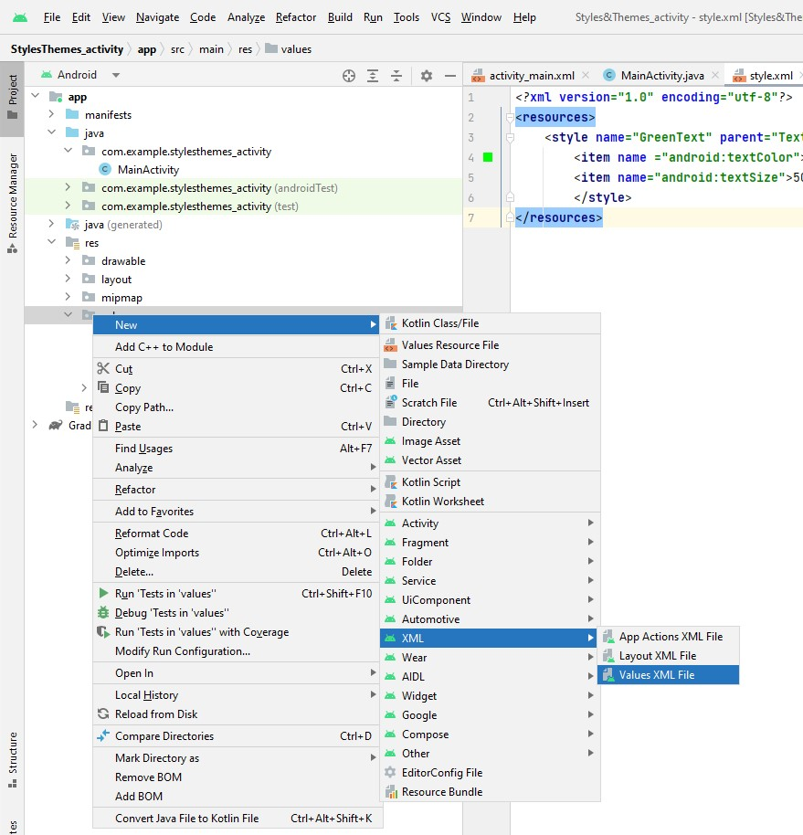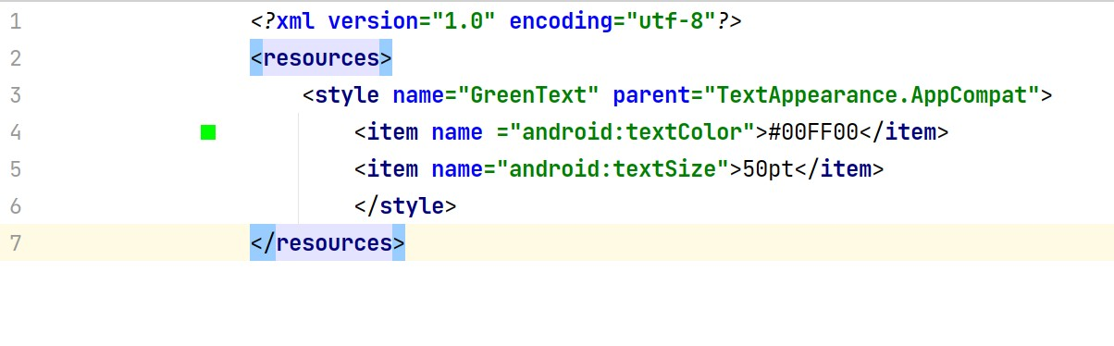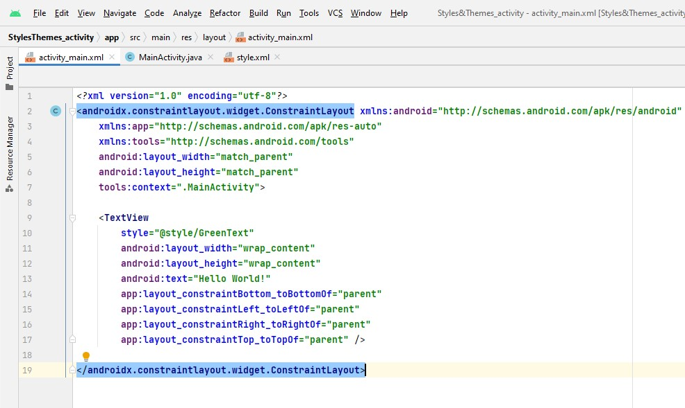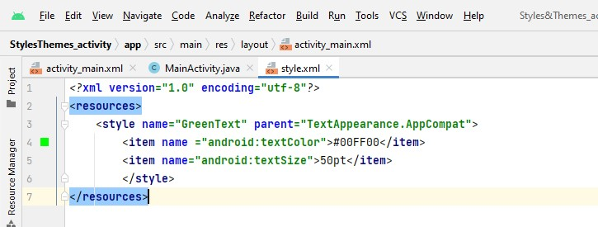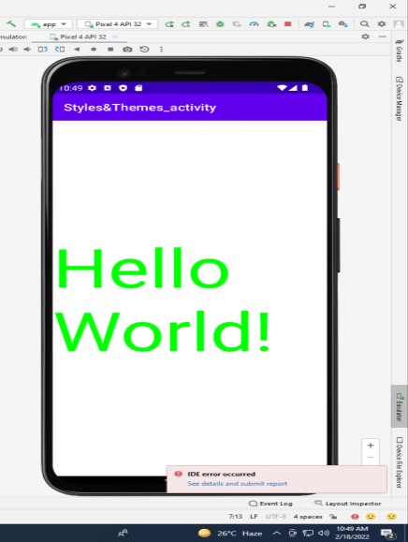

## c) AIM : APPLYING A STYLE AS A THEME

You can create a theme the same way you create styles.

The difference is how you apply it: instead of applying a style with the style attribute on a view, you apply a theme with the android:theme attribute on either the <application> tag or an <activity> tag in the AndroidManifest.xml file.

For Example: Dark Theme

<manifest ... >

<application android:theme="@style/Theme.AppCompat" >

</application>

</manifest>

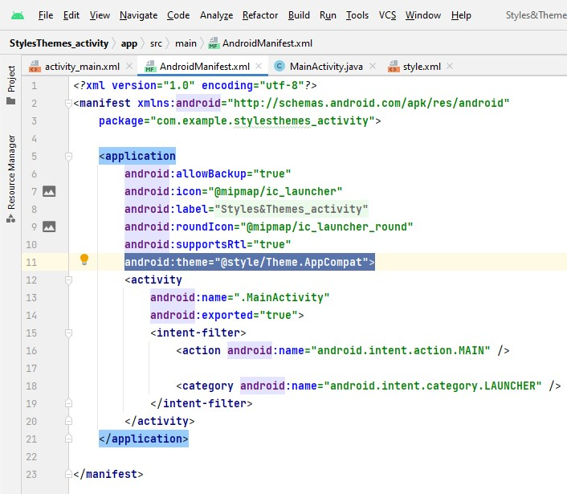

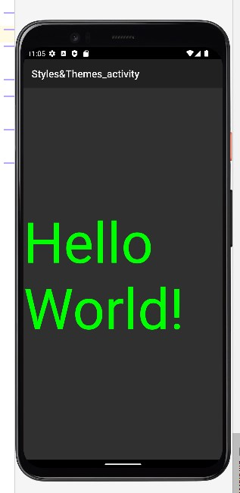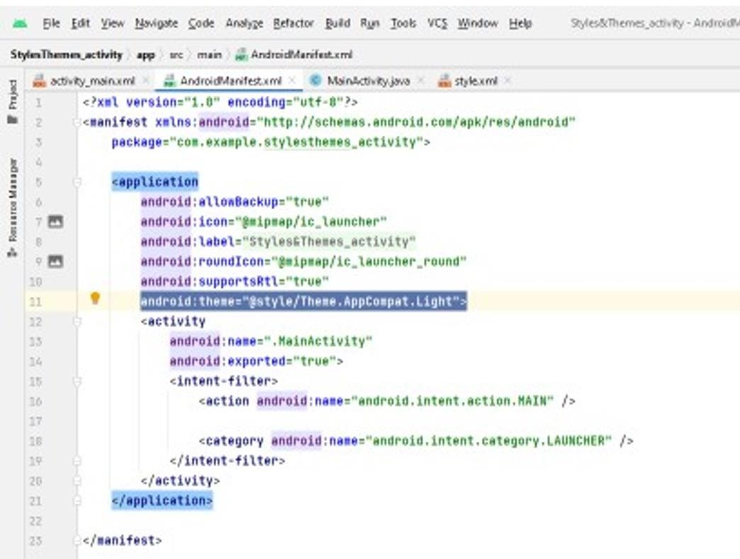

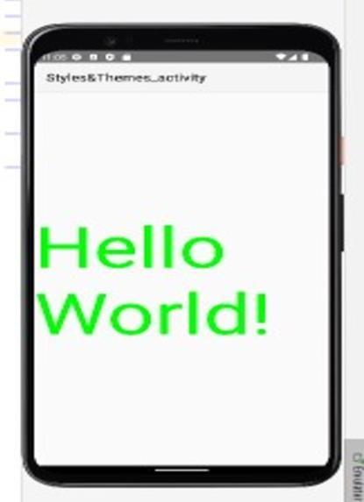

**d) Observing the Activity life cycle using Logcat.**

Step1: Using Android Studio, create a new Android project and name it as shown in Figure 1.

Step2:In the MainActivity.java file, add the following statements in bold: package net.learn2develop.Activities; import android.app.Activity; import android.os.Bundle; import android.util.Log;

public class MainActivity extends Activity { String tag = “Events”;

/** Called when the activity is first created. */

@Override

public void onCreate(Bundle savedInstanceState) { super.onCreate(savedInstanceState); setContentView(R.layout.main); Log.*d*(tag, “In the onCreate() event”);

}

public void onStart()

{

super.onStart();

Log.*d*(tag, “In the onStart() event”);

}

public void onRestart()

{

super.onRestart();

Log.*d*(tag, “In the onRestart() event”);

}

public void onResume()

{

super.onResume();

Log.*d*(tag, “In the onResume() event”);

}

public void onPause()

{

super.onPause();

Log.*d*(tag, “In the onPause() event”);

}

public void onStop()

{

super.onStop();

Log.*d*(tag, “In the onStop() event”);

}

public void onDestroy()

{

super.onDestroy();

Log.*d*(tag, “In the onDestroy() event”);

}

}

Step 3. Press F11 to debug the application on the Android Emulator.

Step 4. When the activity is first loaded, you should see the following in the LogCat window (click on theDebug perspective; see also Figure 2-3):

12-28 13:45:28.115: DEBUG/Events(334): In the onCreate() event

12-28 13:45:28.115: DEBUG/Events(334): In the onStart() event

12-28 13:45:28.115: DEBUG/Events(334): In the onResume() event

Step5: When you now press the back button on the Android Emulator, observe that the following is printed:

12-28 13:59:46.266: DEBUG/Events(334): In the onPause() event

12-28 13:59:46.806: DEBUG/Events(334): In the onStop() event

12-28 13:59:46.806: DEBUG/Events(334): In the onDestroy() event

Step 6 Click the Home button and hold it there. Click the Activities icon and observe the following:

12-28 14:00:54.115: DEBUG/Events(334): In the onCreate() event

12-28 14:00:54.156: DEBUG/Events(334): In the onStart() event

12-28 14:00:54.156: DEBUG/Events(334): In the onResume() event

Step 7 Press the Phone button on the Android Emulator so that the activity is pushed to the background.

Observe the output in the LogCat window:

12-28 14:01:16.515: DEBUG/Events(334): In the onPause() event

12-28 14:01:17.135: DEBUG/Events(334): In the onStop() event

Step 8 Notice that the onDestroy() event is not called, indicating that the activity is still in memory. Exit

the phone dialer by pressing the Back button. The activity is now visible again. Observe the output in the LogCat window:

12-28 14:02:17.255: DEBUG/Events(334): In the onRestart() event

12-28 14:02:17.255: DEBUG/Events(334): In the onStart() event

12-28 14:02:17.255: DEBUG/Events(334): In the onResume() event

The onRestart() event is now fi red, followed by the onStart() and onResume() events.

## b) AIM: Hiding the Activity Title

You can also hide the title of an activity if desired (such as when you just want to display a status update

to the user). To do so, use the requestWindowFeature() method and pass it the Window.FEATURE_NO_

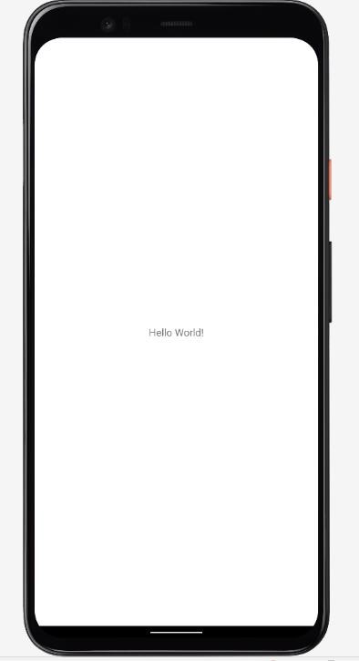TITLE constant, like this: package net.learn2develop.Activities; import android.app.Activity; import android.os.Bundle; import android.util.Log; import android.view.Window; public class MainActivity extends Activity { String tag = “Events”;

/** Called when the activity is first created. */

@Override

public void onCreate(Bundle savedInstanceState) { super.onCreate(savedInstanceState);

//---hides the title bar---

requestWindowFeature(Window.FEATURE_NO_TITLE); setContentView(R.layout.main); Log.*d*(tag, “In the onCreate() event”);

}

}

## Experiment -3: Intents

**Design an application that shows both Implicit and explicit intents.**

An Android application can contain zero or more activities. When your application has more than one activity, you may need to navigate from one activity to another. In Android, you navigate between activities through what is known as an *intent*.

The best way to understand this very important but somewhat abstract concept in Android is to experience it first-hand and see what it helps you to achieve.

The following Try It Out shows how to add another activity to an existing project and then navigate between the two activities.

**Step 1: Let’s design the UI of activity_main.xml:**

First design the [text view](https://abhiandroid.com/ui/textview/) displaying basic details of the App

Second design the two [button](https://abhiandroid.com/ui/button/) of Explicit Intent Example and Implicit Intent Example

**Below is the complete code of activity_main.xml**

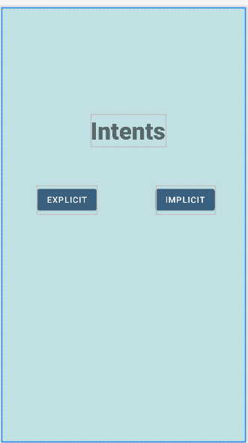*<?*xml version="1.0" encoding="utf-8"*?>*<RelativeLayout xmlns:android="http://schemas.android.com/apk/res/android"  
 xmlns:app="http://schemas.android.com/apk/res-auto"  
 xmlns:tools="http://schemas.android.com/tools"  
 android:layout_width="match_parent"  
 android:layout_height="match_parent"  
 tools:context=".MainActivity"  
 android:background="#C0E0E4">  
 <TextView  
 android:layout_width="wrap_content"  
 android:layout_height="wrap_content"  
 android:text="Intents"  
 android:layout_marginLeft="150dp"  
 android:layout_marginTop="180dp"  
 android:textSize="40dp"  
 android:fontFamily="sans-serif-black"/>  
 <Button  
 android:layout_width="wrap_content"  
 android:layout_height="wrap_content"  
 android:layout_marginTop="300dp"  
 android:layout_marginLeft="60dp"  
 android:text="explicit"  
 android:id="@+id/exp"/>  
 <Button  
 android:layout_width="wrap_content"  
 android:layout_height="wrap_content"  
 android:layout_marginTop="300dp"  
 android:layout_marginLeft="260dp"  
 android:text="implicit"  
 android:id="@+id/imp"/>  
  
</RelativeLayout>

**Step 2: Design the UI of second activity**

Now lets design UI of another activity where user will navigate after he click on Explicit Example [button.](https://abhiandroid.com/ui/button/) Go to layout folder, create a new activity res>layout>right click>new>activity>empty activity>name it as MainActivity2

In this activity we will simply use [TextView](https://abhiandroid.com/ui/textview/) to tell user he is now on second activity.

**Below is the complete code of activity_main2.xml**

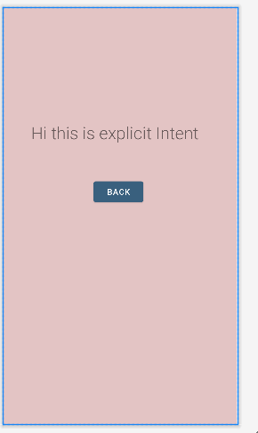*<?*xml version="1.0" encoding="utf-8"*?>*<RelativeLayout xmlns:android="http://schemas.android.com/apk/res/android"  
 xmlns:app="http://schemas.android.com/apk/res-auto"  
 xmlns:tools="http://schemas.android.com/tools"  
 android:layout_width="match_parent"  
 android:layout_height="match_parent"  
 tools:context=".MainActivity2"  
 android:background="#E3C4C4">  
 <TextView  
 android:layout_width="wrap_content"  
 android:layout_height="wrap_content"  
 android:text="Hi this is explicit Intent"  
 android:textSize="30dp"  
 android:layout_marginTop="200dp"  
 android:fontFamily="sans-serif-light"  
 android:layout_marginLeft="50dp"/>  
 <Button  
 android:layout_width="wrap_content"  
 android:layout_height="wrap_content"  
 android:layout_marginTop="300dp"  
 android:layout_marginLeft="160dp"  
 android:text="back"  
 android:id="@+id/back"/>  
  
</RelativeLayout>

**Step 3: Implement onClick event for Implicit and Explicit Button inside**

**MainActivity.java**

Now we will use setOnClickListener() method to implement OnClick event on both the [button.](https://abhiandroid.com/ui/button/) Implicit button will open Vignan.ac.in homepage in browser and Explicit button will move to SecondActivity.java.

**Below is the complete code of MainActivity.java**

package com.example.intents;  
  
import androidx.appcompat.app.AppCompatActivity;  
  
import android.content.Intent;  
import android.os.Bundle;  
import android.view.View;  
import android.widget.Button;  
  
public class MainActivity extends AppCompatActivity {  
  
 @Override  
 protected void onCreate(Bundle savedInstanceState) {  
 super.onCreate(savedInstanceState);  
 setContentView(R.layout.*activity_main*);  
 Button b1=findViewById(R.id.*exp*);  
 b1.setOnClickListener(new View.OnClickListener() { @Override  
 public void onClick(View view) {  
 Intent i=new Intent(getApplicationContext(),MainActivity2.class);  
 startActivity(i);  
 }  
 });  
  
 Button b2=findViewById(R.id.*imp*);  
 b2.setOnClickListener(new View.OnClickListener() { @Override  
 public void onClick(View view) {  
 Intent i=new Intent(getApplicationContext(),MainActivity3.class);  
 startActivity(i);  
 }  
  
 });  
 }  
  
}

**Step 4: write the functionality for MainActivity2**

Now open the MainActivity2.java to write functionality. Also we will use [Toast](https://abhiandroid.com/programming/custom-toast-tutorial-example.html/) to display message that he is on second activity.

**Below is the complete code of** MainActivity2**.java:**

package com.example.intents;  
  
import androidx.appcompat.app.AppCompatActivity;  
  
import android.content.Intent;  
import android.os.Bundle;  
import android.view.View;  
import android.widget.Button;  
import android.widget.Toast;  
  
public class MainActivity2 extends AppCompatActivity {  
  
 @Override  
 protected void onCreate(Bundle savedInstanceState) {  
 super.onCreate(savedInstanceState);  
 setContentView(R.layout.*activity_main2*);  
 Toast.*makeText*(getApplicationContext(), "We are moved to second Activity",Toast.*LENGTH_LONG*).show();  
  
  
 Button b2=findViewById(R.id.*back*);  
 b2.setOnClickListener(new View.OnClickListener() {  
 @Override  
 public void onClick(View view) {  
 Intent intent=new Intent(getApplicationContext(),MainActivity.class);  
 startActivity(intent);  
 }  
 });  
  
 }  
}

**Step 5: Create another activity to show implicit activity follow same procedure to create new activity and name it as MainActivity3:**

**Here create the design for activity to show implicit intents, so we create different buttons for different actions**

**Complete code for activity_main3.xml:**

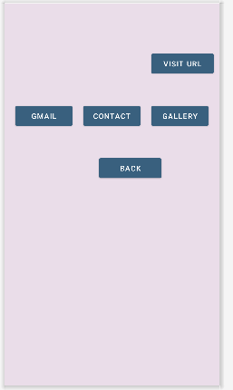*<?*xml version="1.0" encoding="utf-8"*?>*<RelativeLayout xmlns:android="http://schemas.android.com/apk/res/android"  
 xmlns:app="http://schemas.android.com/apk/res-auto"  
 xmlns:tools="http://schemas.android.com/tools"  
 android:layout_width="match_parent"  
 android:layout_height="match_parent"  
 tools:context=".MainActivity3">  
  
 <EditText  
 android:layout_width="250dp"  
 android:height="40dp"  
 android:layout_marginTop="100dp"  
 android:layout_marginLeft="20dp"  
 android:id="@+id/url"  
 android:layout_height="40dp"/>  
 <Button  
 android:layout_width="120dp"  
 android:layout_height="50dp"  
 android:layout_marginLeft="280dp"  
 android:layout_marginTop="90dp"  
 android:text="visit url"  
 tools:ignore="MissingConstraints"  
 android:id="@+id/go"/>  
 <Button  
 android:layout_width="110dp"  
 android:layout_height="50dp"  
 android:layout_marginLeft="280dp"  
 android:layout_marginTop="190dp"  
 android:text="gallery"  
 tools:ignore="MissingConstraints"  
 android:id="@+id/gallery"/>  
 <Button  
 android:layout_width="110dp"  
 android:layout_height="50dp"  
 android:layout_marginLeft="150dp"  
 android:layout_marginTop="190dp"  
 android:text="contact"  
 tools:ignore="MissingConstraints"  
 android:id="@+id/contacts"/>  
 <Button  
 android:layout_width="110dp"  
 android:layout_height="50dp"  
 android:layout_marginLeft="20dp"  
 android:layout_marginTop="190dp"  
 android:text="gmail"  
 tools:ignore="MissingConstraints"  
 android:id="@+id/button7"/>  
 <Button  
 android:layout_width="120dp"  
 android:layout_height="50dp"  
 android:layout_marginLeft="180dp"  
 android:layout_marginTop="290dp"  
 android:text="back"  
 tools:ignore="MissingConstraints"  
 android:id="@+id/back"/>  
  
</RelativeLayout>

**Step 6: write the functionality for MainActivity3**

**Now open MainActivity3.java and add the functionality for implicit intents.**

**Here is complete code for MainActivity3.java**

package com.example.intents;  
  
import androidx.appcompat.app.AppCompatActivity;  
  
import android.content.Intent;  
import android.net.Uri;  
import android.os.Bundle;  
import android.provider.ContactsContract;  
import android.view.View;  
import android.widget.Button;  
import android.widget.EditText;  
  
public class MainActivity3 extends AppCompatActivity {  
  
 @Override  
 protected void onCreate(Bundle savedInstanceState) {  
 super.onCreate(savedInstanceState);  
 setContentView(R.layout.*activity_main3*);  
  
 Button email=(Button) findViewById(R.id.*button7*); email.setOnClickListener(new View.OnClickListener() {  
 @Override  
 public void onClick(View view) {  
 Intent email = new Intent(Intent.*ACTION_SEND*); email.setType("message/rfc822");  
 email.putExtra(Intent.*EXTRA_EMAIL*, new String[]{"cse@gmail.com"}); email.putExtra(Intent.*EXTRA_SUBJECT*, "Welcome to CSE"); email.putExtra(Intent.*EXTRA_TEXT*, "Hi Guest, Welcome to Amar Jukuntla's World"); startActivity(Intent.*createChooser*(email,"Choose Mail App"));  
  
 }  
 });  
 Button cnt=(Button)findViewById(R.id.*contacts*); cnt.setOnClickListener(new View.OnClickListener() {  
 @Override  
 public void onClick(View view) {  
 Intent amar=new  
 Intent(Intent.*ACTION_PICK*, ContactsContract.Contacts.*CONTENT_URI*); startActivity(amar);  
 }  
 });  
  
 Button gly=(Button)findViewById(R.id.*gallery*); gly.setOnClickListener(new View.OnClickListener() {  
 @Override  
 public void onClick(View view) {  
 Intent intent = new Intent();  
 intent.setAction(android.content.Intent.*ACTION_VIEW*); intent.setType("image/*");  
 intent.setFlags(Intent.*FLAG_ACTIVITY_NEW_TASK*);  
 startActivity(intent);  
  
 }  
 });  
 EditText e1 = findViewById(R.id.*url*);  
 Button b3= findViewById(R.id.*go*);  
 b3.setOnClickListener(new View.OnClickListener() {  
 @Override  
 public void onClick(View view) {  
 String url = e1.getText().toString();  
 Intent urlIntent = new Intent(Intent.*ACTION_VIEW*, Uri.*parse*("https://www." + url));  
 startActivity(urlIntent);  
 }  
 });  
  
  
 Button backk=(Button) findViewById(R.id.*back*);  
  
 backk.setOnClickListener(new View.OnClickListener() {  
 @Override  
 public void onClick(View view) {  
 Intent i=new Intent(getApplicationContext(),MainActivity.class); startActivity(i);  
 }  
 });  
  
 }  
  
 }

**Step 6: Manifest file**

Make sure Manifest file has the MainActivity and MainActivity2,MainActivity3 listed it. Also here MainActivity is our main activity which will be launched first. So make sure intent-filter is correctly added just below MainActivity.

**Below is the code of Manifest file:**

*<?*xml version="1.0" encoding="utf-8"*?>*<manifest xmlns:android="http://schemas.android.com/apk/res/android"  
 package="com.example.intents">  
  
 <application  
 android:allowBackup="true"  
 android:icon="@mipmap/ic_launcher"  
 android:label="@string/app_name"  
 android:roundIcon="@mipmap/ic_launcher_round"  
 android:supportsRtl="true"  
 android:theme="@style/Theme.Testimp">  
 <activity  
 android:name=".MainActivity3"  
 android:exported="false" />  
 <activity  
 android:name=".MainActivity2"  
 android:exported="false" />  
 <activity  
 android:name=".MainActivity"  
 android:exported="true">  
 <intent-filter>  
 <action android:name="android.intent.action.MAIN" />  
  
 <category android:name="android.intent.category.LAUNCHER" />  
 </intent-filter>  
  
 </activity>  
 </application>  
  
</manifest>

**Output:**

Now run the above program in your Emulator. The App will look like this:

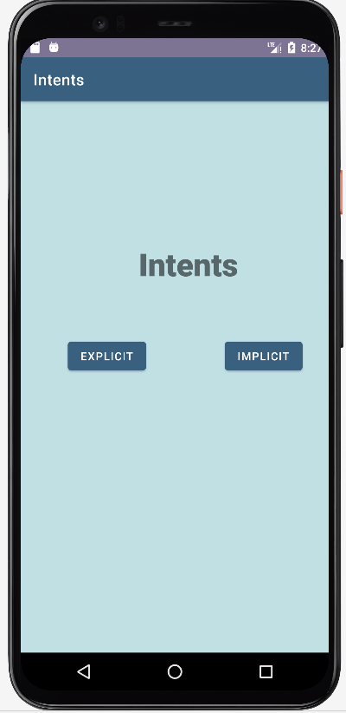

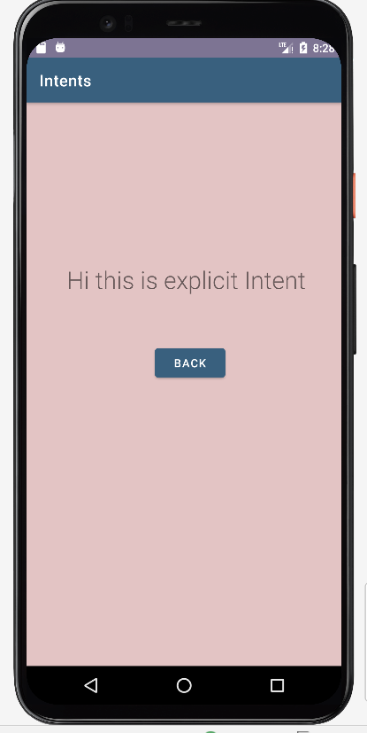

Similarly, we can open available apps in Phone like email, contacts and gallery as follows

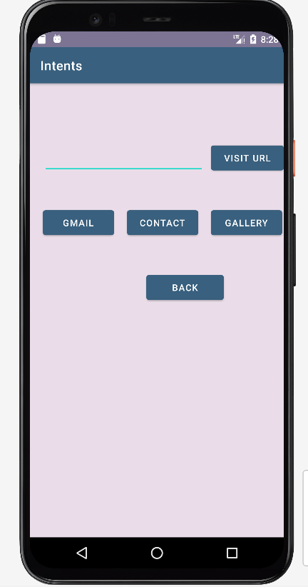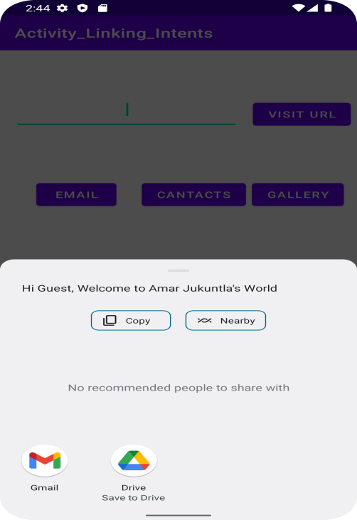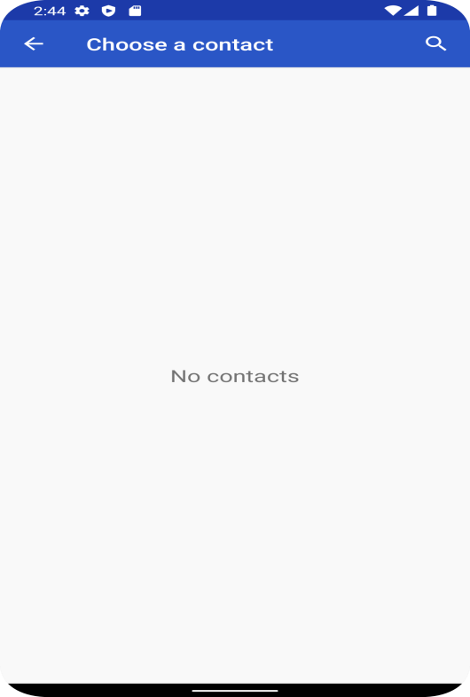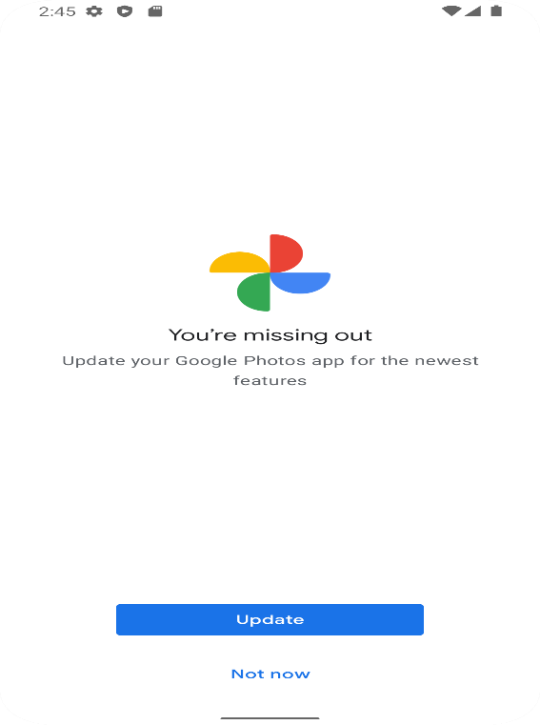

# Experiment -4: View Groups

*Types Of Linear Layout Orientation*

There are two types of linear layout orientation:

1. Vertical
2. Horizontal

As the name specified these two orientations are used to arrange there child one after the other, in a line, either vertically or horizontally. Let’s we describe these in detail.

**1.Vertical:**

In this all the child are arranged vertically in a line one after the other. In below code snippets we have specified orientation “vertical” so the childs/views of this layout are displayed vertically.

|  |
| --- |
| <LinearLayout xmlns:android="http://schemas.android.com/apk/res/android" android:layout_width="fill_parent" android:layout_height="wrap_content"  android:orientation="vertical"> <!-- Vertical Orientation set -->  <!-- Child Views(In this case 2 Button) are here -->    <Button  android:layout_width="wrap_content" android:layout_height="wrap_content" android:text="Button1" android:id="@+id/button" android:background="#358a32" />    <Button  android:layout_width="wrap_content" android:layout_height="wrap_content" android:text="Button2" android:id="@+id/button2" android:background="#0058b6" />      </LinearLayout> |

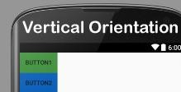

**2. Horizontal:**

In this all the child are arranged horizontally in a line one after the other. In below code snippets we have specified orientation “horizontal” so the childs/views of this layout are displayed horizontally.

|  |
| --- |
| <LinearLayout xmlns:android="http://schemas.android.com/apk/res/android" android:layout_width="fill_parent" android:layout_height="wrap_content"  android:orientation="horizontal"> <!-- Horizontal Orientation set -->  <!-- Child Views(In this case 2 Button) are here -->    <Button  android:layout_width="wrap_content" android:layout_height="wrap_content" android:text="Button1" android:id="@+id/button" android:background="#358a32" />    <Button  android:layout_width="wrap_content" android:layout_height="wrap_content" android:text="Button2" android:id="@+id/button2" android:background="#0058b6" />    </LinearLayout> |

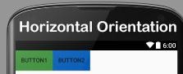

**Aim:** Demonstrate a form by using basic views.

**Description:** Apply Relative layout and create a form with desired fields (TextView , Radiobox ,Checkbox, Edit view ,Button, Image views).The user should be able to access and alter the fields as per their requirement. Use the intents to combine multiple Activities and to display user inputs.

**Procedure**: For creating the form and display the user inputs using intents, follow the below steps,

**Step**:1

Create an XML file with relative layout and desired fields (TextView , Radiobox ,Checkbox, Editview ,Button, Image views).

**Activity_main.xml**

<?xml version="1.0" encoding="utf-8"?>  
<RelativeLayout xmlns:android="http://schemas.android.com/apk/res/android"  
 xmlns:tools="http://schemas.android.com/tools"  
 xmlns:app="http://schemas.android.com/apk/res-auto"  
 android:id="@+id/activity_main"  
 android:layout_width="match_parent"  
 android:layout_height="match_parent"  
 android:background="@drawable/back7">  
  
  
 <TextView  
 android:id="@+id/title"  
 android:layout_width="321dp"  
 android:layout_height="58dp"  
 android:layout_alignParentTop="true"  
 android:layout_alignParentEnd="true"  
 android:layout_alignParentBottom="true"  
 android:layout_centerVertical="true"  
 android:layout_marginTop="28dp"  
 android:layout_marginEnd="39dp"  
 android:layout_marginBottom="644dp"  
 android:text="Let's Meditate"  
 android:textColor="#D500F9"  
 android:textSize="25sp"  
 android:textStyle="bold"  
 app:layout_constraintEnd_toEndOf="parent"  
 app:layout_constraintHorizontal_bias="0.436"  
 app:layout_constraintStart_toStartOf="parent"  
 app:layout_constraintTop_toTopOf="parent" />  
  
 <TextView  
 android:layout_width="306dp"  
 android:layout_height="51dp"  
 android:layout_alignParentEnd="true"  
 android:layout_alignParentBottom="true"  
 android:layout_marginEnd="88dp"  
 android:layout_marginBottom="649dp"  
 android:text="Fill details to get Registered"  
 android:textSize="20dp"  
 android:textStyle="bold" />  
  
 <EditText  
 android:id="@+id/names"  
 android:layout_width="wrap_content"  
 android:layout_height="wrap_content"  
 android:layout_alignParentTop="true"  
 android:layout_alignParentEnd="true"  
 android:layout_marginTop="179dp"  
 android:layout_marginEnd="172dp"  
 android:ems="10"  
 android:hint="Full Name"  
 app:layout_constraintEnd_toEndOf="parent"  
 app:layout_constraintHorizontal_bias="0.184"  
 app:layout_constraintStart_toStartOf="parent"  
 app:layout_constraintTop_toTopOf="parent"  
 tools:ignore="TouchTargetSizeCheck" />  
  
 <EditText  
 android:id="@+id/number"  
 android:layout_width="164dp"  
 android:layout_height="46dp"  
 android:layout_alignParentStart="true"  
 android:layout_alignParentEnd="true"  
 android:layout_alignParentBottom="true"  
 android:layout_marginStart="30dp"  
 android:layout_marginTop="260dp"  
 android:layout_marginEnd="217dp"  
 android:layout_marginBottom="415dp"  
 android:ems="10"  
 android:hint="Reg.No"  
 app:layout_constraintEnd_toEndOf="parent"  
 app:layout_constraintHorizontal_bias="0.151"  
 app:layout_constraintStart_toStartOf="parent"  
 app:layout_constraintTop_toTopOf="parent"  
 tools:ignore="TouchTargetSizeCheck,DuplicateClickableBoundsCheck" />  
  
 <EditText  
 android:id="@+id/dob"  
 android:layout_width="164dp"  
 android:layout_height="46dp"  
 android:layout_alignParentStart="true"  
 android:layout_alignParentTop="true"  
 android:layout_alignParentEnd="true"  
 android:layout_marginStart="34dp"  
 android:layout_marginTop="516dp"  
 android:layout_marginEnd="212dp"  
 android:ems="10"  
 android:hint="DOB"  
 app:layout_constraintEnd_toEndOf="parent"  
 app:layout_constraintHorizontal_bias="0.151"  
 app:layout_constraintStart_toStartOf="parent"  
 app:layout_constraintTop_toTopOf="parent"  
 tools:ignore="TouchTargetSizeCheck" />  
  
 <EditText  
 android:id="@+id/age"  
 android:layout_width="140dp"  
 android:layout_height="48dp"  
 android:layout_alignParentStart="true"  
 android:layout_alignParentTop="true"  
 android:layout_alignParentEnd="true"  
 android:layout_marginStart="32dp"  
 android:layout_marginTop="453dp"  
 android:layout_marginEnd="238dp"  
 android:ems="10"  
 android:hint="Age"  
 android:inputType="text"  
 app:layout_constraintEnd_toEndOf="parent"  
 app:layout_constraintHorizontal_bias="0.863"  
 app:layout_constraintStart_toStartOf="parent"  
 app:layout_constraintTop_toTopOf="parent" />  
  
 <EditText  
 android:id="@+id/Phone"  
 android:layout_width="wrap_content"  
 android:layout_height="wrap_content"  
 android:layout_alignParentStart="true"  
 android:layout_alignParentTop="true"  
 android:layout_alignParentEnd="true"  
 android:layout_marginStart="29dp"  
 android:layout_marginTop="400dp"  
 android:layout_marginEnd="171dp"  
 android:ems="10"  
 android:hint="Phone.No"  
 android:inputType="text"  
 app:layout_constraintEnd_toEndOf="parent"  
 app:layout_constraintHorizontal_bias="0.194"  
 app:layout_constraintStart_toStartOf="parent"  
 app:layout_constraintTop_toTopOf="parent"  
 tools:ignore="TouchTargetSizeCheck" />  
  
 <EditText  
 android:id="@+id/address"  
 android:layout_width="wrap_content"  
 android:layout_height="wrap_content"  
 android:layout_alignParentStart="true"  
 android:layout_alignParentEnd="true"  
 android:layout_alignParentBottom="true"  
 android:layout_marginStart="33dp"  
 android:layout_marginTop="500dp"  
 android:layout_marginEnd="169dp"  
 android:layout_marginBottom="164dp"  
 android:ems="10"  
 android:hint="Address"  
 android:inputType="text"  
 android:maxLines="2"  
 app:layout_constraintEnd_toEndOf="parent"  
 app:layout_constraintHorizontal_bias="0.194"  
 app:layout_constraintStart_toStartOf="parent"  
 app:layout_constraintTop_toTopOf="parent"  
 tools:ignore="TouchTargetSizeCheck" />  
  
  
 <CheckBox  
 android:id="@+id/conditions"  
 android:layout_width="276dp"  
 android:layout_height="45dp"  
 android:layout_alignParentStart="true"  
 android:layout_alignParentTop="true"  
 android:layout_alignParentEnd="true"  
 android:layout_alignParentBottom="true"  
 android:layout_marginStart="56dp"  
 android:layout_marginTop="615dp"  
 android:layout_marginEnd="77dp"  
 android:layout_marginBottom="70dp"  
 android:backgroundTint="@color/white"  
 android:buttonTint="#D500F9"  
 android:text="I accept to receive further notifications"  
 app:layout_constraintEnd_toEndOf="parent"  
 app:layout_constraintHorizontal_bias="0.964"  
 app:layout_constraintStart_toStartOf="parent"  
 app:layout_constraintTop_toTopOf="parent"  
 tools:ignore="TouchTargetSizeCheck" />  
  
 <Button  
 android:id="@+id/button"  
 android:layout_width="wrap_content"  
 android:layout_height="wrap_content"  
 android:layout_alignParentTop="true"  
 android:layout_alignParentEnd="true"  
 android:layout_marginTop="703dp"  
 android:layout_marginEnd="171dp"  
 android:backgroundTint="#D500F9"  
 android:onClick="submitbuttonHandler"  
 android:text="SUBMIT"  
 app:cornerRadius="100dp"  
 app:layout_constraintEnd_toEndOf="parent"  
 app:layout_constraintHorizontal_bias="0.425"  
 app:layout_constraintStart_toStartOf="parent"  
 app:layout_constraintTop_toTopOf="parent"  
 tools:ignore="TouchTargetSizeCheck" />  
  
 <TextView  
 android:id="@+id/gender"  
 android:layout_width="86dp"  
 android:layout_height="wrap_content"  
 android:layout_alignParentStart="true"  
 android:layout_alignParentEnd="true"  
 android:layout_alignParentBottom="true"  
 android:layout_marginStart="38dp"  
 android:layout_marginTop="186dp"  
 android:layout_marginEnd="287dp"  
 android:layout_marginBottom="508dp"  
 android:text="Gender"  
 android:textSize="18sp"  
 app:layout_constraintEnd_toEndOf="parent"  
 app:layout_constraintHorizontal_bias="0.118"  
 app:layout_constraintStart_toStartOf="parent"  
 app:layout_constraintTop_toTopOf="parent" />  
  
 <RadioGroup  
 android:id="@+id/radioGroup"  
 android:layout_width="wrap_content"  
 android:layout_height="wrap_content"  
 android:layout_alignParentEnd="true"  
 android:layout_alignParentBottom="true"  
 android:layout_marginEnd="196dp"  
 android:layout_marginBottom="469dp">  
  
 <RadioButton  
 android:id="@+id/radioMale"  
 android:layout_width="fill_parent"  
 android:layout_height="wrap_content"  
 android:layout_marginTop="10dp"  
 android:checked="false"  
 android:text=" Male"  
 android:textSize="16dp" />  
  
 <RadioButton  
 android:id="@+id/radioFemale"  
 android:layout_width="fill_parent"  
 android:layout_height="wrap_content"  
 android:layout_marginTop="5dp"  
 android:checked="false"  
 android:text=" Female"  
  
 android:textSize="16dp" />  
  
 </RadioGroup>  
  
 <ImageView  
 android:id="@+id/imageView"  
 android:layout_width="115dp"  
 android:layout_height="wrap_content"  
 android:layout_alignParentEnd="true"  
 android:layout_alignParentBottom="true"  
 android:layout_marginEnd="11dp"  
 android:layout_marginBottom="620dp"  
 app:srcCompat="@drawable/yoga" />  
  
  
</RelativeLayout>

**Step**:2

Create a java file and add objects via “id” for each field to read the inputs. Now use onclicklistener function to the button and Use the putExtra function with unique key so the inputs will be taken and the intents can be accessed.

**MainActivity.java**

package com.example.myapplication;  
import android.content.Intent;  
import android.os.Bundle;  
import android.view.View;  
import android.widget.ArrayAdapter;  
import android.widget.Button;  
import android.widget.CheckBox;  
import android.widget.EditText;  
import androidx.appcompat.app.AppCompatActivity;  
public class MainActivity extends AppCompatActivity {  
 public void radioButtonhandler(View view) {  
 // Decide what happens when a user clicks on a button  
 }  
 @Override  
 protected void onCreate(Bundle savedInstanceState) {  
 super.onCreate(savedInstanceState);  
 setContentView(R.layout.*activity_main*);  
 EditText e1 = (EditText) findViewById(R.id.*names*);  
 EditText e2 = (EditText) findViewById(R.id.*number*);  
 EditText e3= (EditText) findViewById(R.id.*age*);  
 EditText e4 = (EditText) findViewById(R.id.*Phone*);  
 EditText e5= (EditText) findViewById(R.id.*address*);  
 EditText e6= (EditText) findViewById(R.id.*dob*);  
 CheckBox conditionsCheckBox = (CheckBox) findViewById(R.id.*conditions*);  
 Boolean checkBoxState = conditionsCheckBox.isChecked();  
 Button send_button = findViewById(R.id.*button*);  
 send_button.setOnClickListener(v -> {  
 String str = e1.getText().toString();  
 String str2 = e5.getText().toString();  
 String str3 = e2.getText().toString();  
 String num1 = e3.getText().toString();  
 String num2 = e4.getText().toString();  
 String num3 = e6.getText().toString();  
 Intent intent = new Intent(getApplicationContext(),MainActivity2.class);  
 intent.putExtra("message_key", str);  
 intent.putExtra("message_key5", str2);  
 intent.putExtra("message_key1", str3);  
 intent.putExtra("message_key2",num1);  
 intent.putExtra("message_key3",num2);  
 intent.putExtra("message_key4",num3);  
 startActivity(intent);  
 });  
 }  
}

**Step:**3 : Create another XML file with textfields where the user inputs will be displayed.

**Activity_main.xml**

<?xml version="1.0" encoding="utf-8"?>  
<RelativeLayout xmlns:android="http://schemas.android.com/apk/res/android"  
 xmlns:tools="http://schemas.android.com/tools"  
 android:layout_width="match_parent"  
 android:layout_height="match_parent"  
 >

<TextView  
 android:id="@+id/ok"  
 android:layout_width="300dp"  
 android:layout_height="50dp"  
 android:layout_alignParentEnd="true"  
 android:layout_alignParentBottom="true"  
 android:layout_marginStart="40dp"  
 android:layout_marginLeft="40dp"  
 android:layout_marginTop="20dp"  
 android:layout_marginEnd="80dp"  
 android:layout_marginBottom="539dp"  
 android:textSize="20sp"  
 android:textStyle="bold" />  
  
 <TextView  
 android:id="@+id/okk"  
 android:layout_width="300dp"  
 android:layout_height="50dp"  
 android:layout_alignParentEnd="true"  
 android:layout_alignParentBottom="true"  
 android:layout_marginStart="40dp"  
 android:layout_marginLeft="40dp"  
 android:layout_marginTop="20dp"  
 android:layout_marginEnd="80dp"  
 android:layout_marginBottom="475dp"  
 android:textSize="20sp"  
 android:textStyle="bold" />  
  
 <TextView  
 android:id="@+id/reg"  
 android:layout_width="300dp"  
 android:layout_height="50dp"  
 android:layout_alignParentEnd="true"  
 android:layout_alignParentBottom="true"  
 android:layout_marginStart="40dp"  
 android:layout_marginLeft="40dp"  
 android:layout_marginTop="20dp"  
 android:layout_marginEnd="78dp"  
 android:layout_marginBottom="406dp"  
 android:textSize="20sp"  
 android:textStyle="bold" />  
  
 <TextView  
 android:id="@+id/age"  
 android:layout_width="300dp"  
 android:layout_height="50dp"  
 android:layout_alignParentEnd="true"  
 android:layout_alignParentBottom="true"  
 android:layout_marginStart="40dp"  
 android:layout_marginLeft="40dp"  
 android:layout_marginTop="20dp"  
 android:layout_marginEnd="80dp"  
 android:layout_marginBottom="276dp"  
 android:textSize="20sp"  
 android:textStyle="bold" />  
  
 <TextView  
 android:id="@+id/DOB"  
 android:layout_width="300dp"  
 android:layout_height="50dp"  
 android:layout_alignParentEnd="true"  
 android:layout_alignParentBottom="true"  
 android:layout_marginStart="40dp"  
 android:layout_marginLeft="40dp"  
 android:layout_marginTop="20dp"  
 android:layout_marginEnd="80dp"  
 android:layout_marginBottom="204dp"  
 android:textSize="20sp"  
 android:textStyle="bold" />  
  
 <TextView  
 android:id="@+id/numa"  
 android:layout_width="300dp"  
 android:layout_height="50dp"  
 android:layout_alignParentEnd="true"  
 android:layout_alignParentBottom="true"  
 android:layout_marginStart="40dp"  
 android:layout_marginLeft="40dp"  
 android:layout_marginTop="20dp"  
 android:layout_marginEnd="80dp"  
 android:layout_marginBottom="342dp"  
 android:textSize="20sp"  
 android:textStyle="bold" />  
  
  
</RelativeLayout>

**Step**4: Create a java file and add objects via “id” for each field. Use the intents with getExtra function to get the user data and this data will be displayed in the textfields defined.

**MainActivity.java**

package com.example.myapplication;  
import android.content.Intent;  
import android.os.Bundle;  
import android.widget.TextView;  
import androidx.appcompat.app.AppCompatActivity;  
public class MainActivity2 extends AppCompatActivity {  
 @Override  
 protected void onCreate(Bundle savedInstanceState) {  
 super.onCreate(savedInstanceState);  
 setContentView(R.layout.*activity_main2*);  
 TextView re1 = findViewById(R.id.*ok*);  
 TextView re2 = findViewById(R.id.*okk*);  
 TextView reg = findViewById(R.id.*reg*);  
 TextView age=(TextView) findViewById(R.id.*age*);  
 TextView numa=(TextView) findViewById(R.id.*numa*);  
 TextView dob=(TextView) findViewById(R.id.*DOB*);  
 Intent intent = getIntent();  
 String str = intent.getStringExtra("message_key");  
 re1.setText("Name :" +str);  
 String str2 = intent.getStringExtra("message_key5");  
 re2.setText("Address: "+str2);  
 String str3 = intent.getStringExtra("message_key1");  
 reg.setText("REG.NO: "+str3);  
 String num1 = intent.getStringExtra("message_key2");  
 age.setText("age :"+num1);  
 String num2 = intent.getStringExtra("message_key3");  
 numa.setText("ph.no :"+num2);  
 String num3 = intent.getStringExtra("message_key4");  
 dob.setText("DOB :"+num3);  
 }  
}

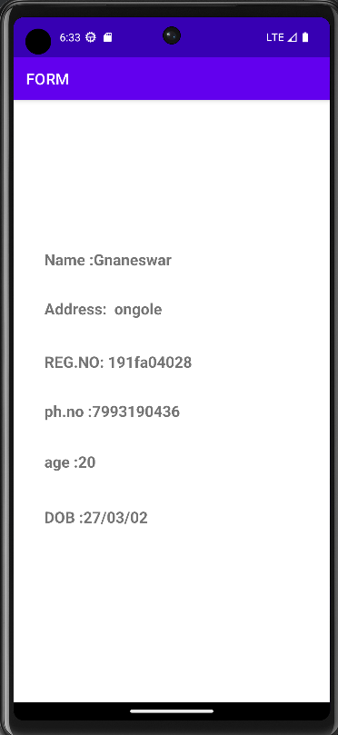**Output** :

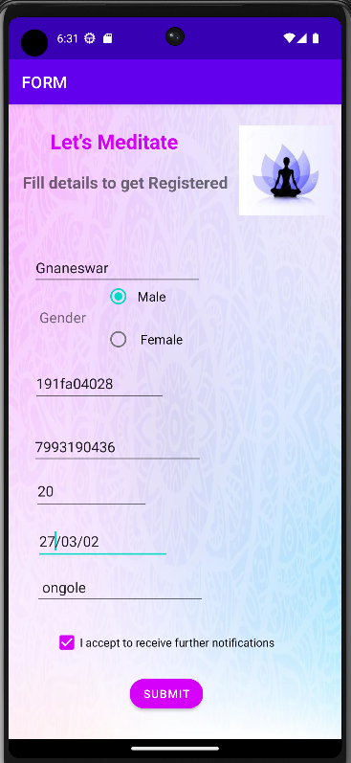

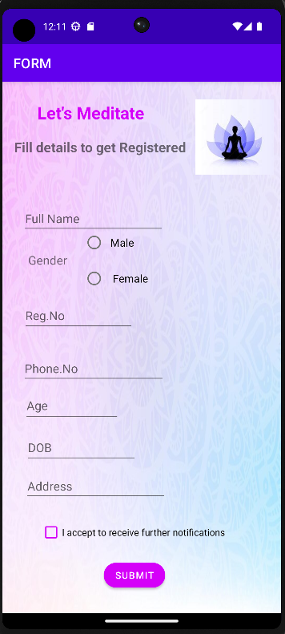

**AIM**: Design a calculator application using LinearLayout( include dialog box when clear button pressed )

DESCRIPTION: Design and demonstrate a calculator application and validate the expressions.  
**PROCEDURE:** For Designing a calculator, follow the below steps

Step:1- Create an XML file for designing a calculator with Linear layout and desired fields (TextView , Editview ,Button)

**Activity_main.xml**

<LinearLayout xmlns:android="http://schemas.android.com/apk/res/android"  
 xmlns:app="http://schemas.android.com/apk/res-auto"  
 xmlns:tools="http://schemas.android.com/tools"  
 android:layout_width="match_parent"  
 android:layout_height="match_parent"  
 android:layout_margin="10dp"  
 android:orientation="vertical">  
  
 <LinearLayout  
 android:layout_width="match_parent"  
 android:layout_height="0dp"  
 android:layout_marginBottom="40dp"  
 android:layout_weight="1"  
 android:gravity="bottom"  
 android:orientation="vertical">  
  
 <TextView  
 android:id="@+id/resultText"  
 android:layout_width="match_parent"  
 android:layout_height="40dp"  
 android:gravity="top"  
 android:hint="Result"  
 android:text=""  
 android:textSize="32dp" />  
  
 <LinearLayout  
 android:layout_width="match_parent"  
 android:layout_height="wrap_content"  
 android:gravity="bottom"  
 android:orientation="horizontal">  
  
 <EditText  
 android:id="@+id/input"  
 android:layout_width="0dp"  
 android:layout_height="wrap_content"  
 android:layout_gravity="bottom"  
 android:layout_marginRight="10dp"  
 android:layout_weight="5"  
 android:hint="Input"  
 android:inputType="number"  
 android:textSize="32dp" />  
  
 <Button  
 android:id="@+id/bback"  
 android:layout_width="0dp"  
 android:layout_height="80dp"  
 android:layout_gravity="top"  
 android:layout_weight="1"  
 android:text="AC"  
 android:textSize="14dp"  
 app:strokeColor="@color/teal_200"  
 tools:ignore="TextSizeCheck" />  
 </LinearLayout>  
 </LinearLayout>  
  
 <LinearLayout  
 android:layout_width="match_parent"  
 android:layout_height="wrap_content"  
 android:layout_marginBottom="40dp"  
 android:orientation="vertical">  
  
 <LinearLayout  
 android:layout_width="wrap_content"  
 android:layout_height="0dp"  
 android:layout_weight="1"  
 android:orientation="horizontal">  
  
 <Button  
 android:id="@+id/bopen"  
 android:layout_width="0dp"  
 android:layout_height="match_parent"  
 android:layout_margin="10dp"  
 android:layout_weight="1"  
 android:padding="20dp"  
 android:text="("  
 app:cornerRadius="100dp"  
 app:strokeColor="@color/teal_200" />  
  
 <Button  
 android:id="@+id/bclose"  
 android:layout_width="0dp"  
 android:layout_height="match_parent"  
 android:layout_margin="10dp"  
 android:layout_weight="1"  
 android:text=")"  
 app:cornerRadius="100dp"  
 app:strokeColor="@color/teal_200" />  
  
 <Button  
 android:id="@+id/bmod"  
 android:layout_width="0dp"  
 android:layout_height="match_parent"  
 android:layout_margin="10dp"  
 android:layout_weight="1"  
 android:text="%"  
 app:cornerRadius="100dp"  
 app:strokeColor="@color/teal_200" />  
  
 <Button  
 android:id="@+id/bdiv"  
 android:layout_width="0dp"  
 android:layout_height="match_parent"  
 android:layout_margin="10dp"  
 android:layout_weight="1"  
 android:text="/"  
 app:cornerRadius="100dp"  
 app:strokeColor="@color/teal_200" />  
 </LinearLayout>  
  
 <LinearLayout  
 android:layout_width="wrap_content"  
 android:layout_height="0dp"  
 android:layout_weight="1"  
 android:orientation="horizontal">  
  
 <Button  
 android:id="@+id/b7"  
 android:layout_width="0dp"  
 android:layout_height="match_parent"  
 android:layout_margin="10dp"  
 android:layout_weight="1"  
 android:padding="20dp"  
 android:text="7"  
 app:cornerRadius="100dp"  
 app:strokeColor="@color/teal_200" />  
  
 <Button  
 android:id="@+id/b8"  
 android:layout_width="0dp"  
 android:layout_height="match_parent"  
 android:layout_margin="10dp"  
 android:layout_weight="1"  
 android:text="8"  
 app:cornerRadius="100dp"  
 app:strokeColor="@color/teal_200" />  
  
 <Button  
 android:id="@+id/b9"  
 android:layout_width="0dp"  
 android:layout_height="match_parent"  
 android:layout_margin="10dp"  
 android:layout_weight="1"  
 android:text="9"  
 app:cornerRadius="100dp"  
 app:strokeColor="@color/teal_200" />  
  
 <Button  
 android:id="@+id/bmul"  
 android:layout_width="0dp"  
 android:layout_height="match_parent"  
 android:layout_margin="10dp"  
 android:layout_weight="1"  
 android:text="*"  
 app:cornerRadius="100dp"  
 app:strokeColor="@color/teal_200" />  
 </LinearLayout>  
  
 <LinearLayout  
 android:layout_width="wrap_content"  
 android:layout_height="0dp"  
 android:layout_weight="1"  
 android:orientation="horizontal">  
  
 <Button  
 android:id="@+id/b4"  
 android:layout_width="0dp"  
 android:layout_height="match_parent"  
 android:layout_margin="10dp"  
 android:layout_weight="1"  
 android:padding="20dp"  
 android:text="4"  
 app:cornerRadius="100dp"  
 app:strokeColor="@color/teal_200" />  
  
 <Button  
 android:id="@+id/b5"  
 android:layout_width="0dp"  
 android:layout_height="match_parent"  
 android:layout_margin="10dp"  
 android:layout_weight="1"  
 android:text="5"  
 app:cornerRadius="100dp"  
 app:strokeColor="@color/teal_200" />  
  
 <Button  
 android:id="@+id/b6"  
 android:layout_width="0dp"  
 android:layout_height="match_parent"  
 android:layout_margin="10dp"  
 android:layout_weight="1"  
 android:text="6"  
 app:cornerRadius="100dp"  
 app:strokeColor="@color/teal_200" />  
  
 <Button  
 android:id="@+id/bsub"  
 android:layout_width="0dp"  
 android:layout_height="match_parent"  
 android:layout_margin="10dp"  
 android:layout_weight="1"  
 android:text="-"  
 app:cornerRadius="100dp"  
 app:strokeColor="@color/teal_200" />  
 </LinearLayout>  
  
 <LinearLayout  
 android:layout_width="wrap_content"  
 android:layout_height="0dp"  
 android:layout_weight="1"  
 android:orientation="horizontal">  
  
 <Button  
 android:id="@+id/b1"  
 android:layout_width="0dp"  
 android:layout_height="match_parent"  
 android:layout_margin="10dp"  
 android:layout_weight="1"  
 android:padding="20dp"  
 android:text="1"  
 app:cornerRadius="100dp"  
 app:strokeColor="@color/teal_200" />  
  
 <Button  
 android:id="@+id/b2"  
 android:layout_width="0dp"  
 android:layout_height="match_parent"  
 android:layout_margin="10dp"  
 android:layout_weight="1"  
 android:text="2"  
 app:cornerRadius="100dp"  
 app:strokeColor="@color/teal_200" />  
  
 <Button  
 android:id="@+id/b3"  
 android:layout_width="0dp"  
 android:layout_height="match_parent"  
 android:layout_margin="10dp"  
 android:layout_weight="1"  
 android:text="3"  
 app:cornerRadius="100dp"  
 app:strokeColor="@color/teal_200" />  
  
 <Button  
 android:id="@+id/badd"  
 android:layout_width="0dp"  
 android:layout_height="match_parent"  
 android:layout_margin="10dp"  
 android:layout_weight="1"  
 android:text="+"  
 app:cornerRadius="100dp"  
 app:strokeColor="@color/teal_200" />  
 </LinearLayout>  
  
 <LinearLayout  
 android:layout_width="wrap_content"  
 android:layout_height="0dp"  
 android:layout_weight="1"  
 android:orientation="horizontal">  
  
 <Button  
 android:id="@+id/bdot"  
 android:layout_width="0dp"  
 android:layout_height="match_parent"  
 android:layout_margin="10dp"  
 android:layout_weight="1"  
 android:padding="20dp"  
 android:text="."  
 app:cornerRadius="100dp"  
 app:strokeColor="@color/teal_200" />  
  
 <Button  
 android:id="@+id/b0"  
 android:layout_width="0dp"  
 android:layout_height="match_parent"  
 android:layout_margin="10dp"  
 android:layout_weight="1"  
 android:text="0"  
 app:cornerRadius="100dp"  
 app:strokeColor="@color/teal_200" />  
  
 <Button  
 android:id="@+id/bclear"  
 android:layout_width="0dp"  
 android:layout_height="match_parent"  
 android:layout_margin="10dp"  
 android:layout_weight="1"  
 android:text="C"  
 android:textSize="11dp"  
 app:cornerRadius="100dp"  
 app:strokeColor="@color/teal_200"  
 tools:ignore="TextSizeCheck" />  
  
 <Button  
 android:id="@+id/bequal"  
 android:layout_width="0dp"  
 android:layout_height="match_parent"  
 android:layout_margin="10dp"  
 android:layout_weight="1"  
 android:text="="  
 app:cornerRadius="100dp"  
 app:strokeColor="@color/teal_200"  
 tools:ignore="TextSizeCheck"/>  
 </LinearLayout>  
 </LinearLayout>  
</LinearLayout>

**Step:2-**

Create a java file and add objects via “id” for each field to read the inputs. Now use onclicklistener method for every button and use switch statement to represent the symbols for printing the values .

Now create a user defined function which is used for validating the expressions .

**MainActivity.java**

package com.example.calculator;  
  
import androidx.appcompat.app.AppCompatActivity;  
  
import android.app.AlertDialog;  
import android.content.DialogInterface;  
import android.os.Bundle;  
import android.view.View;  
import android.widget.Button;  
import android.widget.EditText;  
import android.widget.TextView;  
import android.widget.Toast;  
  
import java.util.EmptyStackException;  
  
public class MainActivity extends AppCompatActivity implements View.OnClickListener {  
  
 Button b1,b2,b3,b4,b5,b6,b7,b8,b9,b0,ba,bs,bm,bd,bmod,bdot,bopen,bclose,bback,bclear,bequal;  
 EditText input;  
 TextView resulttext;  
 @Override  
 protected void onCreate(Bundle savedInstanceState) {  
 super.onCreate(savedInstanceState);  
 setContentView(R.layout.*activity_main*);  
 Button b=(Button) findViewById(R.id.*bclear*);  
 b.setOnClickListener(new View.OnClickListener() {  
 @Override  
 public void onClick(View view) {  
 android.app.AlertDialog.Builder builder=new android.app.AlertDialog.Builder(MainActivity.this);  
 builder.setTitle("Clear All input")  
 .setMessage("Are you sure?")  
 .setCancelable(false)  
 .setPositiveButton("Yes", new DialogInterface.OnClickListener() {  
 @Override  
 public void onClick(DialogInterface dialogInterface, int i) {  
 input.setText("");  
 }  
 })  
 .setNegativeButton("No", new DialogInterface.OnClickListener() {  
 @Override  
 public void onClick(DialogInterface dialogInterface, int i) {  
 Toast.*makeText*(MainActivity.this,"Selected option is No",Toast.*LENGTH_SHORT*).show();  
 }  
 });  
 AlertDialog dialog= builder.create();  
 dialog.show();  
 }  
 });  
 setVals();  
 }  
 public void setVals(){  
 b1 = findViewById(R.id.*b1*);  
 b2 = findViewById(R.id.*b2*);  
 b3 = findViewById(R.id.*b3*);  
 b4 = findViewById(R.id.*b4*);  
 b5 = findViewById(R.id.*b5*);  
 b6 = findViewById(R.id.*b6*);  
 b7 = findViewById(R.id.*b7*);  
 b8 = findViewById(R.id.*b8*);  
 b9 = findViewById(R.id.*b9*);  
 b0 = findViewById(R.id.*b0*);  
 ba = findViewById(R.id.*badd*);  
 bs = findViewById(R.id.*bsub*);  
 bm = findViewById(R.id.*bmul*);  
 bd = findViewById(R.id.*bdiv*);  
 bmod = findViewById(R.id.*bmod*);  
 bdot = findViewById(R.id.*bdot*);  
 bopen = findViewById(R.id.*bopen*);  
 bclose = findViewById(R.id.*bclose*);  
 bback = findViewById(R.id.*bback*);  
 input = findViewById(R.id.*input*);  
 *//bclear = findViewById(R.id.bclear);* bequal = findViewById(R.id.*bequal*);  
  
 resulttext = findViewById(R.id.*resultText*);  
  
 b1.setOnClickListener(this);  
 b2.setOnClickListener(this);  
 b3.setOnClickListener(this);  
 b4.setOnClickListener(this);  
 b5.setOnClickListener(this);  
 b6.setOnClickListener(this);  
 b7.setOnClickListener(this);  
 b8.setOnClickListener(this);  
 b9.setOnClickListener(this);  
 b0.setOnClickListener(this);  
 ba.setOnClickListener(this);  
 bs.setOnClickListener(this);  
 bm.setOnClickListener(this);  
 bd.setOnClickListener(this);  
 bmod.setOnClickListener(this);  
 bdot.setOnClickListener(this);  
 bopen.setOnClickListener(this);  
 bclose.setOnClickListener(this);  
 *//bclear.setOnClickListener(this);* bback.setOnClickListener(this);;  
  
 bequal.setOnClickListener(this);  
 }  
  
 @Override  
 public void onClick(View view) {  
 int pos=input.getText().toString().length();  
 String str = "";  
 String str2 ="";  
 str = input.getText().toString();  
 switch(view.getId()){  
 case R.id.*b1*:  
 str+=1;  
 input.setText(str+str2);  
 break;  
 case R.id.*b2*:  
 str+=2;  
 input.setText(str+str2);  
 break;  
 case R.id.*b3*:  
 str+=3;  
 input.setText(str+str2);  
 break;  
 case R.id.*b4*:  
 str+=4;  
 input.setText(str+str2);  
 break;  
 case R.id.*b5*:  
 str+=5;  
 input.setText(str+str2);  
 break;  
 case R.id.*b6*:  
 str+=6;  
 input.setText(str+str2);  
 break;  
 case R.id.*b7*:  
 str+=7;  
 input.setText(str+str2);  
 break;  
 case R.id.*b8*:  
 str+=8;  
 input.setText(str+str2);  
 break;  
 case R.id.*b9*:  
 str+=9;  
 input.setText(str+str2);  
 break;  
 case R.id.*b0*:  
 str+=0;  
 input.setText(str+str2);  
 break;  
 case R.id.*badd*:  
 str+='+';  
 input.setText(str+str2);  
 break;  
 case R.id.*bsub*:  
 str+='-';  
 input.setText(str+str2);  
 break;  
 case R.id.*bmul*:  
 str+='*';  
 input.setText(str+str2);  
 break;  
 case R.id.*bdiv*:  
 str+='/';  
 input.setText(str+str2);  
 break;  
 case R.id.*bmod*:  
 str+='%';  
 input.setText(str+str2);  
 break;  
 case R.id.*bdot*:  
 str+='.';  
 input.setText(str+str2);  
 break;  
 case R.id.*bopen*:  
 str+='(';  
 input.setText(str+str2);  
 break;  
 case R.id.*bclose*:  
 str+=')';  
 input.setText(str+str2);  
 break;  
 case R.id.*bback*:  
 str = new String(str.toCharArray(),0,str.length()-1);  
 input.setText(str+str2);  
 break;  
 case R.id.*bequal*:  
 displayresult();  
 break;  
  
 }  
  
  
 }  
  
 public void displayresult(){  
 try {  
 String str = input.getText().toString();  
 infixevaluation infixevaluation = new infixevaluation();  
 double ans = infixevaluation.infix(str, str.length());  
 resulttext.setText(ans + "");  
 input.clearFocus();  
 }catch(EmptyStackException e){  
 Toast.*makeText*(getApplicationContext(),"Please Check Expression..!",Toast.*LENGTH_SHORT*).show();  
  
 }  
  
 }  
}

Step3:-

Create another java file for validating the expressions as required.

**infixevaluation.java**

package com.example.calculator;  
  
import java.util.*;  
class infixevaluation{  
 public static boolean isnumber(String str){  
 for(int i = 0; i < str.length(); i++){  
 if((str.charAt(i)>='0' && str.charAt(i)<='9')||str.charAt(i)=='.')  
 continue;  
 else  
 return false;  
 }  
 return true;  
 }  
 public static int priority(char ch){  
 if(ch=='%' || ch=='*' || ch=='/')  
 return 2;  
 return 1;  
 }  
 public static double calculate(double val1,double val2,char op){  
 switch(op){  
 case '+': return val2+val1;  
 case '-': return val2-val1;  
 case '*':return val2*val1;  
 case '/': return val2/val1;  
 case '%': return val2%val1;  
 }  
 return 0;  
  
 }  
 public double infix(String exp,int length){  
 Stack<Character> operator = new Stack<Character>();  
 Stack<Double> values = new Stack<Double>();  
 int i;  
 StringTokenizer st = new StringTokenizer(exp,"*+-/%()",true);  
 while(st.hasMoreTokens()) {  
  
 String var=st.nextToken();  
 if(*isnumber*(var)==true){  
 values.push(Double.*parseDouble*(var));  
 }  
 else{  
 if(var.equals("("))  
 operator.push(var.charAt(0));  
 else if(operator.size()==0||((var.equals("+")||var.equals("-")|var.equals("*")||var.equals("/")||  
 var.equals("%")) && *priority*(operator.peek())<*priority*(var.charAt(0)))||operator.peek()=='('){  
 operator.push(var.charAt(0));  
 }  
 else if(var.equals(")")){  
 while(operator.peek()!='('){  
 values.push(*calculate*(values.pop(),values.pop(),operator.pop()));  
 }  
 operator.pop();  
 }  
 else{  
 while(operator.size()!=0 && *priority*(operator.peek())>*priority*(var.charAt(0))){  
 values.push(*calculate*(values.pop(),values.pop(),operator.pop()));  
 }  
 operator.push(var.charAt(0));  
 }  
 }  
  
 }  
 while(operator.size()!=0){  
 values.push(*calculate*(values.pop(),values.pop(),operator.pop()));  
 }  
 return values.pop();  
 }  
}

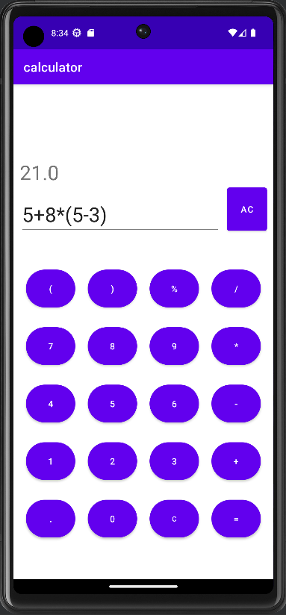

Outputs:

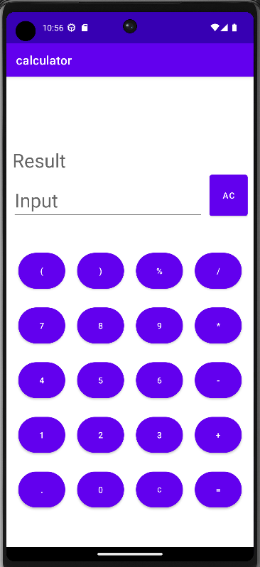

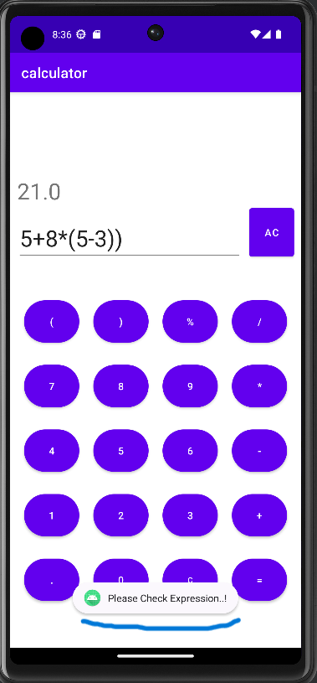

**AIM**: Design an Android application (Gallery) to demonstrate Gridview and FrameLayout. ( includes Progressbar when clicked on image )

**Description**: Develop a gallery application with the RelativeLayout /ScrollView and GridView for showing the Items (pictures) and create another UI uisng FrameLayout with in which a single item can be seen by OnClick functions using the Intents.

**Procedure**: Follow the below steps to develop the gallery application.

**Step:1**

Create a XML file by Relative Layout and GridView with the desired lengths/sizes.

**Activity_main.xml**

<?xml version="1.0" encoding="utf-8"?>  
<RelativeLayout xmlns:android="http://schemas.android.com/apk/res/android"  
 xmlns:app="http://schemas.android.com/apk/res-auto"  
 xmlns:tools="http://schemas.android.com/tools"  
 android:layout_width="match_parent"  
 android:layout_height="match_parent"  
 android:paddingBottom="10dp"  
 android:paddingLeft="5dp"  
 android:paddingRight="5dp"  
 android:paddingTop="10dp"  
 tools:context=".MainActivity">  
 <GridView  
 android:layout_width="wrap_content"  
 android:layout_height="match_parent"  
 android:layout_centerVertical="true"  
 android:layout_centerHorizontal="true"  
 android:scrollbarDefaultDelayBeforeFade="@integer/material_motion_duration_short_1"  
 android:numColumns="3"  
 android:columnWidth="100dp"  
 android:horizontalSpacing="10dp"  
 android:verticalSpacing="10dp"  
 tools:layout_editor_absoluteX="1dp"  
 tools:layout_editor_absoluteY="1dp"  
 tools:ignore="MissingConstraints"  
 android:id="@+id/gridvieww"/>  
  
</RelativeLayout>

**Step**:**2**

Create a java file and define the object for the gridview by “id”.create a method as “onItemClick” and use the intents to display the selected Item in another Activity.

**MainActivity.java**

package com.example.myapplication;  
import android.app.ProgressDialog;  
import android.content.Intent;  
  
import android.os.Bundle;  
import android.os.Handler;  
import android.os.Message;  
import android.view.View;  
import android.widget.AdapterView;  
import android.widget.GridView;  
  
import androidx.annotation.NonNull;  
import androidx.appcompat.app.AppCompatActivity;  
  
public class MainActivity extends AppCompatActivity {  
 ProgressDialog pd;  
 @Override  
 protected void onCreate(Bundle savedInstanceState) {  
 super.onCreate(savedInstanceState);  
  
 setContentView(R.layout.*activity_main*);  
 GridView gv = (GridView) findViewById(R.id.*gridvieww*);  
 gv.setAdapter(new ImageAdapter(this));  
 gv.setOnItemClickListener(new AdapterView.OnItemClickListener() {  
 Handler handler=new Handler(){  
  
 @Override  
  
 public void handleMessage(@NonNull Message msg) {  
  
 super.handleMessage(msg);  
  
 pd.incrementProgressBy(3);  
  
 }  
  
 };  
 public void onItemClick(AdapterView<?> parent, View v, int position, long id) {  
 pd=new ProgressDialog(MainActivity.this);  
 pd.setMessage("Loading…");  
 pd.setProgressStyle(ProgressDialog.*STYLE_HORIZONTAL*);  
 pd.show();  
 pd.setCancelable(false);  
 new Thread(new Runnable() {  
 @Override  
 public void run() {  
 try {  
 while(pd.getProgress()<=pd.getMax())  
 {  
 Thread.*sleep*(200);  
 handler.sendMessage(handler.obtainMessage());  
 if(pd.getProgress()==pd.getMax())  
 {  
 pd.dismiss();  
 }  
 }  
 }catch (InterruptedException e){  
 e.printStackTrace();  
 }  
 }  
 }).start();  
 Intent i = new Intent(getApplicationContext(), FullImageActivity.class);  
 *// passing array index* i.putExtra("id", position);  
 startActivity(i);  
 }  
 });  
 }  
}

**Step:3**

Create another java file and extend it with BaseAdapter. Now define the Items that has been given in the drawable file. Do the necessary changes in the java file and create a ImageView so that the height and width of the image can be defined according to the user requirement.

**ImageAdapter.java**

package com.example.myapplication;  
import android.content.Context;  
import android.view.View;  
import android.view.ViewGroup;  
import android.widget.BaseAdapter;  
import android.widget.GridView;  
import android.widget.ImageView;  
public class ImageAdapter extends BaseAdapter {  
 private Context context;  
 public Integer[] images={  
 R.drawable.*aa*,R.drawable.*ab*,R.drawable.*ac*,  
 R.drawable.*ad*,R.drawable.*ae*,R.drawable.*af*,  
 R.drawable.*aq*,R.drawable.*aw*,R.drawable.*ar*,  
 R.drawable.*at*,R.drawable.*ay*,R.drawable.*au*,  
 R.drawable.*ai*,R.drawable.*ao*,R.drawable.*ag*,  
 R.drawable.*ah*,R.drawable.*ak*,R.drawable.*ar*,  
 R.drawable.*ad*,R.drawable.*at*,R.drawable.*ab*,  
 R.drawable.*ah*,R.drawable.*at*,R.drawable.*ay*,  
 R.drawable.*ah*,R.drawable.*ak*,R.drawable.*ar*,  
 R.drawable.*ad*,R.drawable.*at*,R.drawable.*ab*,  
 };  
 public ImageAdapter(Context c){  
 context=c;  
 }  
 @Override  
 public int getCount() {  
 return images.length;  
 }  
 @Override  
 public Object getItem(int position) {  
 return images[position];  
 }  
 @Override  
 public long getItemId(int i) {  
 return 0;  
 }  
 @Override  
 public View getView(int position, View view, ViewGroup parent) {  
 ImageView imageView=new ImageView(context);  
 imageView.setImageResource(images[position]);  
 imageView.setScaleType(ImageView.ScaleType.*CENTER_CROP*);  
 imageView.setLayoutParams(new GridView.LayoutParams(290, 290));  
 return imageView;}}

**Step:4**

Create another XML file with FrameLayout and an ImageView. This is the reference space where the image should be displayed when OnClick operation performed.

**Activity_main2.xml**

<?xml version="1.0" encoding="utf-8"?>  
<FrameLayout xmlns:android="http://schemas.android.com/apk/res/android"  
 xmlns:android="http://schemas.android.com/apk/res/android"  
 xmlns:tools="http://schemas.android.com/tools"  
 android:layout_width="match_parent"  
 android:layout_height="match_parent"  
 android:paddingTop="0dp"  
 android:paddingRight="0dp"  
 android:paddingBottom="0dp"  
 android:paddingLeft="0dp"  
 tools:context=".FullImageActivity">  
 <ImageView  
 android:id="@+id/imageView"  
 android:layout_width="match_parent"  
 android:layout_height="match_parent"  
 android:layout_centerHorizontal="true"  
 android:layout_centerVertical="true"  
 android:scaleType="centerInside"  
 />  
</FrameLayout>

**Step:5**

Create a java file and use intents with in it, so that the ImageView can be accessed to display items when clicked.

**FulllImageActivity.xml**

package com.example.myapplication;  
  
import androidx.appcompat.app.AppCompatActivity;  
  
import android.content.Intent;  
import android.os.Bundle;  
import android.widget.ImageView;  
  
public class FullImageActivity extends AppCompatActivity {  
  
 @Override  
 protected void onCreate(Bundle savedInstanceState) {  
 super.onCreate(savedInstanceState);  
 setContentView(R.layout.*activity_main2*);  
 Intent i = getIntent();  
 int position=i.getExtras().getInt("id");  
 ImageAdapter adapter=new ImageAdapter(this);  
 ImageView imageView=(ImageView) findViewById(R.id.*imageView*);  
 imageView.setImageResource(adapter.images[position]);  
  
  
 }  
}

**AndroidManifest.xml**

<?xml version="1.0" encoding="utf-8"?>  
<manifest xmlns:android="http://schemas.android.com/apk/res/android"  
 xmlns:tools="http://schemas.android.com/tools">  
  
 <application  
 android:allowBackup="true"  
 android:dataExtractionRules="@xml/data_extraction_rules"  
 android:fullBackupContent="@xml/backup_rules"  
 android:icon="@mipmap/ic_launcher"  
 android:label="@string/app_name"  
 android:supportsRtl="true"  
 android:theme="@style/Theme.MyApplication"  
 tools:targetApi="31">  
 <activity  
 android:name=".FullImageActivity"  
 android:exported="false" />  
 <activity  
 android:name=".ImageAdapter"  
 android:exported="false" />  
 <activity  
 android:name=".MainActivity"  
 android:exported="true">  
 <intent-filter>  
 <action android:name="android.intent.action.MAIN" />  
 <category android:name="android.intent.category.LAUNCHER" />  
 </intent-filter>  
 </activity>  
 </application></manifest>

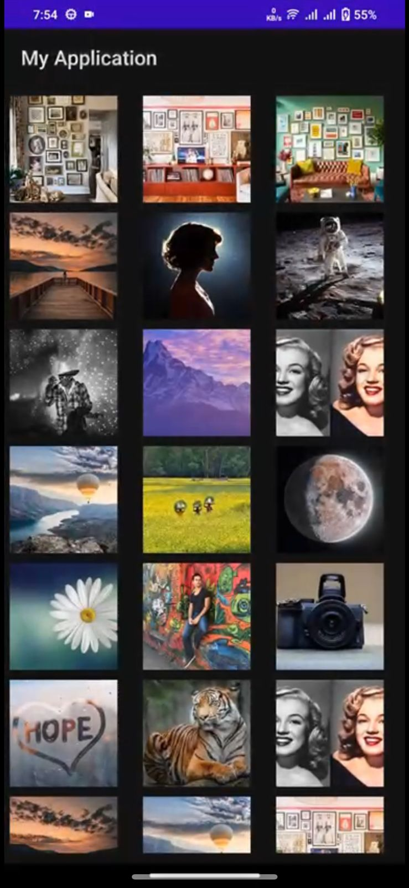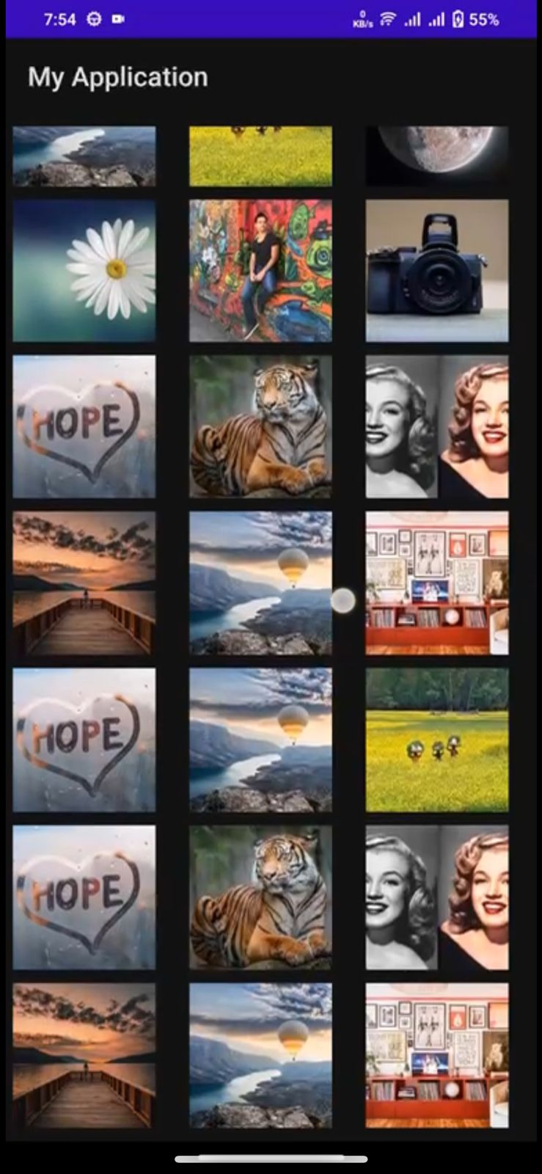**Outputs**: Gallery Application

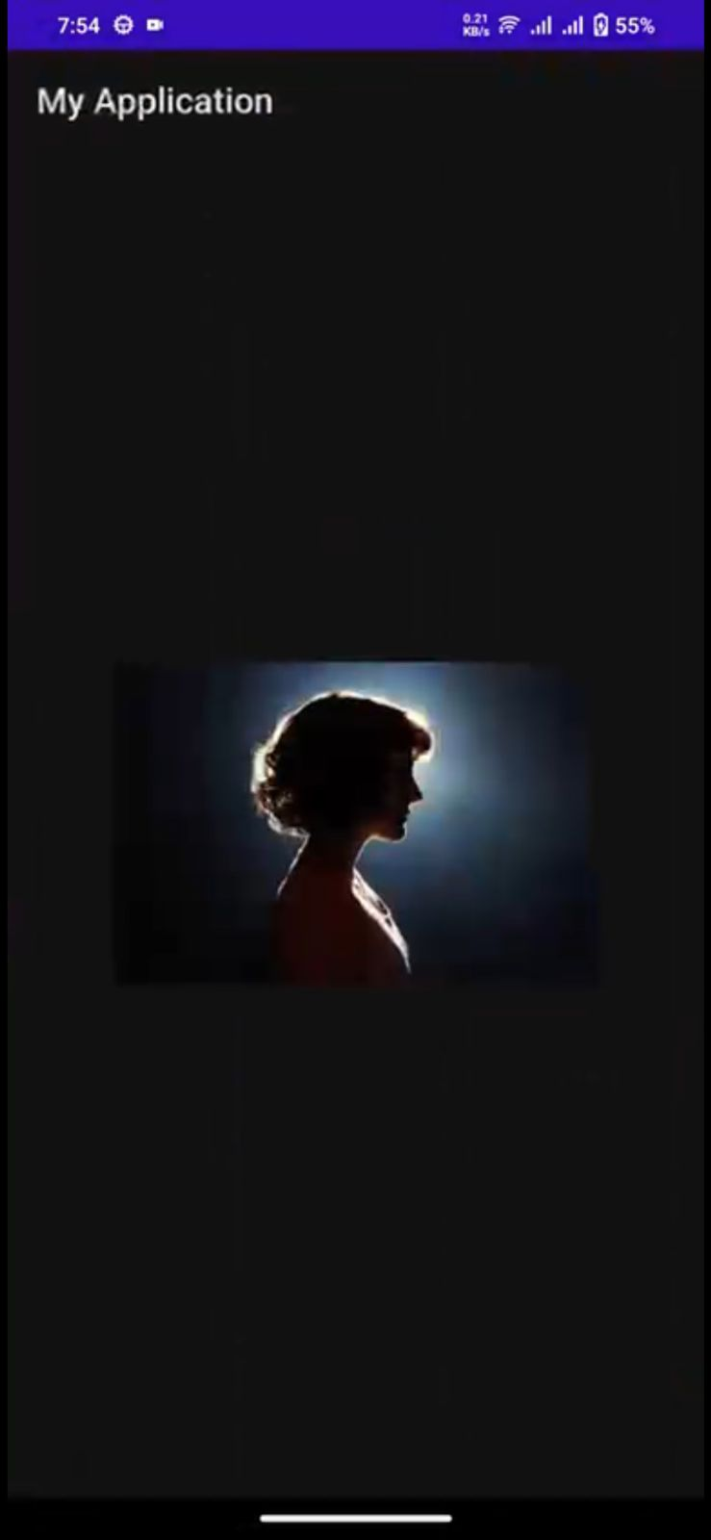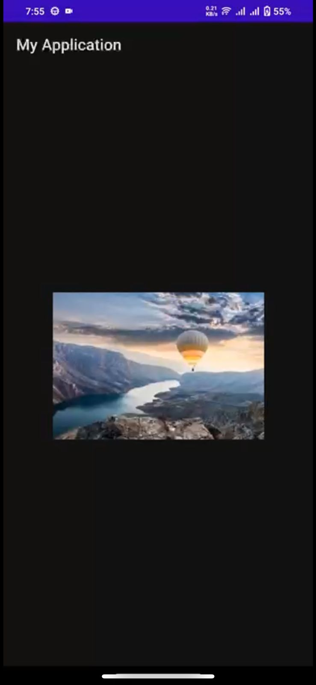Output when Clicked on particular item

**Experiment- 5: Action bar**

## a)

**Experiment-5:Action Bar**

## AIM:Design an application to demonstrate Action Bar.

**Procedure:**

**STEP-1:**Go to “res” in project pane under “app”.

Then res->New->Directory.

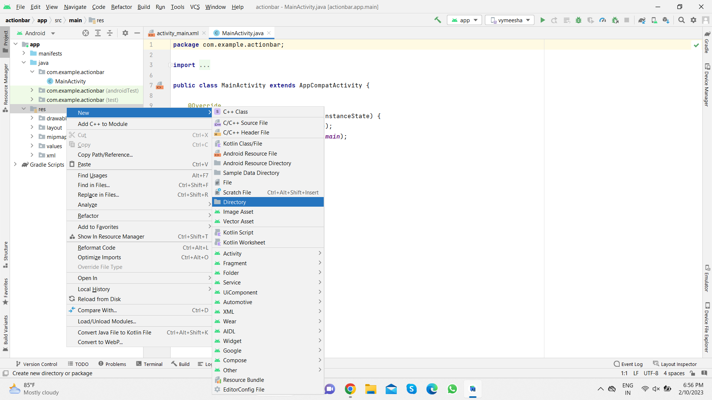

And name the directory as menu.Now you can find the menu directory under “res”.

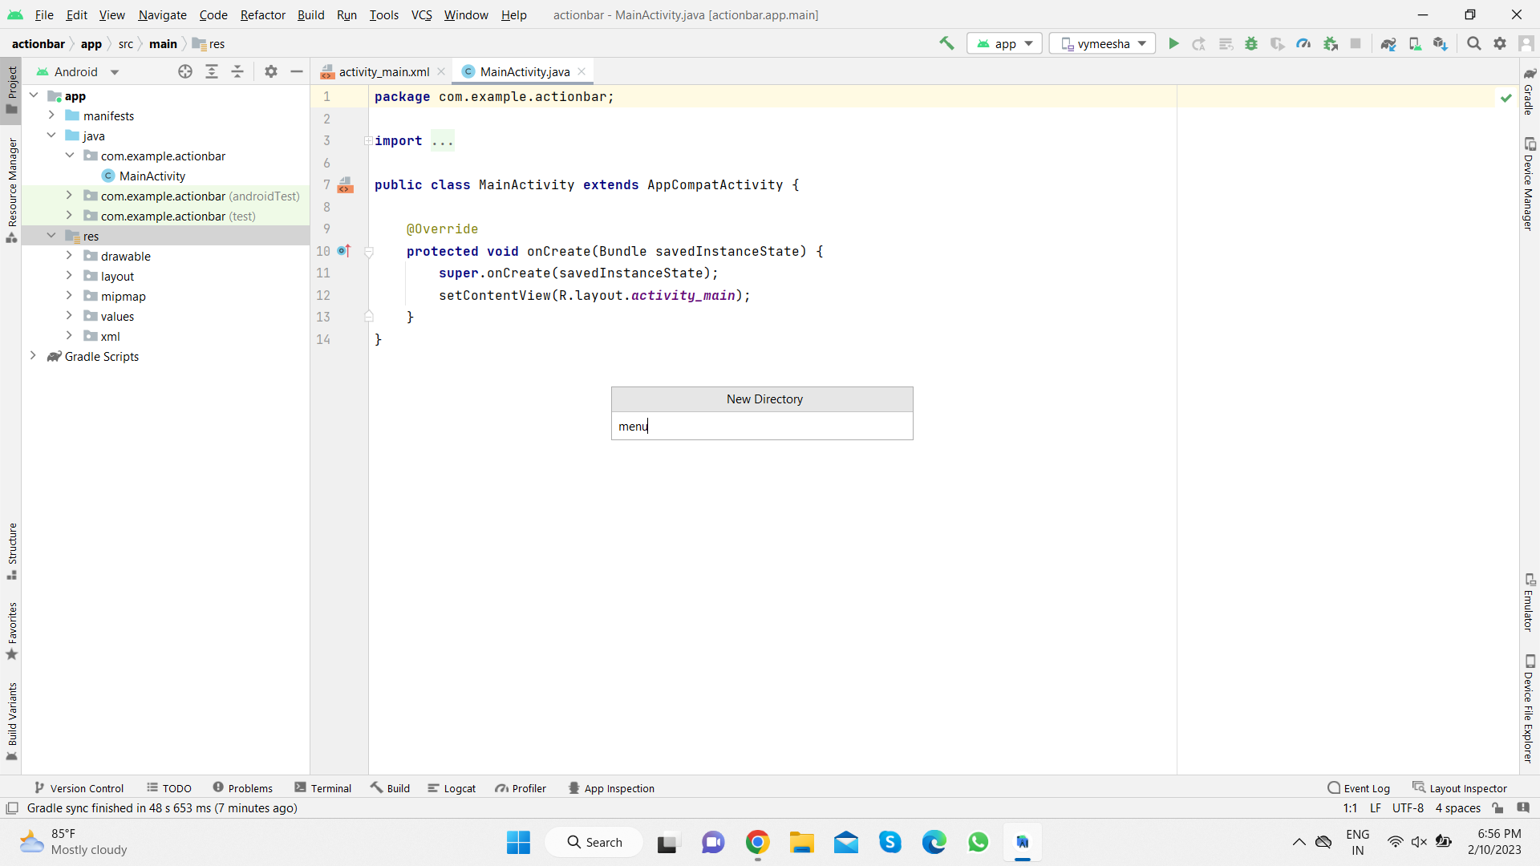

STEP-2:Go to “menu” directory under “res”.

Then res->menu->New->MenuResourceFile.

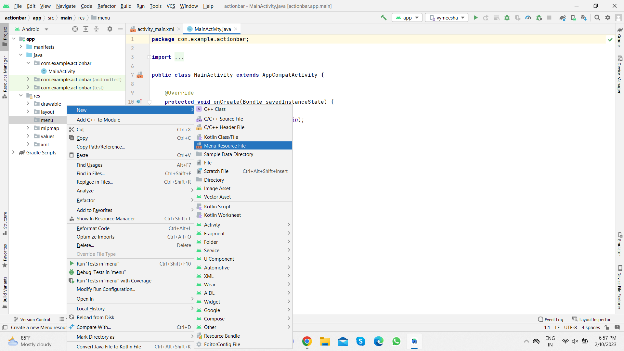

And give the File name as main.

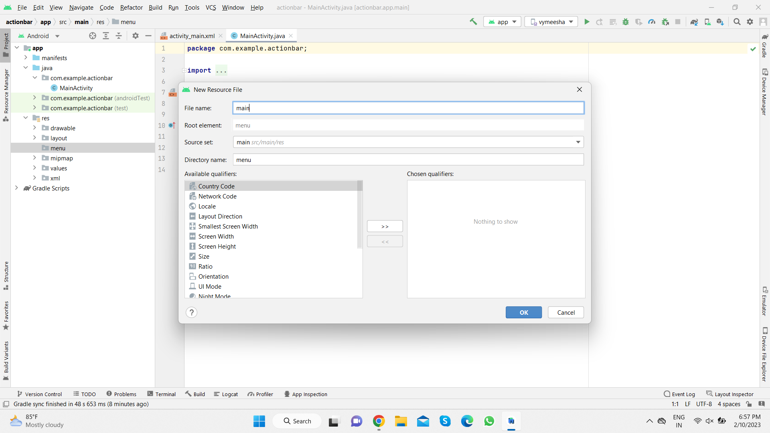

Now under “menu” of “res” you will be able to find main.xml.Click on it.

**main.xml:**

*<?*xml version="1.0" encoding="utf-8"*?>* <menu xmlns:android="http://schemas.android.com/apk/res/android"  
 xmlns:app="http://schemas.android.com/apk/res-auto">  
 <item android:id="@+id/search"  
 android:icon="@drawable/ic_action_search"  
 android:orderInCategory="101"  
 android:title="SEARCH"  
 app:showAsAction="always" />  
 <item android:id="@+id/refresh"  
 android:icon="@drawable/ic_action_refresh"  
 android:orderInCategory="102"  
 android:title="REFRESH"  
 app:showAsAction="always" />  
 <item android:id="@+id/hello"  
 android:orderInCategory="100"  
 android:title="HAI!!!!!HELLO"  
 app:showAsAction="ifRoom" />  
 <item android:id="@+id/details"  
 android:orderInCategory="100"  
 android:title="ENTER DETAILS"  
 app:showAsAction="ifRoom" />  
 </menu>

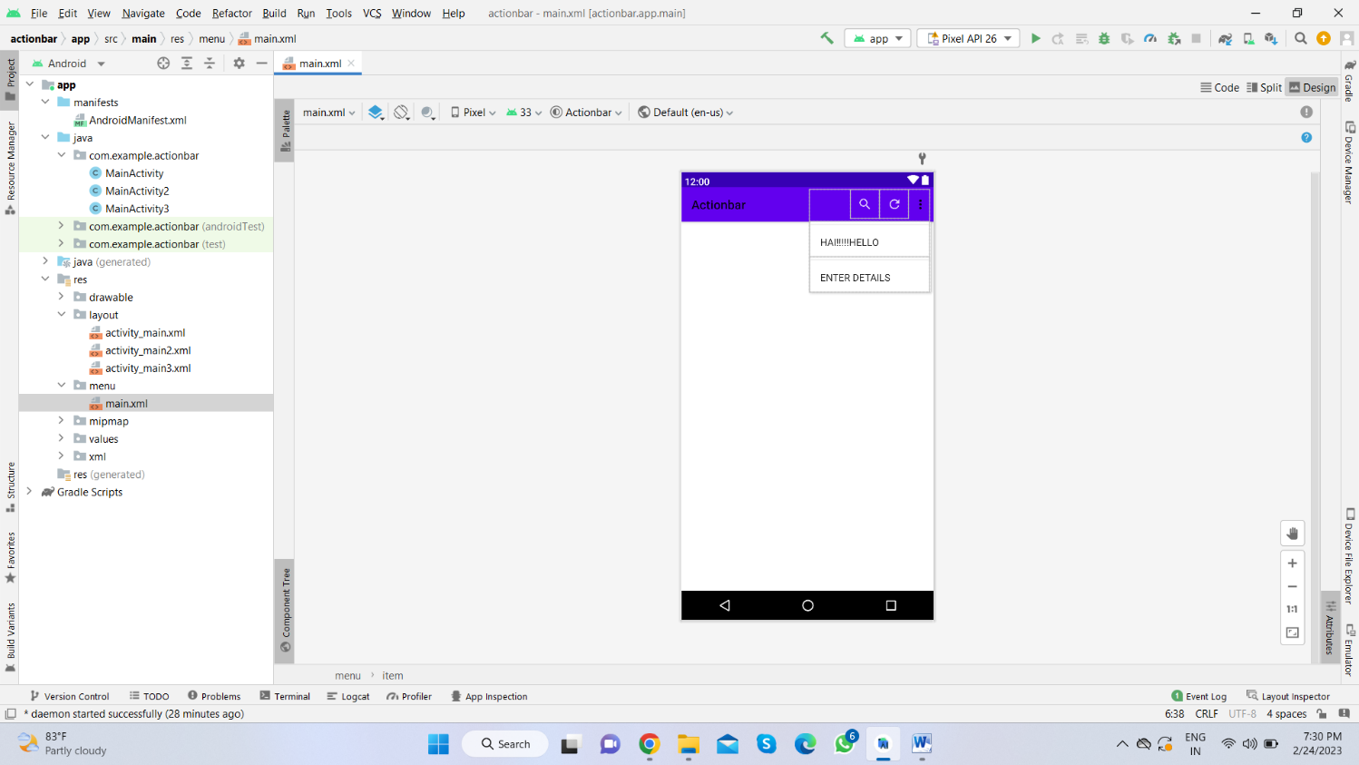

**STEP-3:**Go to activity_main.xml under “layouts”.

**activity_main.xml:**

*<?*xml version="1.0" encoding="utf-8"*?>*<androidx.constraintlayout.widget.ConstraintLayout xmlns:android="http://schemas.android.com/apk/res/android"  
 xmlns:app="http://schemas.android.com/apk/res-auto"  
 xmlns:tools="http://schemas.android.com/tools"  
 android:layout_width="match_parent"  
 android:layout_height="match_parent"  
 tools:context=".MainActivity">  
  
 <ImageView  
 android:id="@+id/imageView2"  
 android:layout_width="161dp"  
 android:layout_height="259dp"  
 app:layout_constraintBottom_toBottomOf="parent"  
 app:layout_constraintLeft_toLeftOf="parent"  
 app:layout_constraintRight_toRightOf="parent"  
 app:layout_constraintTop_toTopOf="parent"  
 app:layout_constraintVertical_bias="0.582"  
 app:srcCompat="@drawable/ic_action_logo" />  
  
</androidx.constraintlayout.widget.ConstraintLayout>

**STEP-4:**Go to MainActivity.java

**MainActivity.java:**

package com.example.actionbar;  
  
import androidx.annotation.NonNull;  
import androidx.appcompat.app.AppCompatActivity;  
  
import android.content.Intent;  
import android.os.Bundle;  
import android.view.Menu;  
import android.view.MenuItem;  
import android.widget.Toast;  
  
public class MainActivity extends AppCompatActivity {  
  
 @Override  
 protected void onCreate(Bundle savedInstanceState) {  
 super.onCreate(savedInstanceState);  
 setContentView(R.layout.*activity_main*);  
 getSupportActionBar().setDisplayShowHomeEnabled(true);  
 getSupportActionBar().setIcon(R.drawable.*ic_action_vignan*);  
 getSupportActionBar().setTitle(" VIGNAN");  
 }  
 public boolean onCreateOptionsMenu(Menu menu)  
 {  
 getMenuInflater().inflate(R.menu.*main*,menu);  
 return super.onCreateOptionsMenu(menu);  
 }  
 public boolean onOptionsItemSelected(@NonNull MenuItem item)  
 {  
 switch(item.getItemId())  
 {  
 case R.id.*search*:  
 Toast.*makeText*(this, "Search Clicked", Toast.*LENGTH_SHORT*).show();  
 break;  
 case R.id.*refresh*:  
 Toast.*makeText*(this, "Refresh Clicked", Toast.*LENGTH_SHORT*).show();  
 break;  
 case R.id.*details*:  
 Intent i=new Intent(getApplicationContext(),MainActivity2.class);  
 startActivity(i);  
 break;  
 case R.id.*hello*:  
 Toast.*makeText*(this, "Hai!!!Hello Clicked", Toast.*LENGTH_SHORT*).show();  
 break;  
 }  
 return super.onOptionsItemSelected(item);  
 }  
  
}

**STEP-5:**create another two empty activites and name it as activity_main2.xml,activity_main3.xml

**activity_main2.xml:**

*<?*xml version="1.0" encoding="utf-8"*?>*<RelativeLayout  
 xmlns:android="http://schemas.android.com/apk/res/android"  
 xmlns:app="http://schemas.android.com/apk/res-auto"  
 xmlns:tools="http://schemas.android.com/tools"  
 android:layout_width="match_parent"  
 android:layout_height="match_parent"  
 tools:context=".MainActivity3">  
  
 <TextView  
 android:id="@+id/textView3"  
 android:layout_width="wrap_content"  
 android:layout_height="48dp"  
 android:layout_alignParentStart="true"  
 android:layout_alignParentTop="true"  
 android:layout_alignParentEnd="true"  
 android:layout_alignParentBottom="true"  
 android:layout_marginStart="88dp"  
 android:layout_marginTop="78dp"  
 android:layout_marginEnd="66dp"  
 android:layout_marginBottom="605dp"  
 android:text="ENTER YOUR DETAILS"  
 android:textColor="@color/black"  
 android:textSize="20dp" />  
  
 <TextView  
 android:id="@+id/textView4"  
 android:textColor="@color/black"  
 android:layout_width="wrap_content"  
 android:layout_height="wrap_content"  
 android:layout_alignParentEnd="true"  
 android:layout_alignParentBottom="true"  
 android:layout_marginEnd="313dp"  
 android:layout_marginBottom="499dp"  
 android:text="USERNAME" />  
 <EditText  
 android:id="@+id/edituser"  
 android:textColor="@color/black"  
 android:layout_width="wrap_content"  
 android:layout_height="wrap_content"  
 android:layout_alignParentEnd="true"  
 android:layout_alignParentBottom="true"  
 android:layout_marginEnd="69dp"  
 android:layout_marginBottom="488dp"  
 android:ems="10"  
 android:inputType="textPersonName" />  
 <TextView  
 android:id="@+id/textView5"  
 android:textColor="@color/black"  
 android:layout_width="wrap_content"  
 android:layout_height="wrap_content"  
 android:layout_alignParentEnd="true"  
 android:layout_alignParentBottom="true"  
 android:layout_marginEnd="311dp"  
 android:layout_marginBottom="449dp"  
 android:text="PASSWORD" />  
  
 <EditText  
 android:id="@+id/editpass"  
 android:textColor="@color/black"  
 android:layout_width="wrap_content"  
 android:layout_height="wrap_content"  
 android:layout_alignParentEnd="true"  
 android:layout_alignParentBottom="true"  
 android:layout_marginEnd="68dp"  
 android:layout_marginBottom="433dp"  
 android:ems="10"  
 android:inputType="textPassword" />  
 <TextView  
 android:id="@+id/textView7"  
 android:layout_width="wrap_content"  
 android:layout_height="wrap_content"  
 android:layout_alignParentEnd="true"  
 android:layout_alignParentBottom="true"  
 android:layout_marginEnd="330dp"  
 android:textColor="@color/black"  
 android:layout_marginBottom="382dp"  
 android:text="E-mail" />  
 <EditText  
 android:id="@+id/editemail"  
 android:textColor="@color/black"  
 android:layout_width="wrap_content"  
 android:layout_height="wrap_content"  
 android:layout_alignParentEnd="true"  
 android:layout_alignParentBottom="true"  
 android:layout_marginEnd="65dp"  
 android:layout_marginBottom="372dp"  
 android:ems="10"  
 android:inputType="textPersonName" />  
  
 <Button  
 android:id="@+id/sub"  
 android:layout_width="wrap_content"  
 android:layout_height="31dp"  
 android:layout_alignParentStart="true"  
 android:layout_alignParentTop="true"  
 android:layout_alignParentEnd="true"  
 android:layout_alignParentBottom="true"  
 android:layout_marginStart="147dp"  
 android:layout_marginTop="547dp"  
 android:layout_marginEnd="157dp"  
 android:layout_marginBottom="153dp"  
 android:backgroundTint="@color/black"  
 android:text="SUBMIT"  
 android:textColor="@color/white"  
 app:layout_constraintBottom_toBottomOf="parent"  
 app:layout_constraintHorizontal_bias="0.84"  
 app:layout_constraintLeft_toLeftOf="parent"  
 app:layout_constraintRight_toRightOf="parent"  
 app:layout_constraintTop_toTopOf="parent"  
 app:layout_constraintVertical_bias="0.932" />  
</RelativeLayout>

**MainActivity2.java:**

package com.example.actionbar;  
  
import androidx.appcompat.app.AppCompatActivity;  
  
import android.content.Intent;  
import android.os.Bundle;  
import android.view.View;  
import android.widget.Button;  
import android.widget.EditText;  
import android.widget.Toast;  
  
public class MainActivity2 extends AppCompatActivity {  
  
 @Override  
 protected void onCreate(Bundle savedInstanceState) {  
 super.onCreate(savedInstanceState);  
 setContentView(R.layout.*activity_main2*);  
 EditText t1=(EditText) findViewById(R.id.*edituser*);  
 EditText t2=(EditText) findViewById(R.id.*editpass*);  
 EditText t3=(EditText) findViewById(R.id.*editemail*);  
 Button b1=(Button) findViewById(R.id.*sub*);  
 b1.setOnClickListener(new View.OnClickListener() {  
 @Override  
 public void onClick(View view) {  
 Intent i1=new Intent(getApplicationContext(),MainActivity3.class);  
 String s=t1.getText().toString();  
 String s11=t2.getText().toString();  
 String s12=t3.getText().toString();  
 if(!s12.isEmpty() && !s11.isEmpty() && !s.isEmpty())  
 {  
 i1.putExtra("USERNAME IS:", s);  
 i1.putExtra("PASSWORD IS:", s11);  
 i1.putExtra("EMAIL IS:", s12);  
 Toast.*makeText*(MainActivity2.this, "DATA IS SUBMITTED", Toast.*LENGTH_SHORT*).show();  
 startActivity(i1);  
 }  
 else  
 {  
 Toast.*makeText*(MainActivity2.this, "DATA CANNOT BE SUBMITTED", Toast.*LENGTH_SHORT*).show();  
 }  
 }  
 });  
 }  
}

**activity_main3.xml:**

*<?*xml version="1.0" encoding="utf-8"*?>*<androidx.constraintlayout.widget.ConstraintLayout xmlns:android="http://schemas.android.com/apk/res/android"  
 xmlns:app="http://schemas.android.com/apk/res-auto"  
 xmlns:tools="http://schemas.android.com/tools"  
 android:layout_width="match_parent"  
 android:layout_height="match_parent"  
 android:textAlignment="center"  
 tools:context=".MainActivity3">  
  
 <TextView  
 android:id="@+id/submit"  
 android:layout_width="wrap_content"  
 android:layout_height="wrap_content"  
 android:text="SUBMITTED DATA"  
 android:textSize="20dp"  
 android:textColor="@color/black"  
 app:layout_constraintBottom_toBottomOf="parent"  
 app:layout_constraintHorizontal_bias="0.498"  
 app:layout_constraintLeft_toLeftOf="parent"  
 app:layout_constraintRight_toRightOf="parent"  
 app:layout_constraintTop_toTopOf="parent"  
 app:layout_constraintVertical_bias="0.13" />  
  
 <TextView  
 android:id="@+id/textView2"  
 android:layout_width="wrap_content"  
 android:layout_height="wrap_content"  
 android:text="Username"  
 android:textColor="@color/black"  
 app:layout_constraintBottom_toBottomOf="parent"  
 app:layout_constraintHorizontal_bias="0.498"  
 app:layout_constraintLeft_toLeftOf="parent"  
 app:layout_constraintRight_toRightOf="parent"  
 app:layout_constraintTop_toTopOf="parent"  
 app:layout_constraintVertical_bias="0.279" />  
  
 <TextView  
 android:id="@+id/text1"  
 android:layout_width="wrap_content"  
 android:layout_height="wrap_content"  
 android:text="T1"  
 android:textColor="@color/black"  
 app:layout_constraintBottom_toBottomOf="parent"  
 app:layout_constraintHorizontal_bias="0.498"  
 app:layout_constraintLeft_toLeftOf="parent"  
 app:layout_constraintRight_toRightOf="parent"  
 app:layout_constraintTop_toTopOf="parent"  
 app:layout_constraintVertical_bias="0.372" />  
  
 <TextView  
 android:id="@+id/textView9"  
 android:layout_width="wrap_content"  
 android:layout_height="wrap_content"  
 android:text="Password "  
 android:textColor="@color/black"  
 app:layout_constraintBottom_toBottomOf="parent"  
 app:layout_constraintHorizontal_bias="0.498"  
 app:layout_constraintLeft_toLeftOf="parent"  
 app:layout_constraintRight_toRightOf="parent"  
 app:layout_constraintTop_toTopOf="parent"  
 app:layout_constraintVertical_bias="0.453" />  
  
 <TextView  
 android:id="@+id/text2"  
 android:layout_width="wrap_content"  
 android:layout_height="wrap_content"  
 android:text="T2"  
 android:textColor="@color/black"  
 app:layout_constraintBottom_toBottomOf="parent"  
 app:layout_constraintHorizontal_bias="0.498"  
 app:layout_constraintLeft_toLeftOf="parent"  
 app:layout_constraintRight_toRightOf="parent"  
 app:layout_constraintTop_toTopOf="parent"  
 app:layout_constraintVertical_bias="0.544" />  
  
 <TextView  
 android:id="@+id/textView11"  
 android:layout_width="wrap_content"  
 android:layout_height="wrap_content"  
 android:text="E-mail "  
 android:textColor="@color/black"  
 app:layout_constraintBottom_toBottomOf="parent"  
 app:layout_constraintHorizontal_bias="0.498"  
 app:layout_constraintLeft_toLeftOf="parent"  
 app:layout_constraintRight_toRightOf="parent"  
 app:layout_constraintTop_toTopOf="parent"  
 app:layout_constraintVertical_bias="0.662" />  
  
 <TextView  
 android:id="@+id/text3"  
 android:layout_width="wrap_content"  
 android:layout_height="wrap_content"  
 android:text="T3"  
 android:textColor="@color/black"  
 app:layout_constraintBottom_toBottomOf="parent"  
 app:layout_constraintHorizontal_bias="0.498"  
 app:layout_constraintLeft_toLeftOf="parent"  
 app:layout_constraintRight_toRightOf="parent"  
 app:layout_constraintTop_toTopOf="parent"  
 app:layout_constraintVertical_bias="0.771" />  
  
</androidx.constraintlayout.widget.ConstraintLayout>

**MainActivity3.java:**

package com.example.actionbar;  
  
import androidx.appcompat.app.AppCompatActivity;  
  
import android.content.Intent;  
import android.os.Bundle;  
import android.widget.TextView;  
  
public class MainActivity3 extends AppCompatActivity {  
  
 @Override  
 protected void onCreate(Bundle savedInstanceState) {  
 super.onCreate(savedInstanceState);  
 setContentView(R.layout.*activity_main3*);  
 TextView r=(TextView) findViewById(R.id.*text1*);  
 Intent i=getIntent();  
 String s=i.getStringExtra("USERNAME IS:");  
 r.setText(s);  
 TextView r1=(TextView) findViewById(R.id.*text2*);  
 Intent i1=getIntent();  
 String s1=i1.getStringExtra("PASSWORD IS:");  
 r1.setText(s1);  
 TextView r2=(TextView) findViewById(R.id.*text3*);  
 Intent i2=getIntent();  
 String s2=i2.getStringExtra("EMAIL IS:");  
 r2.setText(s2);  
 }  
}

**STEP 6: Manifest file**

Make sure Manifest file has the MainActivity and MainActivity2,MainActivity3 listed it. Also here MainActivity is our main activity which will be launched first. So make sure intent-filter is correctly added just below MainActivity.

**AndroidMainfest.xml:**

*<?*xml version="1.0" encoding="utf-8"*?>*<manifest xmlns:android="http://schemas.android.com/apk/res/android"  
 xmlns:tools="http://schemas.android.com/tools"  
 package="com.example.actionbar">  
  
 <application  
 android:allowBackup="true"  
 android:dataExtractionRules="@xml/data_extraction_rules"  
 android:fullBackupContent="@xml/backup_rules"  
 android:icon="@mipmap/ic_launcher"  
 android:label="@string/app_name"  
 android:roundIcon="@mipmap/ic_launcher_round"  
 android:supportsRtl="true"  
 android:theme="@style/Theme.Actionbar"  
 tools:targetApi="31">  
 <activity  
 android:name=".MainActivity3"  
 android:parentActivityName=".MainActivity"  
 android:exported="false" />  
 <activity  
 android:name=".MainActivity2"  
 android:parentActivityName=".MainActivity"  
 android:exported="false" />  
 <activity  
 android:name=".MainActivity"  
 android:exported="true">  
 <intent-filter>  
 <action android:name="android.intent.action.MAIN" />  
  
 <category android:name="android.intent.category.LAUNCHER" />  
 </intent-filter>  
 </activity>  
 </application>  
  
</manifest>

**Outputs:**

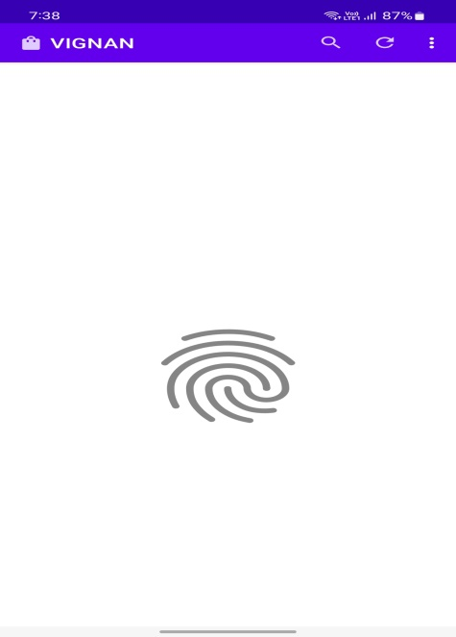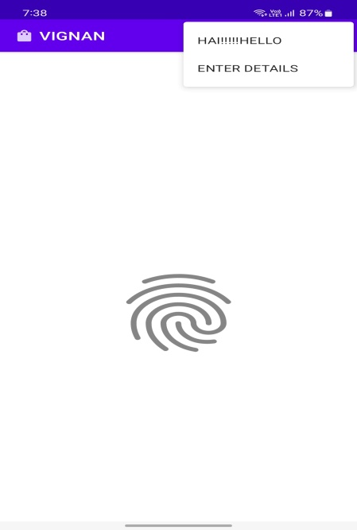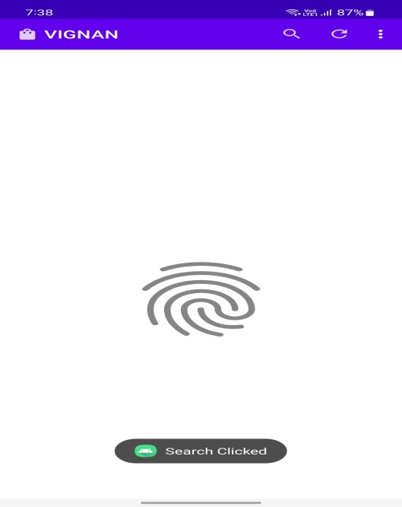

“HOME PAGE” CLICK ON OVERFLOW IF SEARCH CLICKED

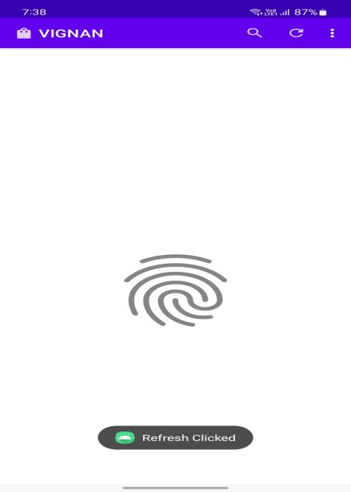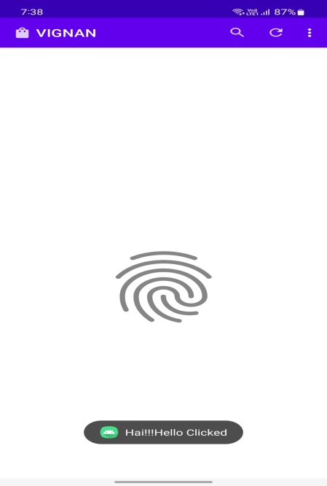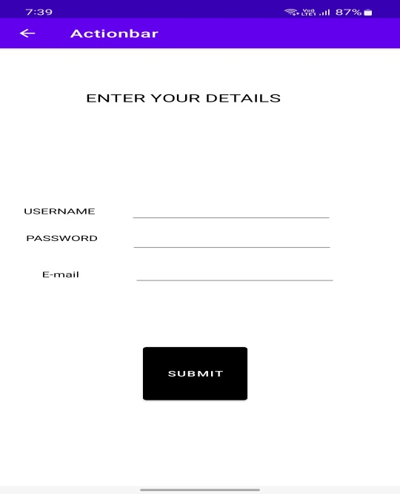

IF REFRESH CLICKED IF HAI!!!HELLO CLICKED IF ENTER DETAILS CLICKED

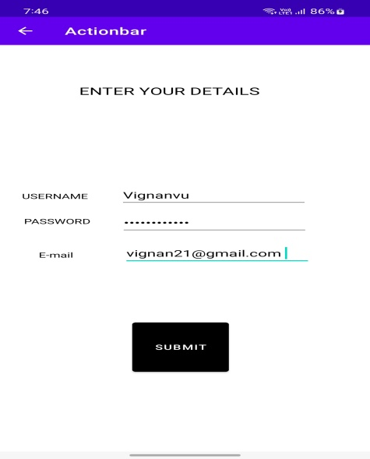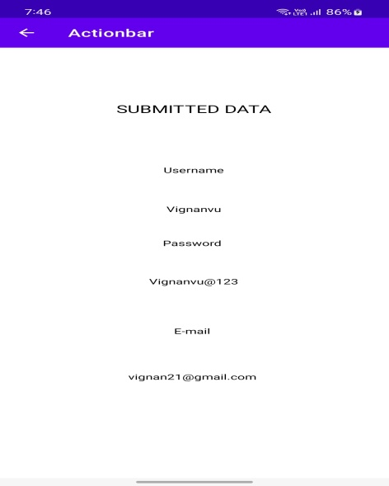

IF CLICKED ON SUBMIT

## Experiment -6: Dialog boxes

**Design an application to demonstrate different types of dialog boxes.**

*Important Methods*

*of*

*ProgressDialog*

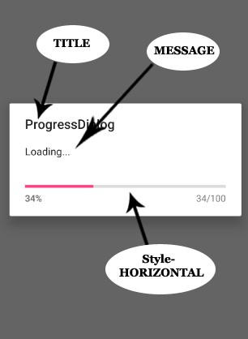

1. **setTitle(CharSequence title) –** This component is used to set the title of the [progress dialog.](https://abhiandroid.com/ui/progressdialog/)

// Setting Title

progressDialog.setTitle("ProgressDialog");

1. **setMessage(CharSequence message) –** This component displays the required message in the progress dialog.

// Setting Message

progressDialog.setMessage("Loading...");

1. **setProgressStyle(ProgressDialog.STYLE_HORIZONTAL) –** This is used for setting the horizontal style of the progress dialog.

// Progress Dialog Style Horizontal

progressDialog.setProgressStyle(ProgressDialog.STYLE_HORIZONTAL);

1. **setProgressStyle(ProgressDialog.STYLE_SPINNER) –** This is used for setting the [spinner](https://abhiandroid.com/ui/spinner/) style of the progress dialog.

// Progress Dialog Style Spinner progressDialog.setProgressStyle(ProgressDialog.STYLE_SPINNER);

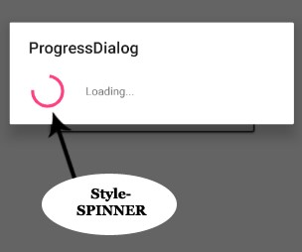

1. **setMax(int max) –** This method sets the maximum value of the progress dialog.

// Progress Dialog Max Value progressDialog.setMax(100);

1. **getMax() –** This method return the maximum value of the progress dialog, basically this method is used while applying condition over the progress dialog.

// Fetching max value progressDialog.getMax();

1. **getProgess() –** This returns current progress of the progress dialog in numeric.

// Fetching current progress progressDialog.getProgress();

1. **incrementProgressBy(int diff) –** This method increments the progress dialog value with the defined value.

// Incremented By Value 2 progressDialog.incrementProgressBy(2);

1. **setCancelable(boolean cancelable) –** This method has boolean value i.e true/false. If set to false it allows to cancel the dialog box by clicking on area outside the dialog default it is true if method is not used.

// Cannot Cancel Progress Dialog progressDialog.setCancelable(false);

1. **dismiss() –** This method dismiss the [progressdialog.](https://abhiandroid.com/ui/progressdialog/)

//Dismiss the dialog

progressDialog.dismiss();

*ProgressDialog Example In Android Studio:*

Below is the example of Progress Dialog in which the functionality of [ProgressDialog](https://abhiandroid.com/ui/progressdialog/) is defined over the buttons click. In this example we have used a simple buttons and over that [button](https://abhiandroid.com/ui/button/) click the ProgressDialog will appear.

Below you can download code, see final output and step by step explanation of ProgressDialog example in Android Studio.

**Step 1:** [Create a new project](https://abhiandroid.com/androidstudio/start-create-project) and name it **ProgressDialogExample/dialg**.

**Step 2:** Open res -> layout -> activity_main.[xml](https://abhiandroid.com/ui/xml/) (or) main.[xml](https://abhiandroid.com/ui/xml/) and add following code:

Here define three buttons

*<?*xml version="1.0" encoding="utf-8"*?>*<androidx.constraintlayout.widget.ConstraintLayout xmlns:android="http://schemas.android.com/apk/res/android" xmlns:app="http://schemas.android.com/apk/res-auto" xmlns:tools="http://schemas.android.com/tools" android:layout_width="match_parent" android:layout_height="match_parent" tools:context=".MainActivity">  
  
 <TextView  
 android:id="@+id/textView"  
 android:layout_width="208dp"  
 android:layout_height="47dp"  
 android:text="Alert Messages"  
 android:textAlignment="center"  
 android:textColor="@color/black"  
 android:textSize="10pt"  
 android:textStyle="bold"  
 app:layout_constraintBottom_toBottomOf="parent"  
 app:layout_constraintLeft_toLeftOf="parent"  
 app:layout_constraintRight_toRightOf="parent"  
 app:layout_constraintTop_toTopOf="parent"  
 app:layout_constraintVertical_bias="0.175" />  
  
 <Button  
 android:layout_width="144dp" android:layout_height="49dp" android:text="Click" android:id="@+id/button"  
 app:layout_constraintBottom_toBottomOf="parent" app:layout_constraintHorizontal_bias="0.538" app:layout_constraintLeft_toLeftOf="parent" app:layout_constraintRight_toRightOf="parent" app:layout_constraintTop_toTopOf="parent" app:layout_constraintVertical_bias="0.402" />  
  
 <Button  
 android:id="@+id/button2" android:layout_width="182dp" android:layout_height="56dp" android:text="Progress Bar"  
 app:layout_constraintBottom_toBottomOf="parent" app:layout_constraintHorizontal_bias="0.539" app:layout_constraintLeft_toLeftOf="parent" app:layout_constraintRight_toRightOf="parent" app:layout_constraintTop_toTopOf="parent" app:layout_constraintVertical_bias="0.539" />  
  
 <Button  
 android:id="@+id/button4"  
 android:layout_width="184dp"  
 android:layout_height="52dp"  
 android:text="progress spinner"  
 app:layout_constraintBottom_toBottomOf="parent"  
 app:layout_constraintEnd_toEndOf="parent"  
 app:layout_constraintHorizontal_bias="0.541"  
 app:layout_constraintStart_toStartOf="parent"  
 app:layout_constraintTop_toTopOf="parent"  
 app:layout_constraintVertical_bias="0.656"  
 tools:ignore="MissingConstraints" />  
</androidx.constraintlayout.widget.ConstraintLayout>

**Step 3 :** Now open app -> [java](https://abhiandroid.com/java/) -> package -> MainActivity.[java](https://abhiandroid.com/java/) and add the below code.

In this we added the progress dialog functionality on the [button](https://abhiandroid.com/ui/button/) click having onclicklistener. The two buttons both are displaying different type of progress dialog which is set using setProgressStyle i.e [spinner](https://abhiandroid.com/ui/spinner/) or horizontal bar.

package com.example.calcdialog;  
import androidx.annotation.NonNull;  
  
import androidx.appcompat.app.AppCompatActivity;  
  
import android.app.AlertDialog;  
  
import android.app.Dialog;  
import android.app.ProgressDialog;  
  
import android.content.DialogInterface;  
  
import android.os.Bundle;  
  
import android.os.Handler;  
  
import android.os.Message;  
  
import android.view.View;  
  
import android.widget.Button;  
  
import android.widget.Toast;  
  
  
  
public class MainActivity extends AppCompatActivity {  
  
 ProgressDialog pd;  
  
 @Override  
  
 protected void onCreate(Bundle savedInstanceState) {  
  
 super.onCreate(savedInstanceState);  
  
 setContentView(R.layout.*activity_main*);  
  
 Button b=(Button) findViewById(R.id.*button*);  
  
 b.setOnClickListener(new View.OnClickListener() {  
  
 @Override  
  
 public void onClick(View view) {  
  
 AlertDialog.Builder builder=new AlertDialog.Builder(MainActivity.this);  
  
 builder.setTitle("Login")  
  
 .setMessage("Are you sure?")  
  
 .setCancelable(false)  
  
 .setPositiveButton("Yes", new DialogInterface.OnClickListener() {  
  
 @Override  
  
 public void onClick(DialogInterface dialogInterface, int i) {  
  
 Toast.*makeText*(MainActivity.this,"Selected option is yes",Toast.*LENGTH_LONG*).show();  
  
 }  
  
 })  
  
 .setNegativeButton("No", new DialogInterface.OnClickListener() {  
  
 @Override  
 public void onClick(DialogInterface dialogInterface, int i) {  
 Toast.*makeText*(MainActivity.this,"Selected option is No",Toast.*LENGTH_SHORT*).show();  
 }  
 });  
 AlertDialog dialog= builder.create();  
 dialog.show();  
 }  
 });  
 Button b3=(Button) findViewById(R.id.*button2*);  
 b3.setOnClickListener(new View.OnClickListener() {  
  
 Handler handler=new Handler(){  
  
 @Override  
  
 public void handleMessage(@NonNull Message msg) {  
  
 super.handleMessage(msg);  
  
 pd.incrementProgressBy(2);  
  
 }  
  
 };  
 @Override  
 public void onClick(View view){  
 pd=new ProgressDialog(MainActivity.this);  
 pd.setMessage("Loading…");  
 pd.setProgressStyle(ProgressDialog.*STYLE_HORIZONTAL*);  
 pd.show();  
 pd.setCancelable(false);  
 new Thread(new Runnable() {  
 @Override  
 public void run() {  
 try {  
 while(pd.getProgress()<=pd.getMax())  
 {  
 Thread.*sleep*(200);  
 handler.sendMessage(handler.obtainMessage());  
 if(pd.getProgress()==pd.getMax())  
 {  
 pd.dismiss();  
 }  
 }  
 }catch (InterruptedException e){  
 e.printStackTrace();  
 }  
 }  
 }).start();  
 }  
 });  
 Button b4=(Button) findViewById(R.id.*button4*);  
  
 b4.setOnClickListener(new View.OnClickListener() {  
 @Override  
 public void onClick(View v) {  
 pd= new ProgressDialog(MainActivity.this);  
 pd.setMessage("Loading..."); *// Setting Message* pd.setTitle("ProgressDialog"); *// Setting Title* pd.setProgressStyle(ProgressDialog.*STYLE_SPINNER*); *// Progress Dialog Style Spinner* pd.show(); *// Display Progress Dialog* pd.setCancelable(false);  
 new Thread(new Runnable() {  
 public void run() {  
 try {  
 Thread.*sleep*(10000);  
 } catch (Exception e) {  
 e.printStackTrace();  
 }  
 pd.dismiss();  
 }  
 }).start();  
 }  
 });  
  
 }  
  
}

**Output:**

Now start the AVD in Emulator and run the App. You will see [button](https://abhiandroid.com/ui/button/)s[.](https://abhiandroid.com/ui/button/) Click on them and see the different ProgressDialog in android.

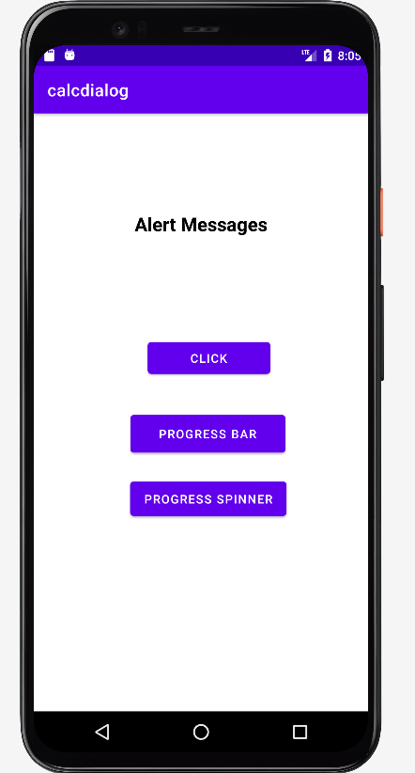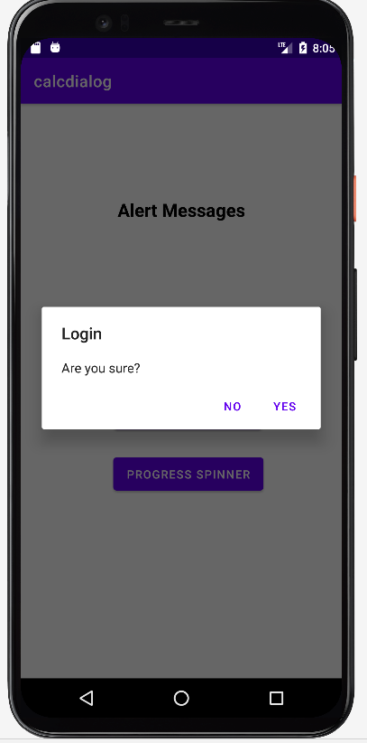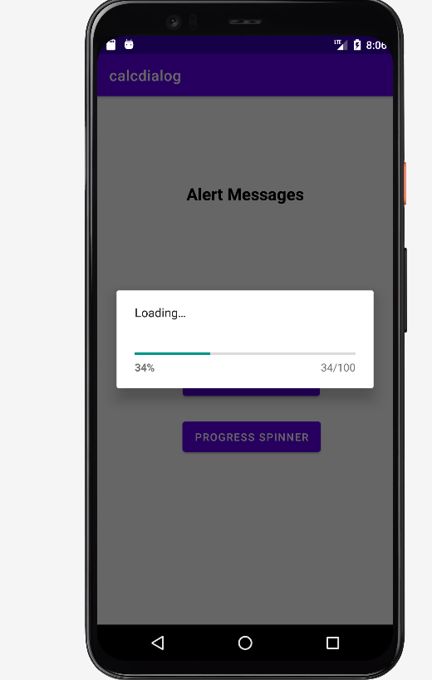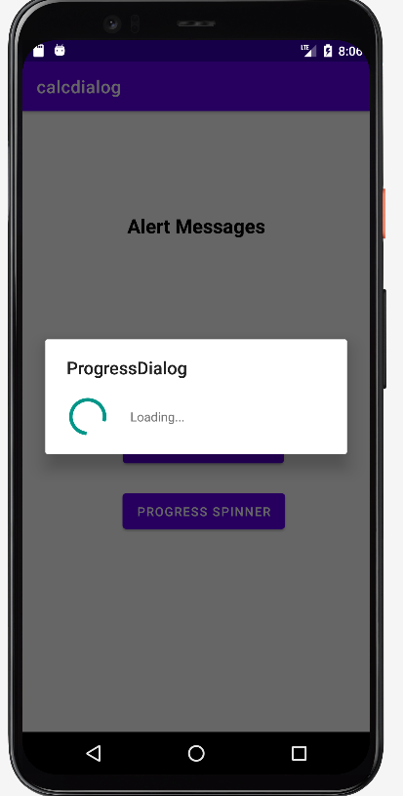

## Experiment – 7: Fragments

**a) Adding Fragments Dynamically Procedure:**

1. Open activity_main.xml, Comment/Delete <fragment> tags
2. Open MainActivity.java file
   1. *Create the FragmentManager instance*
   2. *Enclose FragmentTransaction*
   3. *Retrieve the current display information*
   4. *Display - landscape - fragment1;Potrait – fragment2*
   5. *Commit() to ensure all changes are saved.*

## Files and Relevant Code Activity_main.xml

*<?***xml version="1.0" encoding="utf-8"***?>*

<**LinearLayout xmlns:android="http://schemas.android.com/apk/res/android" xmlns:app="http://schemas.android.com/apk/res-auto" xmlns:tools="http://schemas.android.com/tools" android:layout_width="match_parent" android:layout_height="match_parent" android:orientation="horizontal"**>

</**LinearLayout**>

## Fragment_firstfragment.xml

*<?***xml version="1.0" encoding="utf-8"***?>*

<**LinearLayout xmlns:android="http://schemas.android.com/apk/res/android" xmlns:app="http://schemas.android.com/apk/res-auto" xmlns:tools="http://schemas.android.com/tools" android:layout_width="match_parent" android:layout_height="match_parent" android:orientation="vertical" android:background="#00FF00"**

**tools:context=".firstfragment"**>

*<!--* ***TODO: Update blank fragment layout*** *-->*

<**TextView**

**android:layout_width="fill_parent" android:layout_height="wrap_content" android:text="First_Fragment" android:textColor="#000000"**

**android:textSize="20sp"** />

</**LinearLayout**>

## Firstfragment.java

**package** com.example.fragment; **import** android.os.Bundle; **import** androidx.annotation.Nullable; **import** androidx.fragment.app.Fragment; **import** android.view.LayoutInflater; **import** android.view.View; **import** android.view.ViewGroup;

**public class** firstfragment **extends** Fragment {

@Override

**public** View onCreateView(LayoutInflater inflater, ViewGroup container,

Bundle savedInstanceState) { *// Inflate the layout for this fragment*

**return** inflater.inflate(R.layout.***fragment_firstfragment***, container, **false**);

}

}

## fragment_fragment2.xml

*<?***xml version="1.0" encoding="utf-8"***?>*

<**LinearLayout xmlns:android="http://schemas.android.com/apk/res/android" xmlns:app="http://schemas.android.com/apk/res-auto" xmlns:tools="http://schemas.android.com/tools" android:layout_width="match_parent" android:layout_height="match_parent" android:orientation="vertical" android:background="#FFFE00"**

**tools:context=".fragment2"**>

*<!--* ***TODO: Update blank fragment layout*** *-->*

<**TextView**

**android:layout_width="fill_parent" android:layout_height="wrap_content" android:text="Second_Fragment" android:textColor="#000000"**

**android:textSize="20sp"**/>

</**LinearLayout**>

**fragment2.java package** com.example.fragment; **import** android.os.Bundle; **import** androidx.fragment.app.Fragment; **import** android.view.LayoutInflater; **import** android.view.View; **import** android.view.ViewGroup; **public class** fragment2 **extends** Fragment {

@Override

**public** View onCreateView(LayoutInflater inflater, ViewGroup container,

Bundle savedInstanceState) { *// Inflate the layout for this fragment*

**return** inflater.inflate(R.layout.***fragment_fragment2***, container, **false**); }} **MainActivity.java package** com.example.fragment;

**import** androidx.appcompat.app.AppCompatActivity; **import** androidx.fragment.app.Fragment; **import** androidx.fragment.app.FragmentManager; **import** androidx.fragment.app.FragmentTransaction; **import** android.os.Bundle; **import** android.view.Display; **import** android.view.WindowManager;

**public class** MainActivity **extends** AppCompatActivity {

@Override

**protected void** onCreate(Bundle savedInstanceState) { **super**.onCreate(savedInstanceState); setContentView(R.layout.***activity_main***);

*//to get an instance of fragmentmanager*

FragmentManager fragmentManager= getSupportFragmentManager();

*//fragmenttransactions like - add, remove or replace*

FragmentTransaction fragmentTransaction= fragmentManager.beginTransaction();

*// to retrieve the current display information- is it in portrait mode or landscape mode?//*

WindowManager wm=getWindowManager(); Display d =wm.getDefaultDisplay();

**if**(d.getWidth()>d.getHeight())

{

*//Landscape Mode//*

*//if landscape fetch fragment1 to the display* Fragment fragment1= **new** firstfragment();

fragmentTransaction.replace(android.R.id.***content***,fragment1);

} **else**

{

*//Portrait Mode//*

*//if potrait fetch fragment2 to the display* Fragment fragment2= **new** fragment2();

fragmentTransaction.replace(android.R.id.***content***,fragment2);

}

*//to ensure all the changes take effect* fragmentTransaction.commit();

}

}

**OUTPUT**

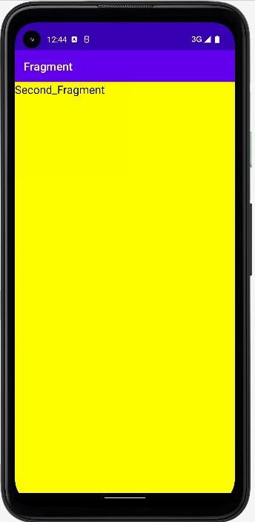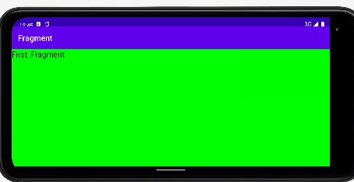

**b) Understanding the Fragment LifeCycle Procedure:**

1. Use the above project - : Adding Fragments Dynamically
2. Open fragment1.xml and add the Log.d statement for all the Fragment cycle States.
3. Repeat the same step for fragment2.xml
4. Enable Logcat
5. Run the “app” on the emulator to experience the lifecycle of an Fragment and its association with the activity.

**Files and Relevant Code firstfragment.java package** com.example.fragment; **import** android.app.Activity; **import** android.os.Bundle; **import** androidx.annotation.Nullable; **import** androidx.fragment.app.Fragment; **import** android.util.Log; **import** android.view.LayoutInflater; **import** android.view.View; **import** android.view.ViewGroup;

**public class** firstfragment **extends** Fragment {

@Override

**public** View onCreateView(LayoutInflater inflater, ViewGroup container,

Bundle savedInstanceState) {

Log.*d*(**"Fragment 1"**,**"onCreateView"**); *// Inflate the layout for this fragment*

**return** inflater.inflate(R.layout.***fragment_firstfragment***, container, **false**);

}

@Override

**public void** onAttach(Activity activity) { **super**.onAttach(activity);

Log.*d*(**"Fragment 1"**,**"onAttach"**);

}

@Override

**public void** onCreate(@Nullable Bundle savedInstanceState) {

**super**.onCreate(savedInstanceState);

Log.*d*(**"Fragment 1"**,**"onCreate"**);

}

@Override

**public void** onActivityCreated(@Nullable Bundle savedInstanceState) {

**super**.onActivityCreated(savedInstanceState); Log.*d*(**"Fragment 1"**,**"onActivityCreated"**);

}

@Override **public void** onStart() { **super**.onStart();

Log.*d*(**"Fragment 1"**,**"onStart"**);

}

@Override **public void** onResume() { **super**.onResume();

Log.*d*(**"Fragment 1"**,**"onResume"**);

}

@Override **public void** onPause() { **super**.onPause();

Log.*d*(**"Fragment 1"**,**"onPause"**);

}

@Override **public void** onStop() { **super**.onStop();

Log.*d*(**"Fragment 1"**,**"onStop"**);

}

@Override

**public void** onDestroyView() { **super**.onDestroyView();

Log.*d*(**"Fragment 1"**,**"onDestroyView"**);

}

@Override **public void** onDestroy() { **super**.onDestroy();

Log.*d*(**"Fragment 1"**,**"onDestroy"**);

}

@Override **public void** onDetach() { **super**.onDetach();

Log.*d*(**"Fragment 1"**,**"onDetach"**);

} }

**fragment2.java package** com.example.fragment; **import** android.app.Activity; **import** android.os.Bundle; **import** androidx.annotation.Nullable; **import** androidx.fragment.app.Fragment; **import** android.util.Log; **import** android.view.LayoutInflater; **import** android.view.View; **import** android.view.ViewGroup; **public class** fragment2 **extends** Fragment {

@Override

**public** View onCreateView(LayoutInflater inflater, ViewGroup container,

Bundle savedInstanceState) {

Log.*d*(**"Fragment 2"**,**"onCreateView"**); *// Inflate the layout for this fragment*

**return** inflater.inflate(R.layout.***fragment_fragment2***, container, **false**);

}

@Override

**public void** onAttach(Activity activity) { **super**.onAttach(activity);

Log.*d*(**"Fragment 2"**,**"onAttach"**);

}

@Override

**public void** onCreate(@Nullable Bundle savedInstanceState) {

**super**.onCreate(savedInstanceState);

Log.*d*(**"Fragment 2"**,**"onCreate"**);

}

@Override

**public void** onActivityCreated(@Nullable Bundle savedInstanceState) { **super**.onActivityCreated(savedInstanceState); Log.*d*(**"Fragment 2"**,**"onActivityCreated"**);

}

@Override **public void** onStart() { **super**.onStart();

Log.*d*(**"Fragment 2"**,**"onStart"**);

}

@Override **public void** onResume() { **super**.onResume(); Log.*d*(**"Fragment 2"**,**"onResume"**);

}

@Override **public void** onPause() { **super**.onPause();

Log.*d*(**"Fragment 2"**,**"onPause"**);

}

@Override **public void** onStop() { **super**.onStop();

Log.*d*(**"Fragment 2"**,**"onStop"**);

}

@Override

**public void** onDestroyView() { **super**.onDestroyView();

Log.*d*(**"Fragment 2"**,**"onDestroyView"**);

}

@Override **public void** onDestroy() { **super**.onDestroy();

Log.*d*(**"Fragment 2"**,**"onDestroy"**);

}

@Override **public void** onDetach() { **super**.onDetach();

Log.*d*(**"Fragment 2"**,**"onDetach"**);

} }

**OUTPUT:**

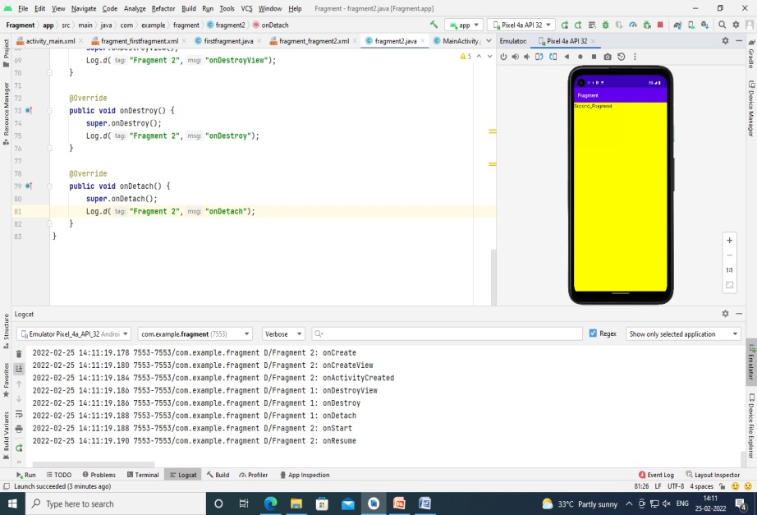

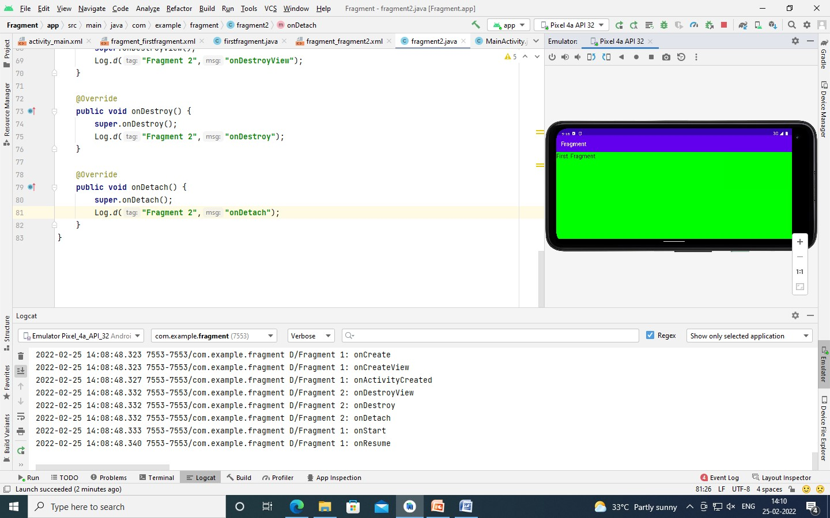

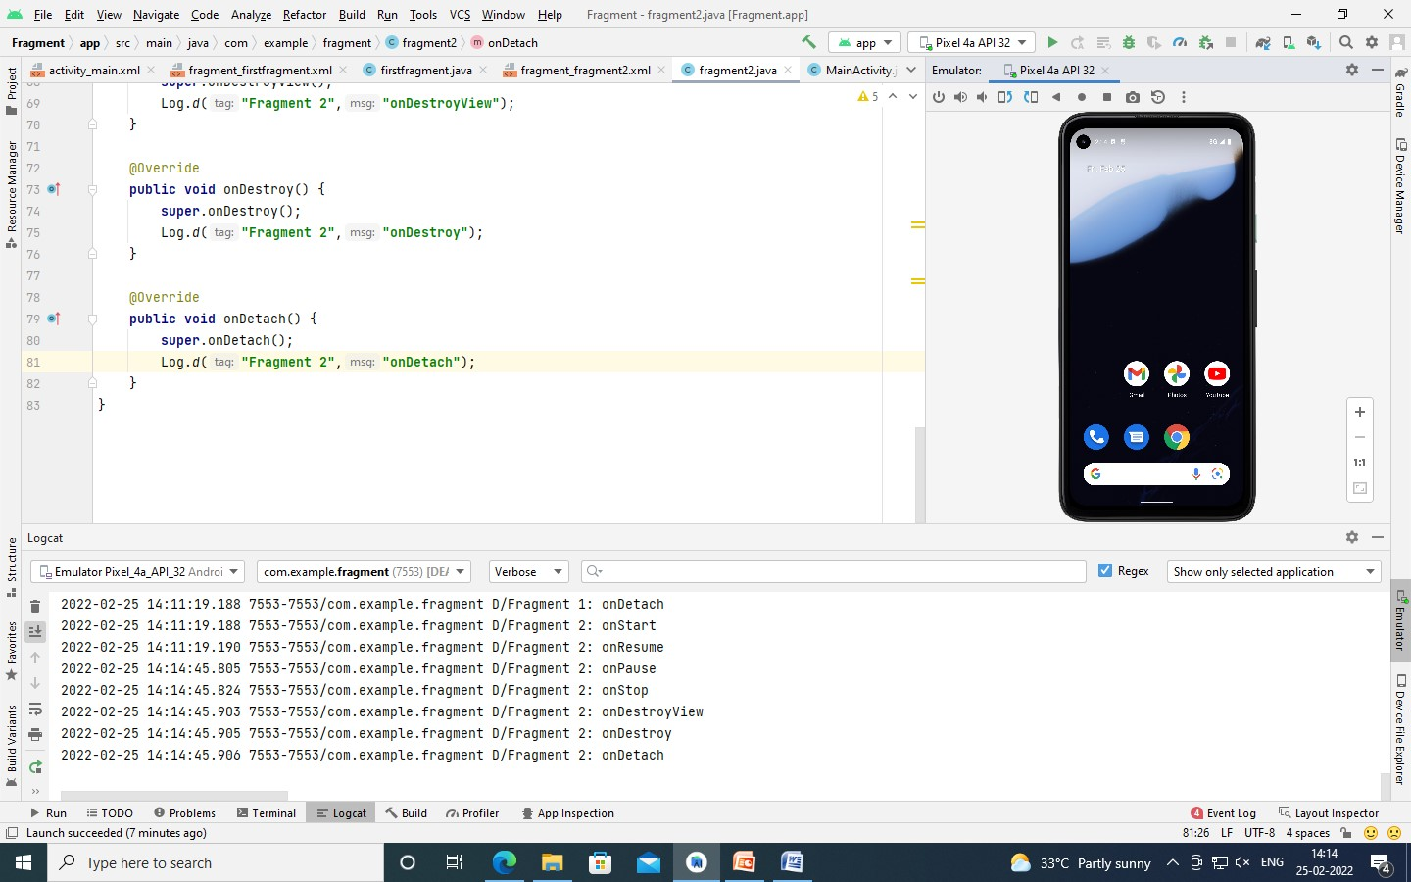

**c) Interaction Between Fragments Procedure:**

1. Create 2 fragment classes – fragment1.java; fragment2.java
2. Open activity_main.xml to create two buttons
3. Open fragment_fragment1.xml
   1. Change background color
   2. Add <textview> tag to display “Fragment 1” Label.
   3. Add <textview>tag to display messages from fragment2. Initially it is set to “ “.
   4. Add <EditText>tag to enter messages that need to be sent to fragment

2.

* 1. Add<Button> tag to send data to fragment2.

1. Open fragment_fragment2.xml
   1. Change background color
   2. Add <textview> tag to display “Fragment 2” Label.
   3. Add <textview>tag to display messages from fragment1. Initially it is set to “ “.
   4. Add <EditText>tag to enter messages that need to be sent to fragment

1.

* 1. Add<Button> tag to send data to fragment1.

1. Open fragment1.java

Complete the file with necessary function calls and methods to execute the buttons and data passing.

1. Open fragment2.java

Complete the file with necessary function calls and methods to execute the buttons and data passing.

1. Open MainActivity.java

Update the code to listen for 2 button calls one for fragment1 , other for fragment 2 and finally to commit the changes in the fragmenttransactions.

1. Run the app in the emulator to experience the data communication between the fragments.

## Files and Relevant Code activity_main.xml

*<?***xml version="1.0" encoding="utf-8"***?>*

<**RelativeLayout xmlns:android="http://schemas.android.com/apk/res/android" xmlns:app="http://schemas.android.com/apk/res-auto" xmlns:tools="http://schemas.android.com/tools" android:layout_width="match_parent" android:layout_height="match_parent" tools:context=".MainActivity"**>

<**FrameLayout**

**android:id="@+id/frameLayout" android:layout_width="match_parent" android:layout_height="600dp"**/>

<**Button**

**android:id="@+id/fragment1btn" android:layout_width="150dp" android:layout_height="60dp" android:backgroundTint="@color/black" android:text="Fragment 1"**

**android:layout_alignParentBottom="true" android:layout_marginBottom="50dp" android:layout_marginStart="50dp"**/>

<**Button**

**android:id="@+id/fragment2btn" android:layout_width="150dp" android:layout_height="60dp" android:backgroundTint="@color/black" android:text="Fragment 2" android:layout_alignParentBottom="true" android:layout_alignParentRight="true" android:layout_marginBottom="50dp"**

**android:layout_marginEnd="50dp"**/>

</**RelativeLayout**>

## Fragment_fragment1.xml

*<?***xml version="1.0" encoding="utf-8"***?>*

<**RelativeLayout xmlns:android="http://schemas.android.com/apk/res/android"**

**xmlns:tools="http://schemas.android.com/tools" android:layout_width="match_parent" android:layout_height="match_parent" android:background="@color/purple_200"**

**tools:context=".fragment1"**>

*<!--* ***TODO: Update blank fragment layout*** *-->*

<**TextView android:layout_width="wrap_content" android:layout_height="wrap_content"**

**android:textStyle="bold" android:text="Fragment 1" android:textSize="30dp"**

**android:layout_centerHorizontal="true" android:layout_marginTop="50dp"**

**android:textColor="@color/black"**/>

<**TextView android:id="@+id/dataFrom2" android:layout_width="wrap_content" android:layout_height="wrap_content" android:text="" android:layout_centerHorizontal="true" android:layout_marginTop="150dp" android:textColor="@color/black"**

**android:textSize="26dp"**/>

<**EditText**

**android:id="@+id/fragment1Data" android:layout_width="match_parent" android:layout_height="wrap_content" android:layout_marginHorizontal="26dp" android:layout_marginTop="300dp" android:ems="10"**

**android:hint="Data to Fragment 2"**

**android:inputType="textPersonName"** />

<**Button**

**android:layout_width="wrap_content" android:layout_height="wrap_content" android:id="@+id/sendData1btn" android:text="Send Data to Fragment 2" android:backgroundTint="@color/black" android:layout_centerHorizontal="true" android:layout_below="@id/fragment1Data"**

**android:layout_marginTop="20dp"**/>

</**RelativeLayout**>

## Fragment_fragment2.xml

*<?***xml version="1.0" encoding="utf-8"***?>*

<**RelativeLayout xmlns:android="http://schemas.android.com/apk/res/android"**

**xmlns:tools="http://schemas.android.com/tools" android:layout_width="match_parent" android:layout_height="match_parent" android:background="@color/teal_700"**

**tools:context=".fragment2"**>

*<!--* ***TODO: Update blank fragment layout*** *-->*

<**TextView android:layout_width="wrap_content" android:layout_height="wrap_content" android:text="Fragment 2" android:textSize="30dp" android:layout_centerHorizontal="true" android:layout_marginTop="50dp"**

**android:textStyle="bold"**

**android:textColor="@color/black"**/>

<**TextView android:id="@+id/dataFrom1" android:layout_width="wrap_content" android:layout_height="wrap_content"**

**android:text="" android:layout_centerHorizontal="true" android:layout_marginTop="150dp" android:textColor="@color/black"**

**android:textSize="26dp"**/>

<**EditText android:id="@+id/fragment2Data" android:layout_width="match_parent" android:layout_height="wrap_content" android:layout_centerHorizontal="true" android:layout_marginTop="300dp" android:layout_marginHorizontal="26dp" android:ems="10"**

**android:inputType="textPersonName" android:hint="Data to Fragment 1"** />

<**Button**

**android:layout_width="wrap_content" android:layout_height="wrap_content" android:id="@+id/sendData2btn" android:text="Send Data to Fragment 1" android:backgroundTint="@color/black" android:layout_centerHorizontal="true" android:layout_below="@id/fragment2Data" android:layout_marginTop="20dp"**/>

</**RelativeLayout**>

## fragment1.java

**package** com.example.fragmentcomm; **import** android.os.Bundle;

**import** androidx.annotation.NonNull; **import** androidx.fragment.app.Fragment; **import** androidx.fragment.app.FragmentResultListener; **import** android.view.LayoutInflater; **import** android.view.View; **import** android.view.ViewGroup; **import** android.widget.Button; **import** android.widget.EditText; **import** android.widget.TextView; **public class** fragment1 **extends** Fragment {

View **view**;

@Override

**public** View onCreateView(LayoutInflater inflater, ViewGroup container,

Bundle savedInstanceState) { *// Inflate the layout for this fragment*

**view** = inflater.inflate(R.layout.***fragment_fragment1***, container, **false**); Button button = **view**.findViewById(R.id.***sendData1btn***);

getParentFragmentManager().setFragmentResultListener(**"dataFrom2"**, **this**, **new**

FragmentResultListener() {

@Override

**public void** onFragmentResult(@NonNull String requestKey, @NonNull Bundle result) {

String data = result.getString(**"df2"**);

TextView textView = **view**.findViewById(R.id.***dataFrom2***); textView.setText(data);

} });

button.setOnClickListener(**new** View.OnClickListener() {

@Override

**public void** onClick(View v) {

EditText editText = **view**.findViewById(R.id.***fragment1Data***); Bundle result = **new** Bundle();

result.putString(**"df1"**,editText.getText().toString());

getParentFragmentManager().setFragmentResult(**"dataFrom1"**,result); editText.setText(**""**);

} });

**return view**; }}

## fragment2.java

**package** com.example.fragmentcomm; **import** android.os.Bundle; **import** androidx.annotation.NonNull; **import** androidx.fragment.app.Fragment; **import** androidx.fragment.app.FragmentResultListener; **import** android.view.LayoutInflater; **import** android.view.View; **import** android.view.ViewGroup; **import** android.widget.Button; **import** android.widget.EditText; **import** android.widget.TextView; **public class** fragment2 **extends** Fragment {

View **view**; @Override

**public** View onCreateView(LayoutInflater inflater, ViewGroup container,

Bundle savedInstanceState) {

*// Inflate the layout for this fragment*

**view** = inflater.inflate(R.layout.***fragment_fragment2***, container, **false**); Button button = **view**.findViewById(R.id.***sendData2btn***); button.setOnClickListener(**new** View.OnClickListener() {

@Override

**public void** onClick(View v) {

EditText editText = **view**.findViewById(R.id.***fragment2Data***); Bundle result = **new** Bundle();

result.putString(**"df2"**,editText.getText().toString());

getParentFragmentManager().setFragmentResult(**"dataFrom2"**,result); editText.setText(**""**);

} });

getParentFragmentManager().setFragmentResultListener(**"dataFrom1"**, **this**, **new**

FragmentResultListener() { @Override

**public void** onFragmentResult(@NonNull String requestKey, @NonNull Bundle result) {

String data = result.getString(**"df1"**);

TextView textView = **view**.findViewById(R.id.***dataFrom1***); textView.setText(data);

} });

**return view**; }}

## MainActivity.java

**package** com.example.fragmentcomm; **import** androidx.appcompat.app.AppCompatActivity; **import** androidx.fragment.app.Fragment; **import** androidx.fragment.app.FragmentManager; **import** androidx.fragment.app.FragmentTransaction; **import** android.os.Bundle; **import** android.view.View; **import** android.widget.Button;

**public class** MainActivity **extends** AppCompatActivity {

Button **firstFragmentBtn**, **secondFragmentBtn**;

@Override

**protected void** onCreate(Bundle savedInstanceState) { **super**.onCreate(savedInstanceState); setContentView(R.layout.***activity_main***);

**firstFragmentBtn** = findViewById(R.id.***fragment1btn***); **secondFragmentBtn** = findViewById(R.id.***fragment2btn***); **firstFragmentBtn**.setOnClickListener(**new** View.OnClickListener() {

@Override **public void** onClick(View v) { replaceFragment(**new** fragment1());

} });

**secondFragmentBtn**.setOnClickListener(**new** View.OnClickListener() {

@Override **public void** onClick(View v) {

replaceFragment(**new** fragment2());

} }); }

**private void** replaceFragment(Fragment fragment) {

FragmentManager fragmentManager = getSupportFragmentManager();

FragmentTransaction fragmentTransaction = fragmentManager.beginTransaction(); fragmentTransaction.replace(R.id.***frameLayout***,fragment); fragmentTransaction.commit(); } }

**OUTPUT:**

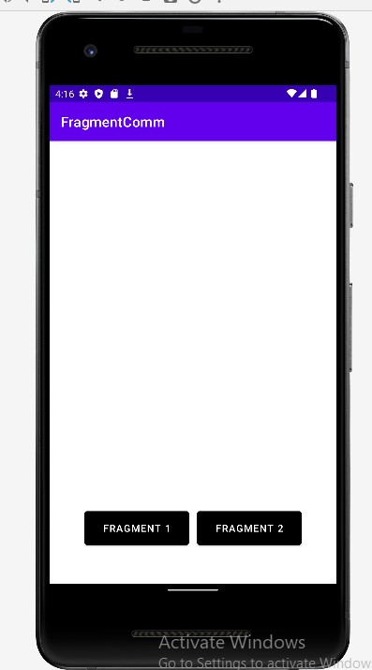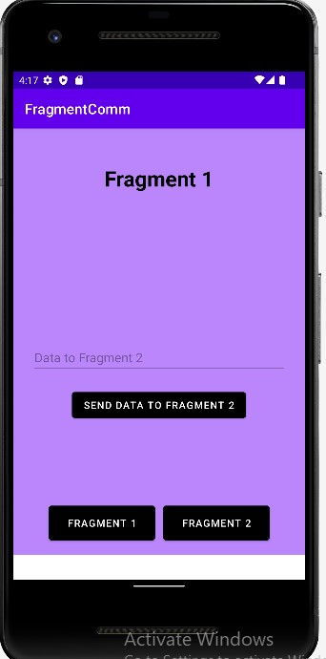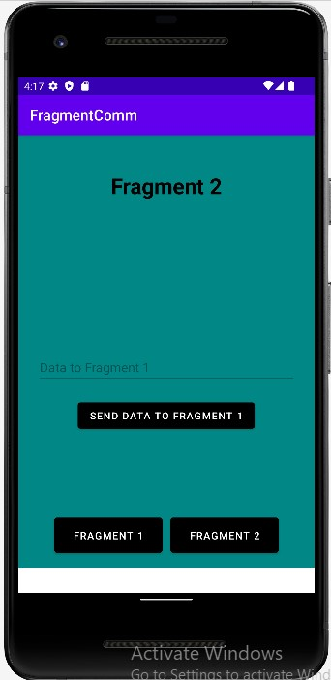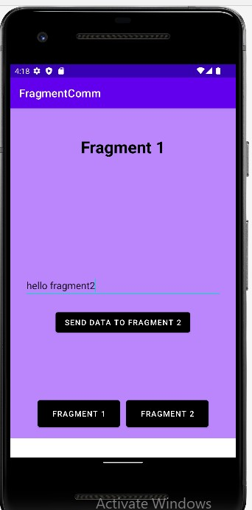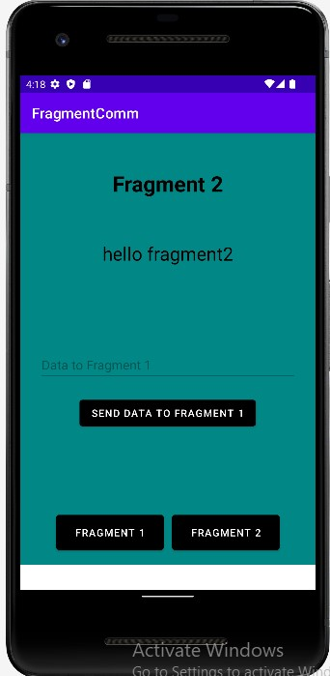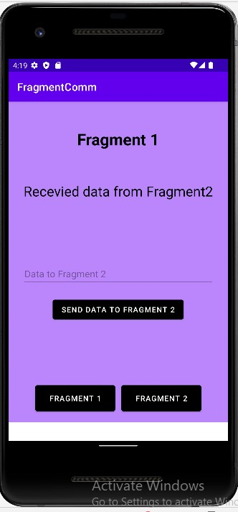

**Experiment 8**: Notification Panes

**AIM:** Design an android app to demonstration notifications Panes

**A)Displaying notifications in status bar**

**Prerequisites:** Android Studio should be installed in your machine.

**Description:**

* Notifications provide short, timely information about events in your app while it's not in use
* A notification in its most basic and compact form (also known as collapsed form) displays an *icon*, a *title*, and a *small amount of content text* **Algorithm:**

**Step 1:** Create a basic notification

To get started, you need to set the notification's content and channel using a [NotificationCompat.Builder](https://developer.android.com/reference/androidx/core/app/NotificationCompat.Builder) object.

* A small icon, set by [setSmallIcon().](https://developer.android.com/reference/androidx/core/app/NotificationCompat.Builder) This is the only user-visible content that's required.
* A title, set by [setContentTitle().](https://developer.android.com/reference/androidx/core/app/NotificationCompat.Builder)
* The body text, set by [setContentText().](https://developer.android.com/reference/androidx/core/app/NotificationCompat.Builder)
* The notification priority, set by [setPriority().](https://developer.android.com/reference/androidx/core/app/NotificationCompat.Builder) The priority determines how intrusive the notification should be on Android 7.1 and lower.

*NotificationCompat.Builder builder = new NotificationCompat.Builder(this, CHANNEL_ID)*

*.setSmallIcon(R.drawable.notification_icon)*

*.setContentTitle(textTitle)*

*.setContentText(textContent)*

*.setPriority(NotificationCompat.PRIORITY_DEFAULT);*

**Step 2:**

* Notice that the NotificationCompat.Builder constructor requires that you provide a channel ID. This is required for compatibility with Android 8.0 (API level 26) and higher, but is ignored by older versions
* By default, the notification's text content is truncated to fit one line
* If you want your notification to be longer, you can enable an expandable notification by adding a style template with setStyle()

*NotificationCompat.Builder builder = new NotificationCompat.Builder(this, CHANNEL_ID)*

*.setSmallIcon(R.drawable.notification_icon)*

*.setContentTitle("My notification")*

*.setContentText("Much longer text that cannot fit one line...")*

***.setStyle(new NotificationCompat.BigTextStyle()***

***.bigText("Much longer text that cannot fit one line..."))***

*.setPriority(NotificationCompat.PRIORITY_DEFAULT);* **Step 3: Create a Channel and set the importance**

* Before you can deliver the notification on Android 8.0 and higher, you must register your app's notification channel with the system by passing an instance of NotificationChannel to createNotificationChannel()

private void createNotificationChannel() {

if (Build.VERSION.SDK_INT >= Build.VERSION_CODES.O) {

CharSequence name = getString(R.string.channel_name);

String description = getString(R.string.channel_description); int importance = NotificationManager.IMPORTANCE_DEFAULT;

NotificationChannel channel = new NotificationChannel(CHANNEL_ID, name, importance); channel.setDescription(description);

// Register the channel with the system; you can't change the importance

// or other notification behaviors after this

NotificationManager notificationManager = getSystemService(NotificationManager.class); notificationManager.createNotificationChannel(channel);

}

}

**Step 4: Set notification**

Intent intent = new Intent(this, AlertDetails.class);

intent.setFlags(Intent.FLAG_ACTIVITY_NEW_TASK |

Intent.FLAG_ACTIVITY_CLEAR_TASK);

PendingIntent pendingIntent = PendingIntent.getActivity(this, 0, intent,

PendingIntent.FLAG_IMMUTABLE);

NotificationCompat.Builder builder = new NotificationCompat.Builder(this, CHANNEL_ID)

.setSmallIcon(R.drawable.notification_icon)

.setContentTitle("My notification")

.setContentText("Hello World!")

.setPriority(NotificationCompat.PRIORITY_DEFAULT)

// Set the intent that will fire when the user taps the notification

.setContentIntent(pendingIntent)

.setAutoCancel(true);

**Step 5: Show notification**

NotificationManagerCompat notificationManager = NotificationManagerCompat.from(this); notificationManager.notify(notificationId, builder.build());

**Source Code:**

**Activity_main.xml**

*<?***xml version="1.0" encoding="utf-8"***?>*<**androidx.constraintlayout.widget.ConstraintLayout xmlns:android="http://schemas.android.com/apk/res/android"  
 xmlns:app="http://schemas.android.com/apk/res-auto"  
 xmlns:tools="http://schemas.android.com/tools"  
 android:layout_width="match_parent"  
 android:layout_height="match_parent"  
 tools:context=".MainActivity"**>  
  
 <**TextView  
 android:layout_width="323dp"  
 android:layout_height="94dp"  
 android:text="NOTIFICATIONS DEMO"  
 android:textColor="@color/black"  
 android:textSize="15pt"  
 app:layout_constraintBottom_toBottomOf="parent"  
 app:layout_constraintEnd_toEndOf="parent"  
 app:layout_constraintHorizontal_bias="0.464"  
 app:layout_constraintStart_toStartOf="parent"  
 app:layout_constraintTop_toTopOf="parent"  
 app:layout_constraintVertical_bias="0.235"** />  
  
 <**Button  
 android:id="@+id/button"  
 android:layout_width="wrap_content"  
 android:layout_height="wrap_content"  
 android:text="notify"  
 android:backgroundTint="@color/black"  
 android:textColor="@color/white"  
 app:layout_constraintBottom_toBottomOf="parent"  
 app:layout_constraintEnd_toEndOf="parent"  
 app:layout_constraintStart_toStartOf="parent"  
 app:layout_constraintTop_toTopOf="parent"** />  
  
</**androidx.constraintlayout.widget.ConstraintLayout**>

## MainActivity.java

**package** com.example.demo;  
  
**import** androidx.appcompat.app.AppCompatActivity;  
**import** androidx.core.app.NotificationCompat;  
  
**import** android.app.NotificationChannel;  
**import** android.app.NotificationManager;  
**import** android.app.PendingIntent;  
**import** android.content.Context;  
**import** android.content.Intent;  
**import** android.os.Build;  
**import** android.os.Bundle;  
**import** android.view.View;  
**import** android.widget.Button;  
  
**public class** MainActivity **extends** AppCompatActivity {  
 String message=**"Hello this is your notification"**;  
 @Override  
 **protected void** onCreate(Bundle savedInstanceState) {  
 **super**.onCreate(savedInstanceState);  
 setContentView(R.layout.***activity_main***);  
 Button b=findViewById(R.id.***button***);  
 **if**(Build.VERSION.***SDK_INT***>=Build.VERSION_CODES.***O***)  
 {  
 NotificationChannel chnnelID=**new** NotificationChannel(**"Notification"**,**"My notification"**, NotificationManager.***IMPORTANCE_DEFAULT***);  
 NotificationManager manager=getSystemService(NotificationManager.**class**);  
 manager.createNotificationChannel(chnnelID);  
 }  
 b.setOnClickListener(**new** View.OnClickListener() {  
 @Override  
 **public void** onClick(View v) {  
 NotificationCompat.Builder builder=**new** NotificationCompat.Builder(MainActivity.**this**,**"MyNotification"**)  
 .setSmallIcon(R.drawable.***logo***)  
 .setContentTitle(**"VIGNAN"**)  
 .setContentText(**"Hello you got notification from vignan"**)  
 .setPriority(NotificationCompat.***PRIORITY_DEFAULT***)  
 .setAutoCancel(**true**);  
 Intent i=**new** Intent(MainActivity.**this**,MainActivity2.**class**);  
 i.addFlags(Intent.***FLAG_ACTIVITY_CLEAR_TOP***);  
 i.putExtra(**"Message"**,**message**);  
 PendingIntent p=PendingIntent.*getActivity*(MainActivity.**this**,0,i,PendingIntent.***FLAG_UPDATE_CURRENT***);  
 builder.setContentIntent(p);  
 NotificationManager manager=(NotificationManager) getSystemService(Context.***NOTIFICATION_SERVICE***);  
 manager.notify(1, builder.build());  
  
 }  
 });  
 }  
}

## activity_main2.xml

*<?***xml version="1.0" encoding="utf-8"***?>*<**androidx.constraintlayout.widget.ConstraintLayout xmlns:android="http://schemas.android.com/apk/res/android"  
 xmlns:app="http://schemas.android.com/apk/res-auto"  
 xmlns:tools="http://schemas.android.com/tools"  
 android:layout_width="match_parent"  
 android:layout_height="match_parent"  
 tools:context=".MainActivity2"**>  
  
 <**TextView  
 android:id="@+id/textView"  
 android:layout_width="209dp"  
 android:layout_height="254dp"  
 android:text="Notification display area"  
 android:textColor="@color/black"  
 android:textSize="15pt"  
 app:layout_constraintBottom_toBottomOf="parent"  
 app:layout_constraintEnd_toEndOf="parent"  
 app:layout_constraintStart_toStartOf="parent"  
 app:layout_constraintTop_toTopOf="parent"** />  
</**androidx.constraintlayout.widget.ConstraintLayout**>

## MainActivity2.java

**package** com.example.demo;  
  
**import** androidx.appcompat.app.AppCompatActivity;  
  
**import** android.os.Bundle;  
**import** android.widget.TextView;  
  
**public class** MainActivity2 **extends** AppCompatActivity {  
  
 @Override  
 **protected void** onCreate(Bundle savedInstanceState) {  
 **super**.onCreate(savedInstanceState);  
 setContentView(R.layout.***activity_main2***);  
 TextView t=findViewById(R.id.***textView***);  
 String m=getIntent().getStringExtra(**"Message"**);  
 t.setText(m);  
 }  
}

# Outputs:

# 

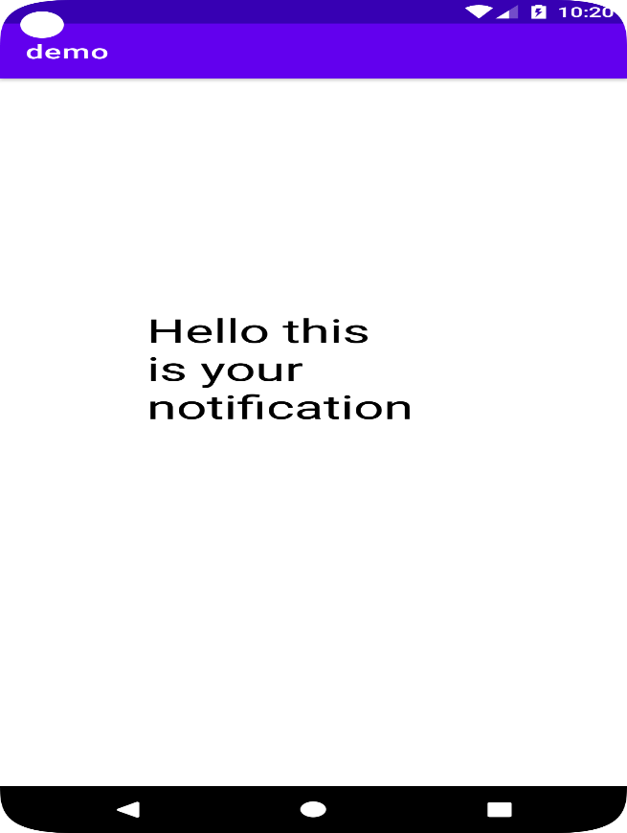

## b) Displaying Expandable Notifications

Will create large, expandable notification by applying one of several notification templates

Steps

1. Create a new project with empty activity
2. In res folder create two resource layout files named custom_normal.xml and custom_expanded.xml
3. Place an image in drawable folder to show in notification

## custom_normal.xml

*<?***xml version="1.0" encoding="utf-8"***?>*<**LinearLayout xmlns:android="http://schemas.android.com/apk/res/android" android:layout_width="match_parent" android:layout_height="match_parent" android:orientation="horizontal"**>  
 <**ImageView android:layout_width="40dp" android:layout_height="40dp" android:src="@drawable/nrml"**/>  
 <**LinearLayout android:layout_width="match_parent" android:layout_height="wrap_content" android:orientation="vertical"**>  
 <**TextView  
 style="@style/TextAppearance.Compat.Notification.Title"  
 android:text="Title of the notification" android:layout_width="match_parent" android:layout_height="wrap_content"** />  
 <**TextView  
 style="@style/TextAppearance.Compat.Notification.Info"  
 android:textColor="@color/black"  
 android:text="Title description of the notitification in collapsed mode. click expand icon to expand it." android:layout_width="match_parent" android:layout_height="wrap_content"** />  
 </**LinearLayout**>  
</**LinearLayout**>

## custom_expanded.xml

*<?***xml version="1.0" encoding="utf-8"***?>*<**LinearLayout xmlns:android="http://schemas.android.com/apk/res/android" android:layout_width="match_parent" android:layout_height="match_parent"  
 android:gravity="center"  
 android:orientation="vertical"**>  
  
 <**TextView  
 style="@style/TextAppearance.Compat.Notification.Title" android:layout_width="match_parent" android:layout_height="wrap_content" android:text="Title of the notification"** />  
  
 <**ImageView  
 android:layout_width="100dp" android:layout_height="100dp"  
 android:src="@drawable/exp"** />  
  
 <**TextView  
 style="@style/TextAppearance.Compat.Notification.Info"  
 android:textColor="@color/black"  
 android:layout_width="match_parent" android:layout_height="wrap_content"  
 android:text="Title description of the notification in expanded mode. click collapse icon to collapse it."** />  
  
</**LinearLayout**>

## activity_main.xml

*<?***xml version="1.0" encoding="utf-8"***?>*<**androidx.constraintlayout.widget.ConstraintLayout xmlns:android="http://schemas.android.com/apk/res/android"  
 xmlns:app="http://schemas.android.com/apk/res-auto"  
 xmlns:tools="http://schemas.android.com/tools"  
 android:layout_width="match_parent"  
 android:layout_height="match_parent"  
 tools:context=".MainActivity"**>  
  
 <**TextView  
 android:layout_width="323dp"  
 android:layout_height="94dp"  
 android:text="NOTIFICATIONS DEMO"  
 android:textColor="@color/black"  
 android:textSize="15pt"  
 app:layout_constraintBottom_toBottomOf="parent"  
 app:layout_constraintEnd_toEndOf="parent"  
 app:layout_constraintHorizontal_bias="0.464"  
 app:layout_constraintStart_toStartOf="parent"  
 app:layout_constraintTop_toTopOf="parent"  
 app:layout_constraintVertical_bias="0.235"** />  
  
 <**Button  
 android:id="@+id/button"  
 android:layout_width="wrap_content"  
 android:layout_height="wrap_content"  
 android:text="notify"  
 android:backgroundTint="@color/black"  
 android:textColor="@color/white"  
 app:layout_constraintBottom_toBottomOf="parent"  
 app:layout_constraintEnd_toEndOf="parent"  
 app:layout_constraintStart_toStartOf="parent"  
 app:layout_constraintTop_toTopOf="parent"** />  
  
</**androidx.constraintlayout.widget.ConstraintLayout**>

## MainActivity.java

**package** com.example.exdemo;  
  
**import** androidx.appcompat.app.AppCompatActivity;  
**import** androidx.core.app.NotificationCompat;  
  
**import** android.app.NotificationChannel;  
**import** android.app.NotificationManager;  
**import** android.app.PendingIntent;  
**import** android.content.Context;  
**import** android.content.Intent;  
**import** android.os.Build;  
**import** android.os.Bundle;  
**import** android.view.View;  
**import** android.widget.Button;  
**import** android.widget.RemoteViews;  
  
**public class** MainActivity **extends** AppCompatActivity {  
 **private static final** String CHANNEL_ID = **"channel_id01"**;  
 **public static final int** NOTIFICATION_ID = 1;  
 @Override  
 **protected void** onCreate(Bundle savedInstanceState) {  
 **super**.onCreate(savedInstanceState);  
 setContentView(R.layout.activity_main);  
 Button b=findViewById(R.id.button);  
 **if**(Build.VERSION.SDK_INT>=Build.VERSION_CODES.O)  
 {  
 CharSequence name = **"My Notification"**;  
 String description = **"My notification description"**;  
 *//importance of your notification* **int** importance = NotificationManager.IMPORTANCE_DEFAULT;  
 NotificationChannel notificationChannel = **new** NotificationChannel(CHANNEL_ID, name, importance);  
 notificationChannel.setDescription(description);  
 NotificationManager notificationManager = (NotificationManager)getSystemService(NOTIFICATION_SERVICE);  
 notificationManager.createNotificationChannel(notificationChannel);  
 }  
 b.setOnClickListener(**new** View.OnClickListener() {  
 @Override  
 **public void** onClick(View v) {  
 RemoteViews remoteCollapsedViews = **new** RemoteViews(getPackageName(), R.layout.***custom_normal***);  
 RemoteViews remoteExpandedViews = **new** RemoteViews(getPackageName(), R.layout.***custom_expanded***);  
 *//start this(MainActivity) on by Tapping notification* Intent mainIntent = **new** Intent(MainActivity.**this**, MainActivity.**class**);  
 mainIntent.setFlags(Intent.***FLAG_ACTIVITY_NEW_TASK*** |  
 Intent.***FLAG_ACTIVITY_CLEAR_TASK***);  
 PendingIntent mainPIntent = PendingIntent.*getActivity*(MainActivity.**this**, 0,mainIntent, PendingIntent.***FLAG_ONE_SHOT***);  
 NotificationCompat.Builder builder=**new** NotificationCompat.Builder(MainActivity.**this**,**"MyNotification"**)  
 .setSmallIcon(R.drawable.***logo***)  
 .setPriority(NotificationCompat.***PRIORITY_DEFAULT***)  
 .setAutoCancel(**true**);  
 builder.setContentIntent(mainPIntent);  
 *//custom style* builder.setStyle(**new** NotificationCompat.DecoratedCustomViewStyle());  
 builder.setCustomContentView(remoteCollapsedViews);  
 builder.setCustomBigContentView(remoteExpandedViews);  
 NotificationManager manager=(NotificationManager) getSystemService(Context.***NOTIFICATION_SERVICE***);  
 manager.notify(1, builder.build());  
  
 }  
 });  
 }  
}

**OUTPUTS**

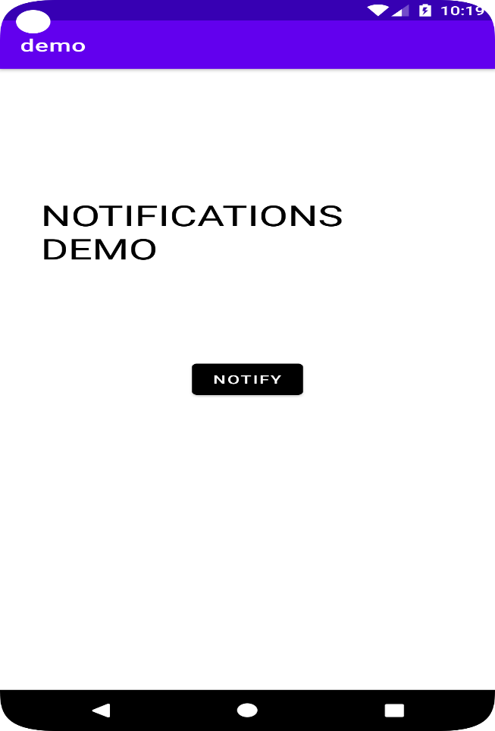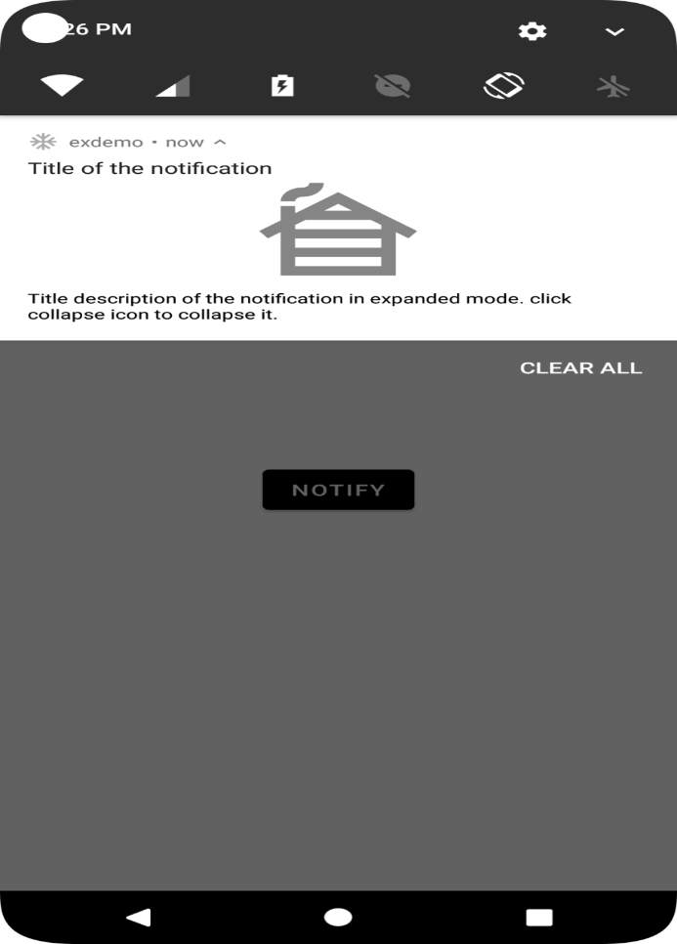

## c) Displaying Timely Notifications

Will create notification based on Alarm Broadcast Receiver

Create a new project with blank activity **activity_main.xml**

<?xml version="1.0" encoding="utf-8"?>

<RelativeLayout xmlns:android="http://schemas.android.com/apk/res/android" xmlns:app="http://schemas.android.com/apk/res-auto" xmlns:tools="http://schemas.android.com/tools" android:layout_width="match_parent" android:layout_height="match_parent"

tools:context="com.example.application.alarmmanagerproject.MainActivity">

<TextView

android:id="@+id/textView" android:layout_width="wrap_content" android:layout_height="wrap_content" android:layout_above="@id/button_timepicker" android:layout_centerHorizontal="true" android:layout_marginBottom="30dp" android:text="No Alarm set"

android:textSize="30sp" />

<Button android:id="@+id/button_timepicker" android:layout_width="wrap_content" android:layout_height="wrap_content" android:layout_centerHorizontal="true" android:layout_centerVertical="true"

android:text="open time picker" />

<Button android:id="@+id/button_cancel" android:layout_width="wrap_content" android:layout_height="wrap_content" android:layout_below="@id/button_timepicker" android:layout_centerHorizontal="true" android:layout_marginTop="27dp"

android:text="cancel alarm" />

</RelativeLayout>

## AndroidManifest.xml

<?xml version="1.0" encoding="utf-8"?>

<manifest xmlns:android="http://schemas.android.com/apk/res/android" package="com.example.application.alarmmanagerproject">

<application

android:allowBackup="true" android:icon="@mipmap/ic_launcher" android:label="@string/app_name" android:roundIcon="@mipmap/ic_launcher_round"

android:supportsRtl="true" android:theme="@style/AppTheme"> <activity android:name=".MainActivity">

<intent-filter>

<action android:name="android.intent.action.MAIN" />

<category android:name="android.intent.category.LAUNCHER" />

</intent-filter>

</activity>

<receiver android:name=".AlertReceiver" />

</application>

</manifest>

## AlertReceiver.java

package com.example.application.alarmmanagerproject;

import android.content.BroadcastReceiver; import android.content.Context; import android.content.Intent;

import android.support.v4.app.NotificationCompat;

public class AlertReceiver extends BroadcastReceiver {

@Override

public void onReceive(Context context, Intent intent) {

NotificationHelper notificationHelper = new NotificationHelper(context); NotificationCompat.Builder nb = notificationHelper.getChannelNotification(); notificationHelper.getManager().notify(1, nb.build());

}

}

## MainActivity.java

package com.example.application.alarmmanagerproject;

import android.app.AlarmManager; import android.app.PendingIntent; import android.app.TimePickerDialog; import android.content.Context; import android.content.Intent; import android.support.v4.app.DialogFragment; import android.support.v7.app.AppCompatActivity; import android.os.Bundle; import android.view.View; import android.widget.Button; import android.widget.TextView; import android.widget.TimePicker; import java.text.DateFormat;

import java.util.Calendar;

public class MainActivity extends AppCompatActivity implements

TimePickerDialog.OnTimeSetListener {

private TextView mTextView;

@Override

protected void onCreate(Bundle savedInstanceState) { super.onCreate(savedInstanceState);

setContentView(R.layout.activity_main);

mTextView = findViewById(R.id.textView);

Button buttonTimePicker = findViewById(R.id.button_timepicker); buttonTimePicker.setOnClickListener(new View.OnClickListener() {

@Override

public void onClick(View v) {

DialogFragment timePicker = new TimePickerFragment(); timePicker.show(getSupportFragmentManager(), "time picker");

}

});

Button buttonCancelAlarm = findViewById(R.id.button_cancel); buttonCancelAlarm.setOnClickListener(new View.OnClickListener() {

@Override

public void onClick(View v) {

cancelAlarm();

}

});

}

@Override

public void onTimeSet(TimePicker view, int hourOfDay, int minute) {

Calendar c = Calendar.getInstance();

c.set(Calendar.HOUR_OF_DAY, hourOfDay);

c.set(Calendar.MINUTE, minute);

c.set(Calendar.SECOND, 0);

updateTimeText(c); startAlarm(c);

}

private void updateTimeText(Calendar c) { String timeText = "Alarm set for: ";

timeText += DateFormat.getTimeInstance(DateFormat.SHORT).format(c.getTime());

mTextView.setText(timeText);

}

private void startAlarm(Calendar c) {

AlarmManager alarmManager = (AlarmManager) getSystemService(Context.ALARM_SERVICE);

Intent intent = new Intent(this, AlertReceiver.class);

PendingIntent pendingIntent = PendingIntent.getBroadcast(this, 1, intent, 0);

if (c.before(Calendar.getInstance())) { c.add(Calendar.DATE, 1);

}

alarmManager.setExact(AlarmManager.RTC_WAKEUP, c.getTimeInMillis(), pendingIntent);

}

private void cancelAlarm() {

AlarmManager alarmManager = (AlarmManager) getSystemService(Context.ALARM_SERVICE);

Intent intent = new Intent(this, AlertReceiver.class);

PendingIntent pendingIntent = PendingIntent.getBroadcast(this, 1, intent, 0);

alarmManager.cancel(pendingIntent);

mTextView.setText("Alarm canceled");

}

}

## NotificationHelper.java

package com.example.application.alarmmanagerproject;

import android.annotation.TargetApi; import android.app.NotificationChannel; import android.app.NotificationManager; import android.content.Context; import android.content.ContextWrapper; import android.os.Build;

import android.support.v4.app.NotificationCompat;

public class NotificationHelper extends ContextWrapper { public static final String channelID = "channelID"; public static final String channelName = "Channel Name";

private NotificationManager mManager;

public NotificationHelper(Context base) {

super(base);

if (Build.VERSION.SDK_INT >= Build.VERSION_CODES.O) { createChannel();

}

}

@TargetApi(Build.VERSION_CODES.O)

private void createChannel() {

NotificationChannel channel = new NotificationChannel(channelID, channelName,

NotificationManager.IMPORTANCE_HIGH);

getManager().createNotificationChannel(channel);

}

public NotificationManager getManager() { if (mManager == null) { mManager = (NotificationManager)

getSystemService(Context.NOTIFICATION_SERVICE);

}

return mManager;

}

public NotificationCompat.Builder getChannelNotification() {

return new NotificationCompat.Builder(getApplicationContext(), channelID)

.setContentTitle("Alarm!")

.setContentText("Your AlarmManager is working.")

.setSmallIcon(R.drawable.ic_android);

}

}

TimePickerFragment.java

package com.example.application.alarmmanagerproject;

import android.app.Dialog; import android.app.TimePickerDialog; import android.os.Bundle; import android.support.annotation.NonNull; import android.support.v4.app.DialogFragment; import android.text.format.DateFormat;

import java.util.Calendar;

public class TimePickerFragment extends DialogFragment {

@NonNull @Override

public Dialog onCreateDialog(Bundle savedInstanceState) { Calendar c = Calendar.getInstance(); int hour = c.get(Calendar.HOUR_OF_DAY); int minute = c.get(Calendar.MINUTE);

return new TimePickerDialog(getActivity(), (TimePickerDialog.OnTimeSetListener) getActivity(), hour, minute, DateFormat.is24HourFormat(getActivity()));

}

}

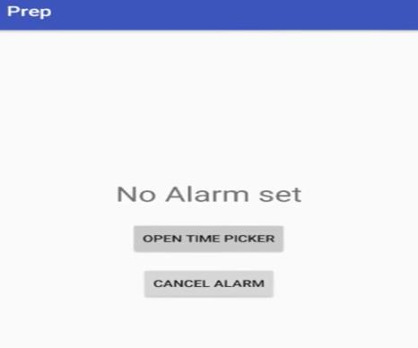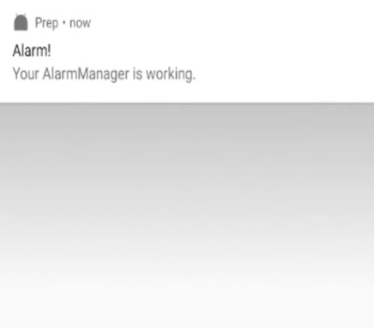

## AIM: Authentication using firebase

Step 1: Create a firebase project with analytics off

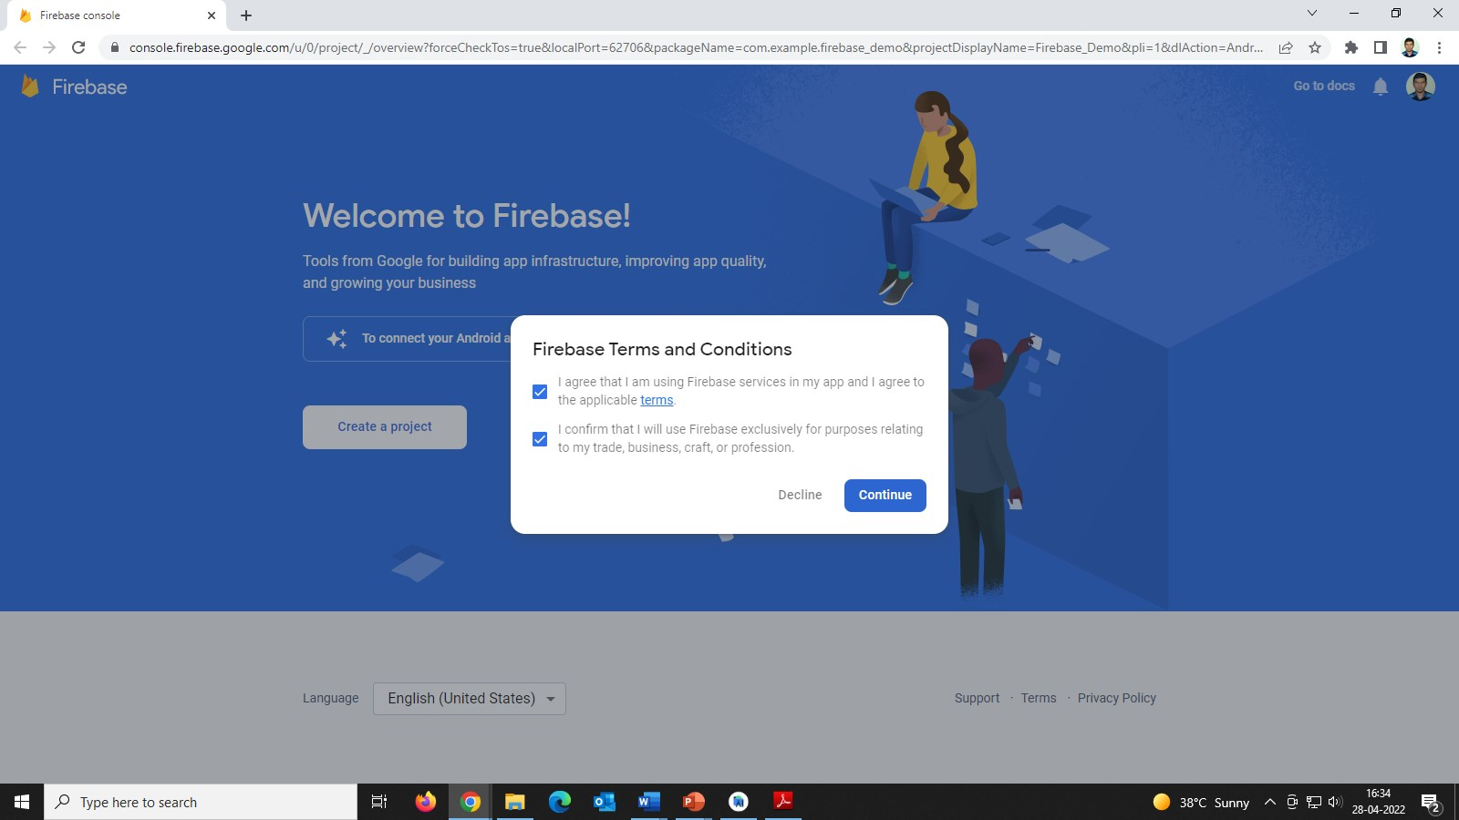

Step 2: now under build in project> authentication enable email authentication.

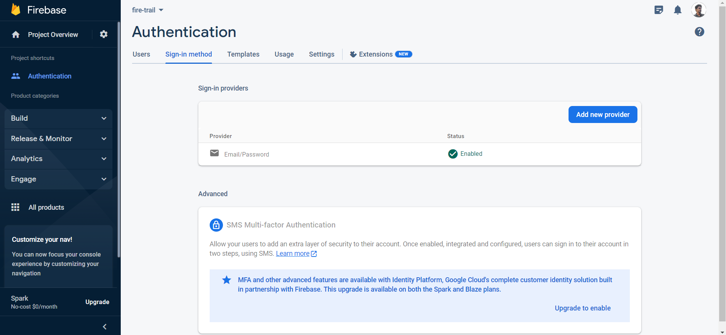

Step 3: Now in our new android studio project goto tools>firebase>authentication> custom authentication

Step 3: under authenticate using custom authentication select connect

Step 4: now application will be redirected to firebase select the project we created in firebase

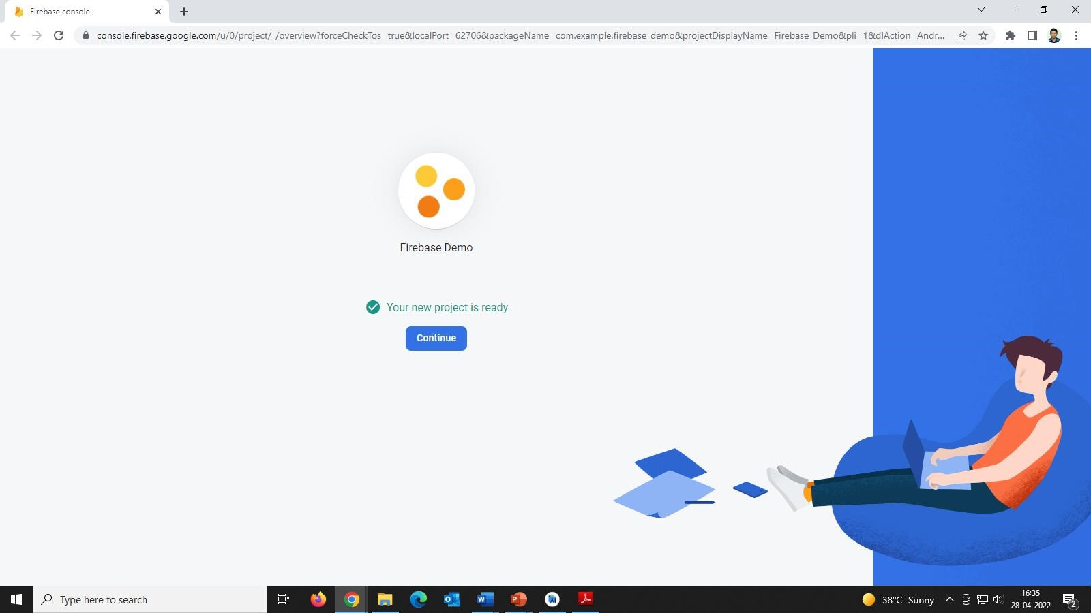

Step 5: and the firebase project will be connected

Step 6: In android studio select option below connect > add Sdk select the and dependencies will be added to gradle

Step 7: Design the home page for register and login

Activity_main.xml

*<?*xml version="1.0" encoding="utf-8"*?>*<ScrollView xmlns:android="http://schemas.android.com/apk/res/android"  
 xmlns:app="http://schemas.android.com/apk/res-auto"  
 xmlns:tools="http://schemas.android.com/tools"  
 android:layout_width="match_parent"  
 android:layout_height="match_parent"  
 tools:context=".MainActivity"  
 android:background="@drawable/bg"  
 >  
 <RelativeLayout  
 android:layout_width="match_parent"  
 android:layout_height="match_parent">  
  
 <TextView  
 android:layout_width="wrap_content"  
 android:layout_height="wrap_content"  
 android:layout_marginLeft="150dp"  
 android:layout_marginTop="20dp"  
 android:text="Register!"  
 android:textColor="#B0FFFFFF"  
 android:textSize="12pt"  
 android:textStyle="bold" />  
 <TextView  
 android:layout_width="wrap_content"  
 android:layout_height="wrap_content"  
 android:text="Create New Account"  
 android:layout_marginTop="60dp"  
 android:layout_marginLeft="130dp"/>  
  
  
 <EditText  
 android:id="@+id/fullname"  
 android:layout_width="320dp"  
 android:layout_height="wrap_content"  
 android:layout_marginLeft="40dp"  
 android:layout_marginTop="130dp"  
 android:background="@drawable/round"  
 android:hint="Full Name"  
 android:padding="10dp" />  
  
 <EditText  
 android:id="@+id/email"  
 android:layout_width="320dp"  
 android:layout_height="wrap_content"  
 android:layout_alignLeft="@+id/fullname"  
 android:layout_marginTop="210dp"  
 android:background="@drawable/round"  
 android:hint="Email"  
 android:padding="10dp" />  
  
 <EditText  
 android:id="@+id/password"  
 android:layout_width="320dp"  
 android:layout_height="wrap_content"  
 android:layout_alignLeft="@+id/fullname"  
 android:layout_marginTop="290dp"  
 android:background="@drawable/round"  
 android:hint="Password"  
 android:inputType="textPassword"  
 android:padding="10dp" />  
  
 <EditText  
 android:id="@+id/phoneno"  
 android:layout_width="320dp"  
 android:layout_height="wrap_content"  
 android:layout_alignLeft="@+id/fullname"  
 android:layout_marginTop="370dp"  
 android:background="@drawable/round"  
 android:hint="Phone No"  
 android:padding="10dp" />  
  
 <Button  
 android:id="@+id/Register"  
 android:layout_width="wrap_content"  
 android:layout_height="wrap_content"  
 android:layout_marginLeft="150dp"  
 android:layout_marginTop="480dp"  
 android:backgroundTint="#4D7E4C"  
 android:text="Register" />  
  
 <TextView  
 android:id="@+id/gotologin"  
 android:layout_width="wrap_content"  
 android:layout_height="wrap_content"  
 android:layout_marginLeft="130dp"  
 android:layout_marginTop="550dp"  
 android:text="Already Registered?\n Login here"  
 android:textColor="#79FDFFFC"  
 android:textSize="17dp"  
 android:textStyle="bold" />  
  
 </RelativeLayout>  
  
</ScrollView>

Step 8: write the functionality in mainActivity.java

package com.example.firebaseauth;  
  
import androidx.annotation.NonNull;  
import androidx.appcompat.app.AppCompatActivity;  
  
import android.content.Intent;  
import android.os.Bundle;  
import android.text.TextUtils;  
import android.util.Log;  
import android.view.View;  
import android.widget.Button;  
import android.widget.EditText;  
import android.widget.TextView;  
import android.widget.Toast;  
  
import com.google.android.gms.tasks.OnCompleteListener;  
import com.google.android.gms.tasks.Task;  
import com.google.firebase.auth.AuthResult;  
import com.google.firebase.auth.FirebaseAuth;  
import com.google.firebase.auth.FirebaseUser;  
  
public class MainActivity extends AppCompatActivity {  
 TextView gotoLogin;  
 EditText Email,pass;  
 private FirebaseAuth mAuth;  
 */*public void onStart() {  
 super.onStart();  
 // Check if user is signed in (non-null) and update UI accordingly.  
 FirebaseUser currentUser = mAuth.getCurrentUser();  
 if(currentUser== null){  
 startActivity(new Intent(MainActivity.this,MainActivity2.class));  
 }  
  
 }*/* @Override  
 protected void onCreate(Bundle savedInstanceState) {  
 super.onCreate(savedInstanceState);  
  
 setContentView(R.layout.activity_main);  
 gotoLogin = findViewById(R.id.gotologin);  
 gotoLogin.setOnClickListener(new View.OnClickListener() {  
 @Override  
 public void onClick(View view) {  
 Intent intent = new Intent(getApplicationContext(),MainActivity2.class);  
 startActivity(intent);  
 }  
 });  
 mAuth = FirebaseAuth.getInstance();  
 Email = findViewById(R.id.email);  
 pass = findViewById(R.id.password);  
  
 Button btn = findViewById(R.id.Register);  
 btn.setOnClickListener(new View.OnClickListener() {  
 @Override  
 public void onClick(View view) {  
 createAccount();  
 }  
 });  
  
 }  
 private void createAccount(){  
 String email = Email.getText().toString();  
 String password = pass.getText().toString();  
 if(TextUtils.isEmpty(email)){  
 Email.setError("Email cannot be empty");  
 Email.requestFocus();  
 }  
 else if(TextUtils.isEmpty(password)){  
 pass.setError("Password cannot be Empty");  
 pass.requestFocus();  
 }  
 else {  
 mAuth.createUserWithEmailAndPassword(email,password).addOnCompleteListener(new OnCompleteListener<AuthResult>() {  
 @Override  
 public void onComplete(@NonNull Task<AuthResult> task) {  
 if(task.isSuccessful()){  
 Toast.makeText(MainActivity.this,"email and password Registered",Toast.LENGTH_SHORT).show();  
 }  
 else  
 {  
 Toast.makeText(MainActivity.this,"Registration failed",Toast.LENGTH_SHORT).show();  
 }  
 }  
 });  
 }  
 }  
  
  
}

activity_main2.xml

*<?*xml version="1.0" encoding="utf-8"*?>*<ScrollView xmlns:android="http://schemas.android.com/apk/res/android"  
 xmlns:app="http://schemas.android.com/apk/res-auto"  
 xmlns:tools="http://schemas.android.com/tools"  
 android:layout_width="match_parent"  
 android:layout_height="match_parent"  
 tools:context=".MainActivity2"  
 android:background="@drawable/bg"  
 >  
 <RelativeLayout  
 android:layout_width="match_parent"  
 android:layout_height="match_parent"  
 >  
 <TextView  
 android:layout_width="wrap_content"  
 android:layout_height="wrap_content"  
 android:text="Login!"  
 android:textSize="12pt"  
 android:layout_marginTop="90dp"  
 android:textStyle="bold"  
 android:textColor="@color/white"  
 android:layout_marginLeft="160dp"  
 />  
  
 <EditText  
 android:id="@+id/loginemail"  
 android:layout_width="320dp"  
 android:layout_height="wrap_content"  
 android:layout_marginLeft="50dp"  
 android:layout_marginTop="210dp"  
 android:background="@drawable/round"  
 android:hint="Email"  
 android:padding="10dp" />  
  
 <EditText  
 android:id="@+id/loginpassword"  
 android:layout_width="320dp"  
 android:layout_height="wrap_content"  
 android:layout_marginLeft="50dp"  
 android:layout_marginTop="290dp"  
 android:background="@drawable/round"  
 android:hint="Password"  
 android:inputType="textPassword"  
 android:padding="10dp" />  
  
 <Button  
 android:id="@+id/LoginBtn"  
 android:layout_width="wrap_content"  
 android:layout_height="wrap_content"  
 android:layout_marginLeft="155dp"  
 android:layout_marginTop="400dp"  
 android:backgroundTint="#4D7E4C"  
 android:text="Login" />  
  
 <TextView  
 android:id="@+id/gotoRegister"  
 android:layout_width="wrap_content"  
 android:layout_height="wrap_content"  
 android:layout_marginLeft="130dp"  
 android:layout_marginTop="500dp"  
 android:text="Create New Account"  
 android:textColor="#68FFFFFF"  
 android:textSize="17dp"  
 android:textStyle="bold" />  
 </RelativeLayout>  
  
  
</ScrollView>

MainActivity2.java

package com.example.firebaseauth;  
  
import androidx.annotation.NonNull;  
import androidx.appcompat.app.AppCompatActivity;  
  
import android.content.Intent;  
import android.content.SharedPreferences;  
import android.os.Bundle;  
import android.text.TextUtils;  
import android.view.View;  
import android.widget.Button;  
import android.widget.EditText;  
import android.widget.TextView;  
import android.widget.Toast;  
  
import com.google.android.gms.tasks.OnCompleteListener;  
import com.google.android.gms.tasks.Task;  
import com.google.firebase.auth.AuthResult;  
import com.google.firebase.auth.FirebaseAuth;  
  
public class MainActivity2 extends AppCompatActivity {  
 TextView gotoRegister;  
 EditText email1;  
 EditText pass1;  
 Button login;  
 FirebaseAuth mAuth;  
 @Override  
 protected void onCreate(Bundle savedInstanceState) {  
 super.onCreate(savedInstanceState);  
 setContentView(R.layout.activity_main2);  
 mAuth = FirebaseAuth.getInstance();  
 gotoRegister = findViewById(R.id.gotoRegister);  
 gotoRegister.setOnClickListener(new View.OnClickListener() {  
 @Override  
 public void onClick(View view) {  
 Intent i = new Intent(MainActivity2.this,MainActivity.class);  
 startActivity(i);  
 }  
 });  
 login = findViewById(R.id.LoginBtn);  
 login.setOnClickListener(new View.OnClickListener() {  
 @Override  
 public void onClick(View view) {  
 signin();  
 }  
 });  
 email1 = findViewById(R.id.loginemail);  
 pass1 = findViewById(R.id.loginpassword);  
 }  
 private void signin(){  
 String email = email1.getText().toString();  
 String password = pass1.getText().toString();  
 if(TextUtils.isEmpty(email)){  
 email1.setError("Email cannot be empty");  
 email1.requestFocus();  
 }  
 else if(TextUtils.isEmpty(password)){  
 pass1.setError("Password cannot be Empty");  
 pass1.requestFocus();  
 }  
 else {  
 mAuth.signInWithEmailAndPassword(email,password).addOnCompleteListener(new OnCompleteListener<AuthResult>() {  
 @Override  
 public void onComplete(@NonNull Task<AuthResult> task) {  
 if(task.isSuccessful()){  
 Toast.makeText(MainActivity2.this,"login successful",Toast.LENGTH_SHORT).show();  
 *//startActivity(new Intent(MainActivity2.this,MainActivity3.class));* }  
 else  
 {  
 Toast.makeText(MainActivity2.this,"login failed",Toast.LENGTH_SHORT).show();  
 }  
 }  
 });  
 }  
  
 }  
}

Step 9: run the app in mobile phone register the users and it will reflect in firebase>authentication>users

## Experiment -9: Firebase Introduction to FireBase

In the era of rapid prototyping, we can get bright ideas, but sometimes they are not applicable if they take too much work. Often, the back-end is the limiting factor - many considerations never apply to server-side coding due to lack of knowledge or time.

Firebase is a Backend-as-a-Service(BaaS) which started as a YC11 startup. It grew up into a next-generation app-development platform on Google Cloud Platform. Firebase (a NoSQLjSON database) is a real-time database that allows storing a list of objects in the form of a tree. We can synchronize data between different devices.

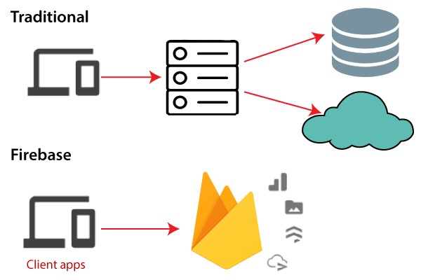

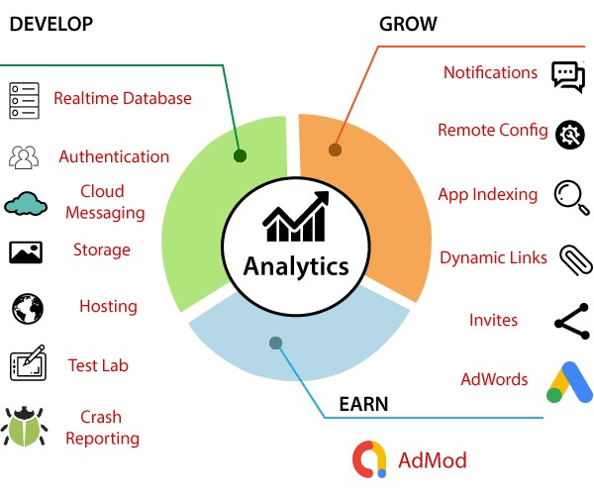

Google Firebase is Google-backed application development software which allows developers to develop **Android, IOS,** and **Web apps**. For reporting and fixing app crashes, tracking analytics, creating marketing and product experiments, firebase provides several tools.

Firebase has three main services, i.e., a real-time database, user authentication, and hosting. We can use these services with the help of the Firebase iOS SDK to create apps without writing any server code.

## History of Firebase

**Firebase** evolved from **Envolve**. Envolve is a prior startup founded by **James Tamplin** and **Andrew Lee** in 2011. Envolve provided developers an API which allowed the integration of online chat functionality into their websites. After releasing the chat service, it found that the envlove was being used to pass application data, which were not chat messages. Developers used Envolve to sync application to separate the real-time architecture and the chat system which powered it. In September 2011, Tamplin and Lee founded firebase as a separate company. It was lastly launched to the public in April 2012.

Firebase Real-time Database was the first product of firebase. It is an API which syncs application data across Android, iOS, and Web devices. It gets stored on Firebase's cloud. Then the firebase real-time database helps the developers to build real-time, collaborative applications.

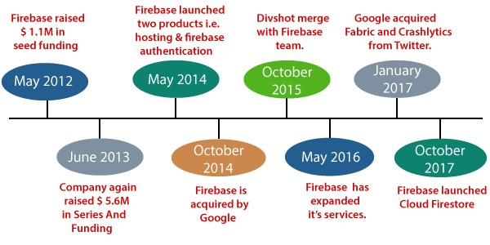

* In May 2012, after launching the beta, Firebase raised $1.1M in seed funding from Greylock Partners, venture capitalists Flybridge Capital Partners, New Enterprise Associates, and Founder Collective. o In June 2013, the company again raised $5.6M in **Series A funding** from Flybridge Capital Partnersandventure capitalists Union Square Ventures. o Firebase launched two products in 2014, i.e., Firebase Hosting and Firebase Authentication. It positioned the company as a mobile backend as a service.
* Firebase was acquired by Google in October 2014.
* Google promoted Divshot to merge it with the Firebase team in October 2015.
* In May 2016, Firebase expanded its services to become a unified platform for mobile developers. Now it has integrated with various other Google services, including AdMob, Google Cloud Platform, and Google Ads, to offer broader products and scale it for developers.
* Google acquired Fabric and Crashlytics from Twitter in January 2017 to add Fabric and Crashlytics services to Firebase. o Firebase launched Cloud Firestore in October 2017. It is a realtime document database as the successor product for the original Firebase Realtime Database.

**Why use Firebase?**

* Firebase manages real-time data in the database. So, it easily and quickly exchanges the data to and from the database. Hence, for developing mobile apps such as live streaming, chat messaging, etc., we can use Firebase.
* Firebase allows syncing real-time data across all devices - iOS, Android, and Web - without refreshing the screen.
* Firebase provides integration to Google Advertising, AdMob, Data Studio, BigQuery DoubleClick, Play Store, and Slack to develop our apps with efficient and accurate management and maintenance. o Everything from databases, analytics to crash reports are included in Firebase. So, the app development team can stay focused on improving the user experience.
* Firebase applications can be deployed over a secured connection to the firebase server. o Firebase offers a simple control dashboard. o It offers a number of useful services to choose from.

## Pros and Cons of Firebase

Pros o Firebase is a real-time database. o It has massive storage size potential. o Firebase is serverless and highly secure. o It is the most advanced hosted BaaS solution and has minimal setup.

* It provides three-way data binding via angular fire and o It provides simple serialization of app state. o There is no server infrastructure required to power apps with data. o It has JSON storage, which means no barrier between data and objects.

Cons

* Firebase is not widely used, or battle-tested for enterprises. o It has very limited querying and indexing. o It provides no aggregation.
* It has no map-reduce functionality. o It cannot query or list users or stored files.

### Features of Firebase

Firebase has several features that make this platform essential. These features include unlimited reporting, cloud messaging, authentication and hosting, etc. Let's take a look at these features to understand how these features make Firebase essential:

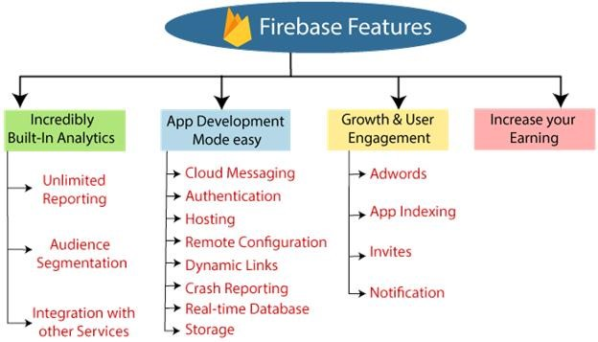

#### Incredibly Built-In Analytics

The analytics dashboard is one of the best features of Firebase, which is equipped with. It is free and can report 500 event types, each with 25 attributes. The dashboard is top-notch for observing user behavior and measuring various user characteristics. Ultimately it helps us to understand how people use our app so that we can better optimize it in the future.

##### Key features

**Unlimited Reporting**

It allows for reporting of 500 distinct events.

**Audience Segmentation**

We can identify custom audiences in the Firebase console based on device data, custom events, or user properties. After that, we can use these audiences that we specified with other Firebase attributes when targeting new features or notifications.

**Integration with Other Services**

We can integrate Firebase with other services that can utilize our business apps such as Big Query, Firebase Notifications, Firebase Remote Configuration, Firebase CrashReporting, and Google Tag Manager.

#### App Development Made Easy

With Firebase, we can focus our time and attention on developing the best possible applications for our business. The operation and internal functions are very solid. They have taken care of the Firebase Interface. We can spend more time in developing high-quality apps that users want to use.

There are the following features which we can develop:

**Cloud Messaging**

Firebase allows us to deliver and receive messages in a more reliable way across platforms.

**Authentication**

Firebase has little friction with acclaimed authentication.

**Test Lab**

Test in the lab instead on your users. **Hosting**

Firebase delivers web content faster.

**Remote Configuration**

It allows us to customize our app on the go.

**Dynamic Links**

Dynamic Links are smart URLs which dynamically change behavior for providing the best experience across different platforms. These links allow app users to take directly to the content of their interest after installing the app - no matter whether they are completely new or lifetime customers.

**Crash Reporting**

It keeps our app stable.

**Real-time Database**

It can store and sync app data in real-time.

**Storage**

We can easily store the file in the database.

#### Growth and User Engagement

One of the most important aspects of application development is being able to develop and engage with users over time. Firebase has a lot of built-in features, which ensures that it is exactly what we do. With the platform leading to commercial apps, it is really at the center of what makes Firebase so great. Here are some user interaction aspects which make development a piece of cake:

**AdWords**

Linking AdWords is very easy, and with it, we can segment and define our user base using Firebase Analytics. Also, it is easy to improve our targeting in marketing advertising campaigns. Some other benefits include conversion tracking, cross-network, attribution networks, and LTV (Calculating Customer Lifetime Value).

**App Indexing**

With app indexing, we can work on aspects like re-engaging with our app, especially by surfing the in-app content within Google search results. It will also help in ranking our application in Google search results.

**Invites**

It is a perfect tool for referrals and sharing. Get the help of our users to develop our app easily via email or SMS, allowing their existing users to share our app or in-app content. If we use this feature in combination with promotions, then we can also work towards acquiring new customers and retaining our existing customers.

**Notifications**

We can manage information campaigns very easily, including the ability to set and schedule messages to engage users at the right time of day. These notifications are completely free. These are unlimited for both iOS and Android. There is only one dashboard to worry about, and if we integrate with Firebase Analytics, we can use various user segmentation features.

#### Increase Your Earnings

Of course, the thing about having an app or any other business strategy is that we can increase our earnings. With the feature of AdMob, we can monetize our app, considering the best possible experience for our users. Showing real-time ads to millions of Google advertisers, choosing a format which suits our app, and working with over 40 top ads networks using AdMob Mediation, we can make app development well worth it, while speaking silently. We can also cross-promote between our apps with AdMob House ads for free!

## Adding Firebase to App

Firebase is developed for mobile applications. Android Studio is the best platform for developing android applications. Firebase is a backend -as-a-service, which allows us to store a list of objects in the form of a tree.

To store data into Firebase, we first have to add the Firebase into our android application.

Before adding Firebase into our android application, we need to be aware of some prerequisites. These requisites are as follows:

* It is required that we should have a Google account to work with Firebase.
* We also required a device or emulator, which is running on Android 4.0 or newer. o We also required the latest version of Android Studio, i.e., version 1.5 or higher. o The app must use Gradle 4.1 or later.

There are two methods through which we can add Firebase to our application:

1. One is through the Firebase assistant, which is a nice little wizard inside Android Studio. It will connect our existing project or create a new one for us and automatically install any necessary Gradle dependencies. It requires some additional configuration.
2. The second one is, we can manually add Firebase to our android application via Firebase console. It is the recommended way of adding Firebase to our application.

**8.2.1 Add Firebase to android application manually:**

**Step 1:** In the first step, go to the firebase console by using the following link<https://firebase.google.com/>

**Step 2:** Create a Firebase project. Firebase project will go through and describe what it is.

This allows us to add an app to that project can have many projects inside of Firebase. **Step 3:** Now, we have to give a name and id to the project, enable Google Analytics for the project, set an analytics location, and accept all the terms and conditions. Firebase console automatically creates a unique id for the project.

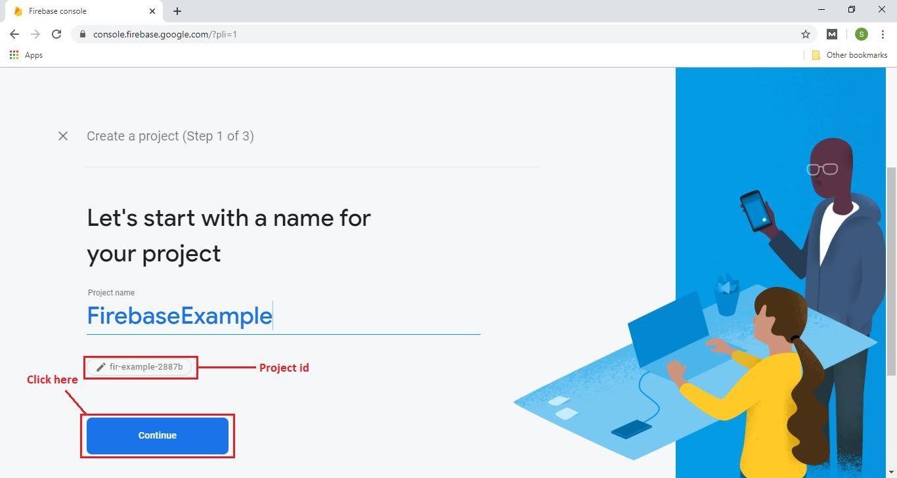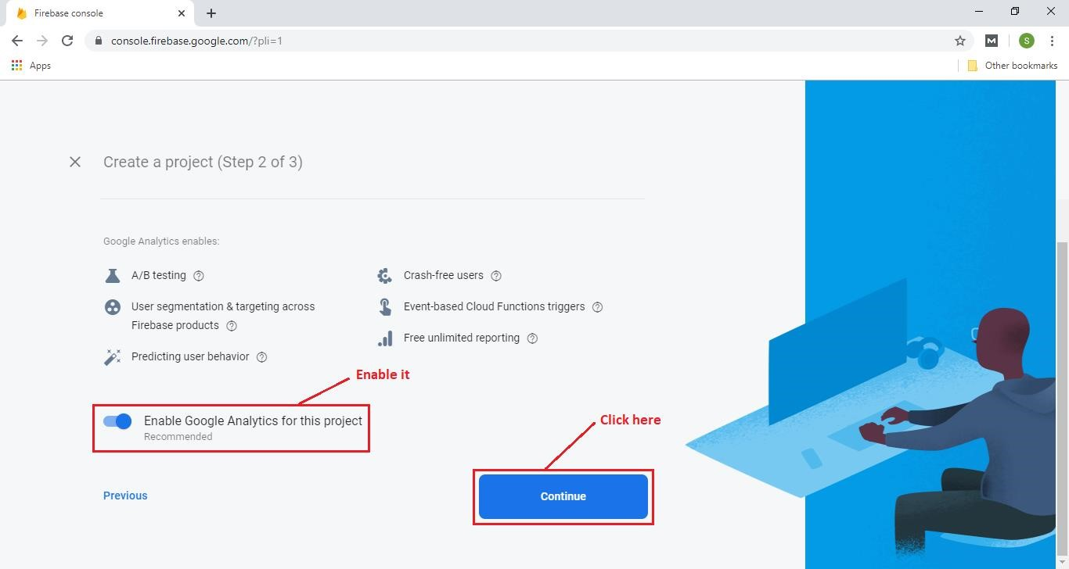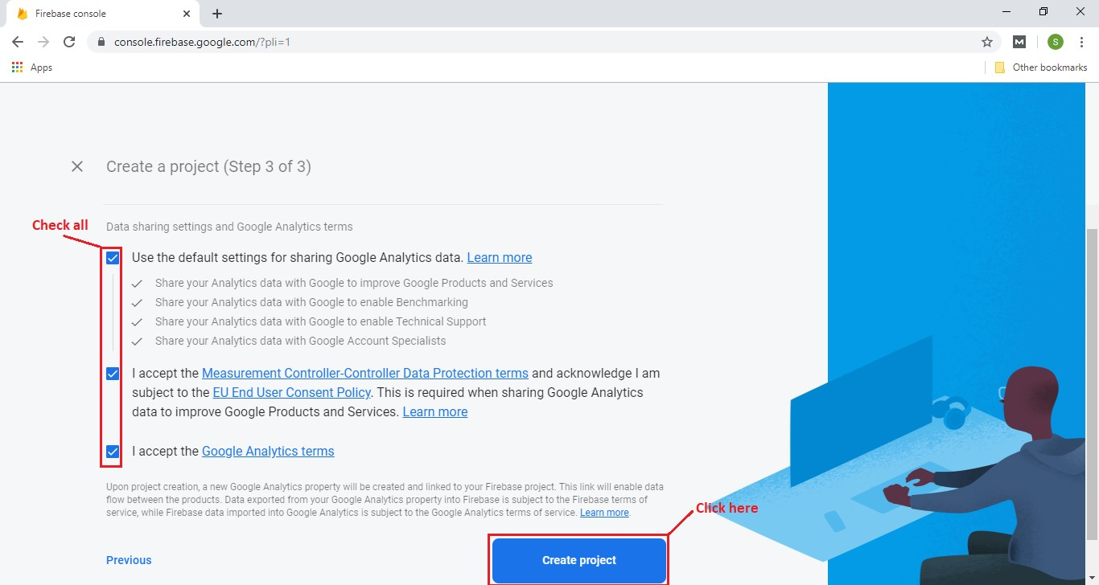

When we click on create the project, the creation of the Firebase project is started, and once our project will be created, we have to click on continue to enter in our project.

**Step 4:**

In the next step, we have to choose the platform to add Firebase to our application. The platform can be Android, iOS, Web, and Unity.

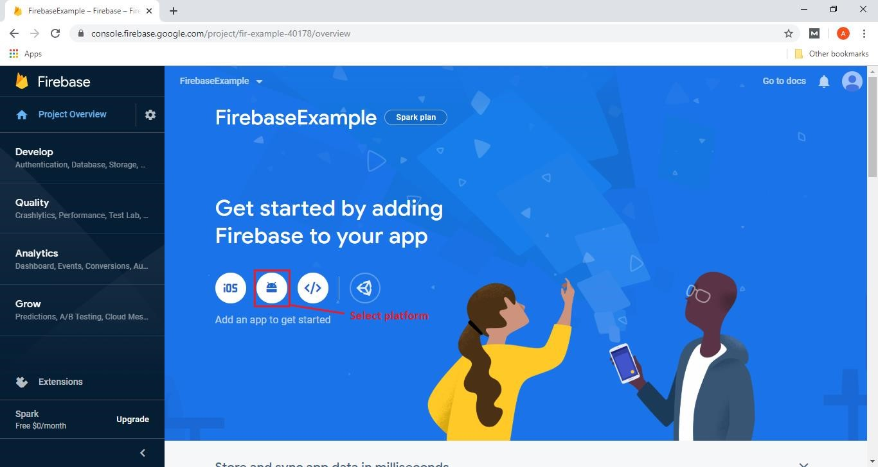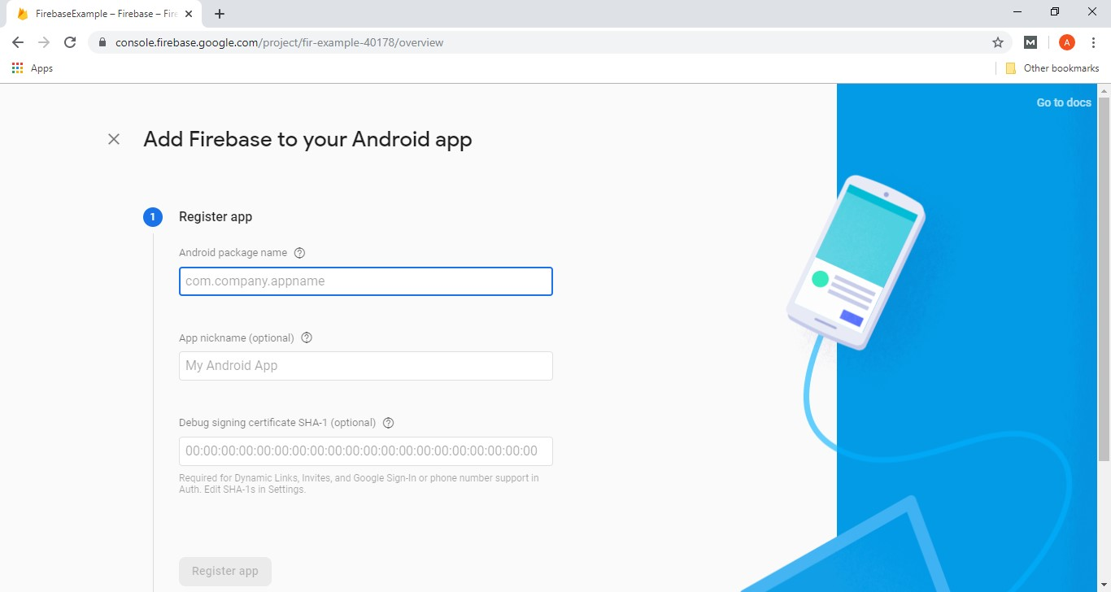

**Step 5:**

In the next step, we have to mention the package name, and the package name is the mandatory and important thing. The package name should be matched with our Android applications package name. We can find the package name of our application in any of the Java class or Manifest file.

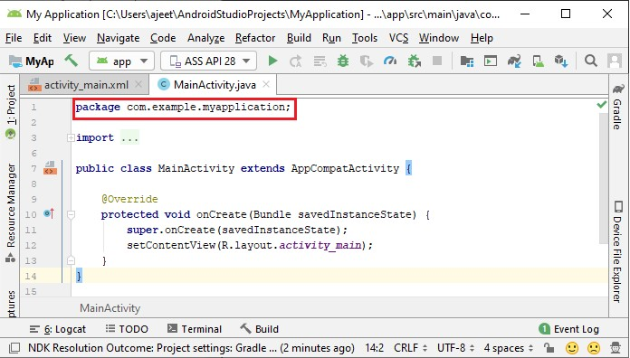

**Step 6:**

In the next step, we will give a nickname to our application. It is an optional field. There is another optional field for SHA-1, which is required to do for certain feature. We can find the SHA-1 by hitting on the **signing report**.

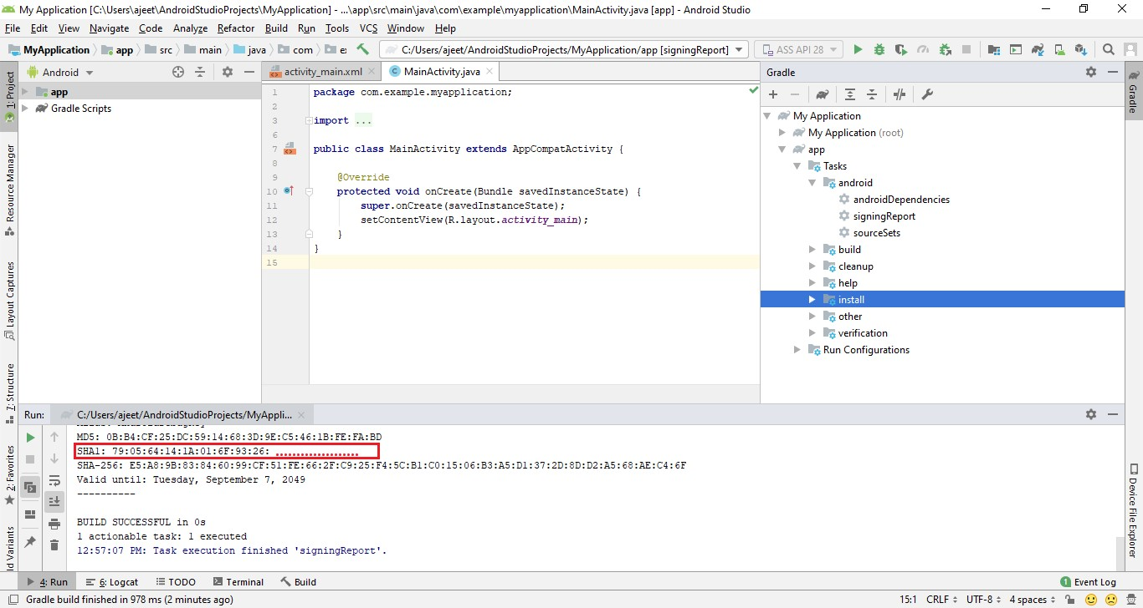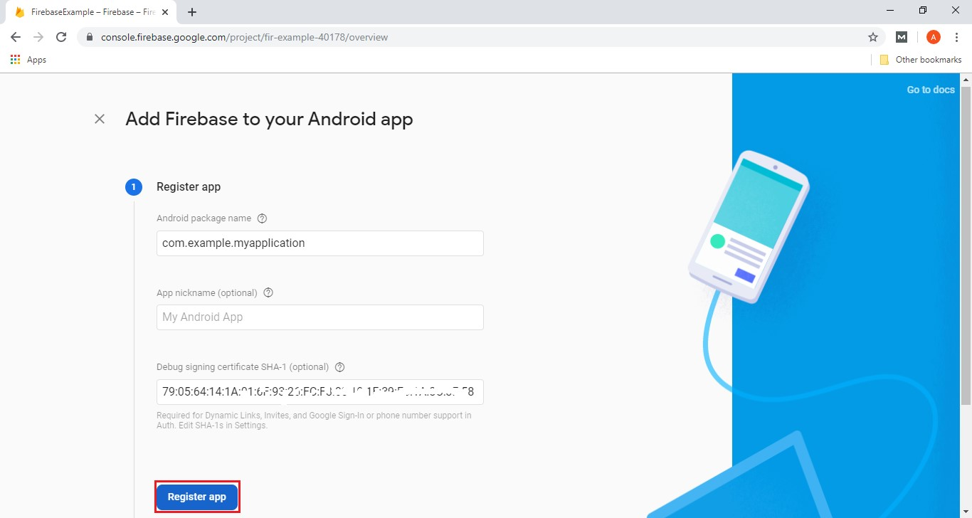

When we click on the **Register app**, we will go to the next field i.e., **Download config file**.

**Step 7:**

It is one of the most important steps. In this step, we have to download the google-services.json file. This file is provided by Firebase for us to put it inside our application folder in our application. This is a necessary file which is needed by our application to connect with Firebase.

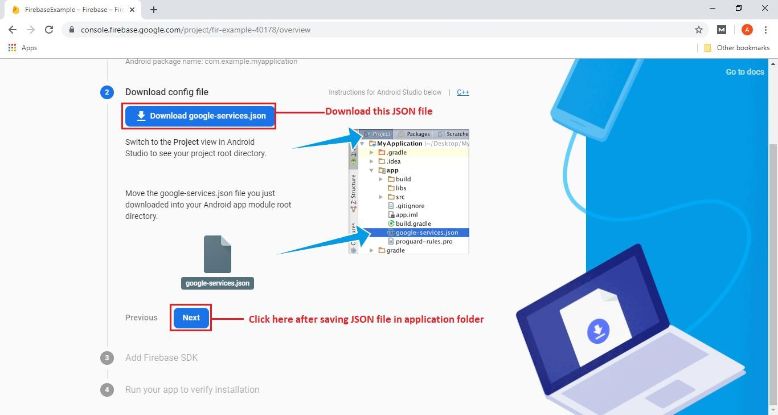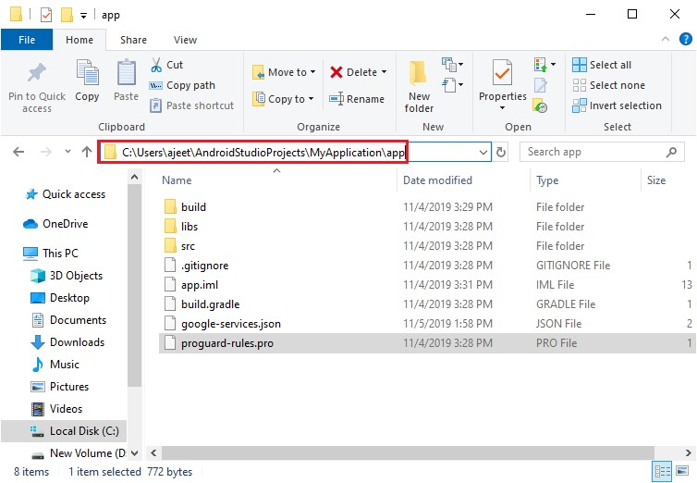

When we click on next, we will switch to the next field i.e., Add **Firebase SDK**.

**Step 8:**

In the next step, we will add the Firebase SDK. This has been done inside the Android Studio.

We have to modify the build. Gradle files once in your project with the following lines of code.

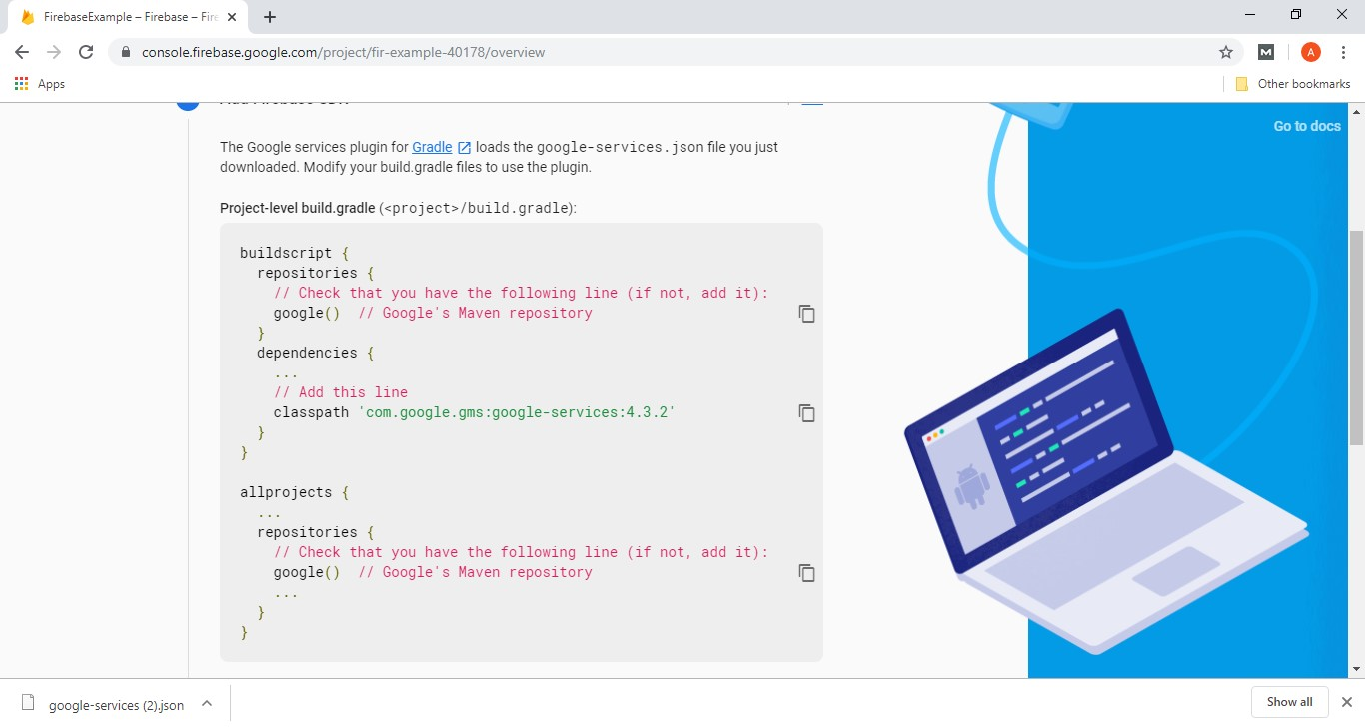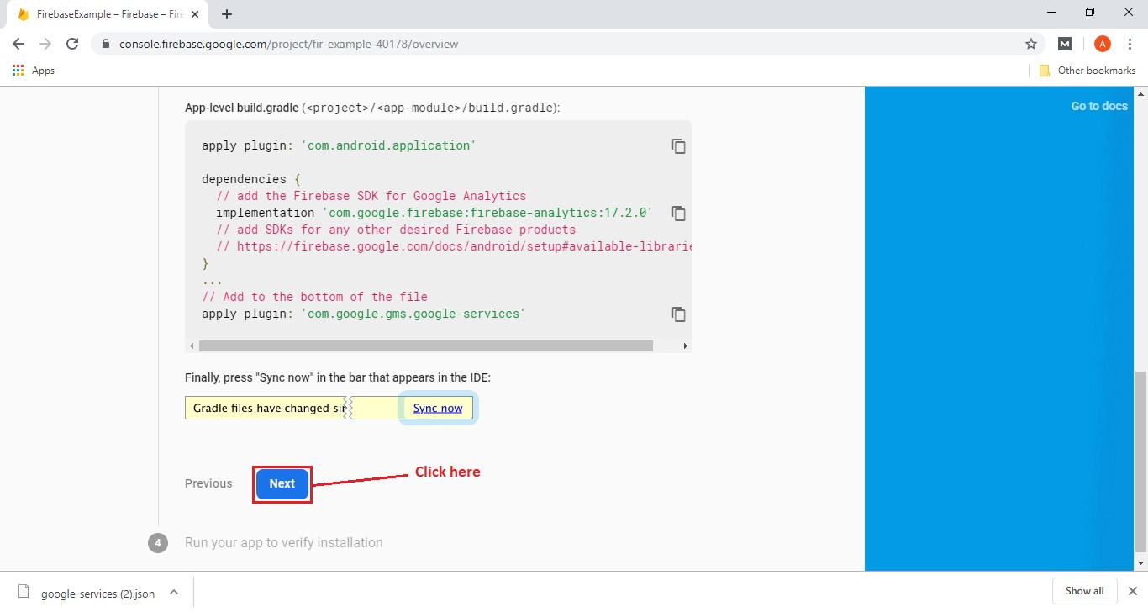

We will skip the four-field, i.e., **Run your app to verify the installation**.

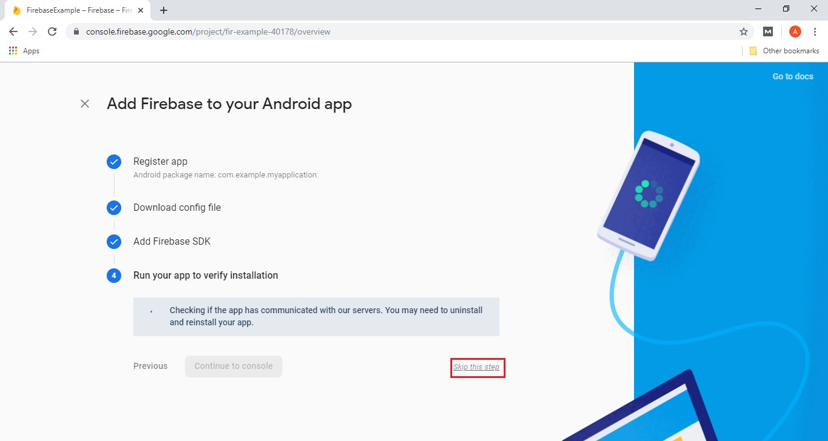

After clicking on the skip, we will switch to the overview page where we can see our application.

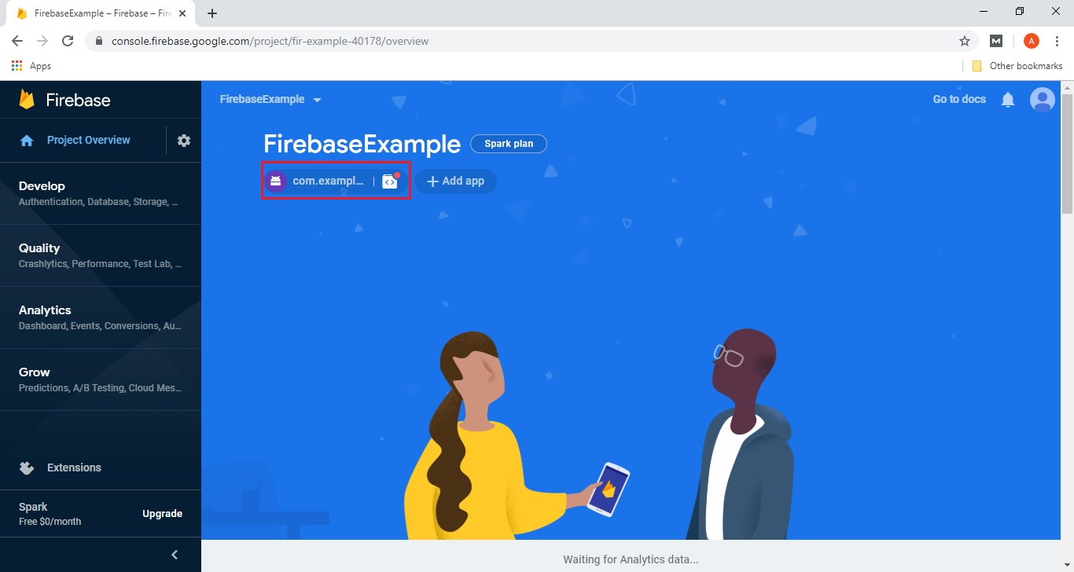

When our application runs on the device, we will check the Firebase console to ensure that our application is communicating with Firebase or not.

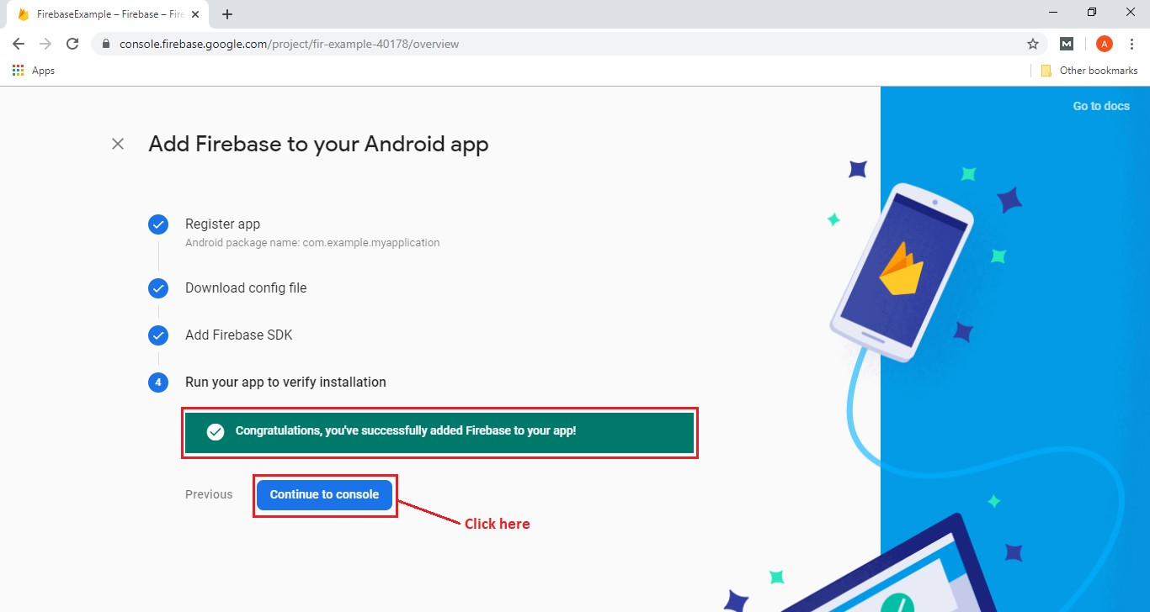

### Firebase Assistance

Firebase Assistance automatically adds the necessary Firebase files and code to our Android project. We can simply add Firebase using Firebase Assistance by selecting Firebase from the tools menu in Android Studio.

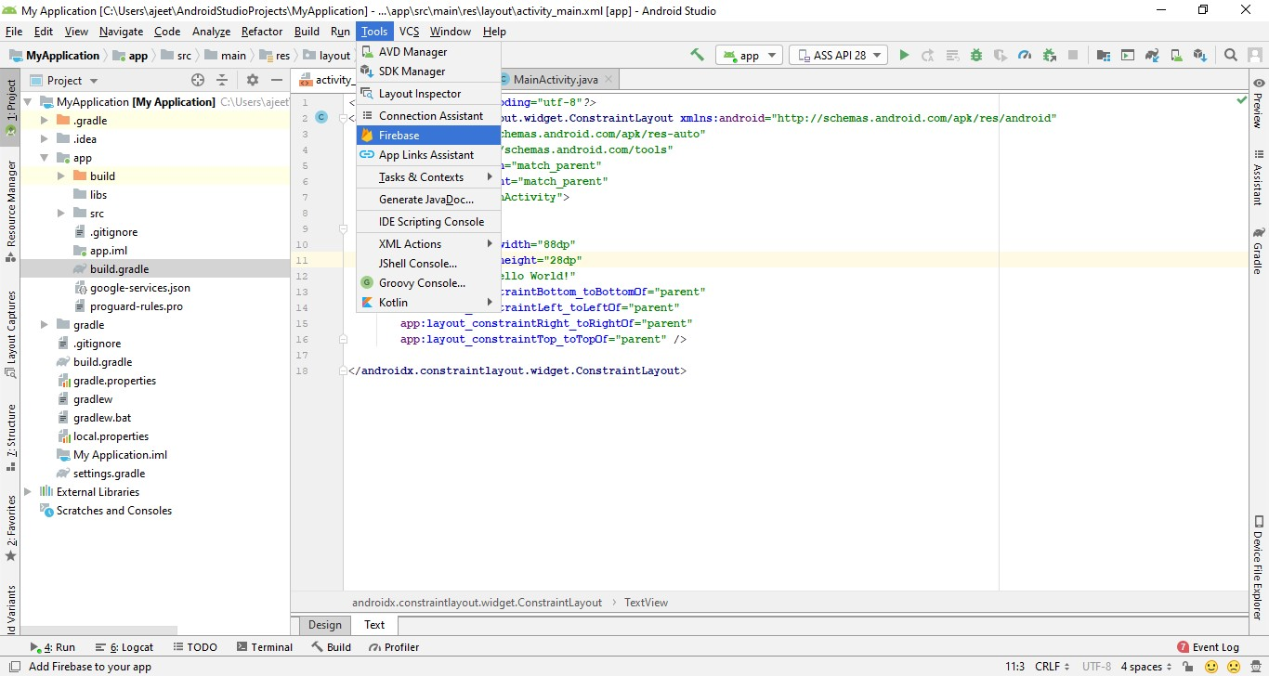

When we click on Firebase, a new window will open that contains several Firebase features such as Analytics, Cloud Messaging, Authentication, and Real-time Database, etc.

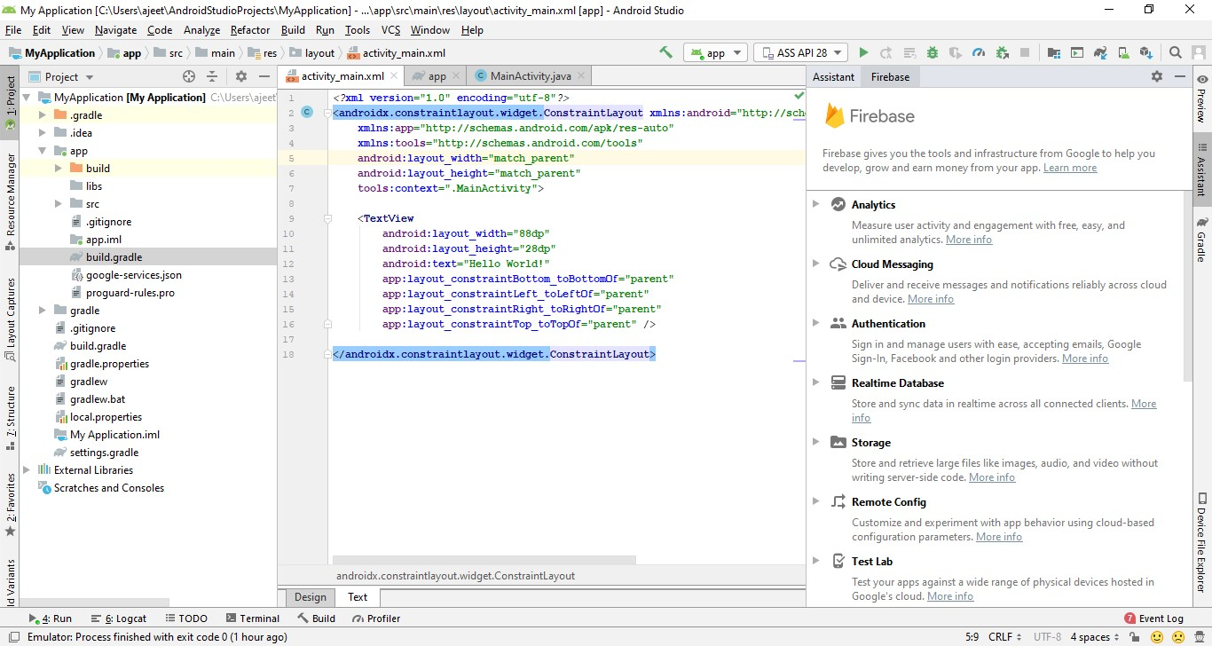

Let's start with basics, i.e., Analytics. When we select Analytics, it gives us the step by step guide of what we need to do.

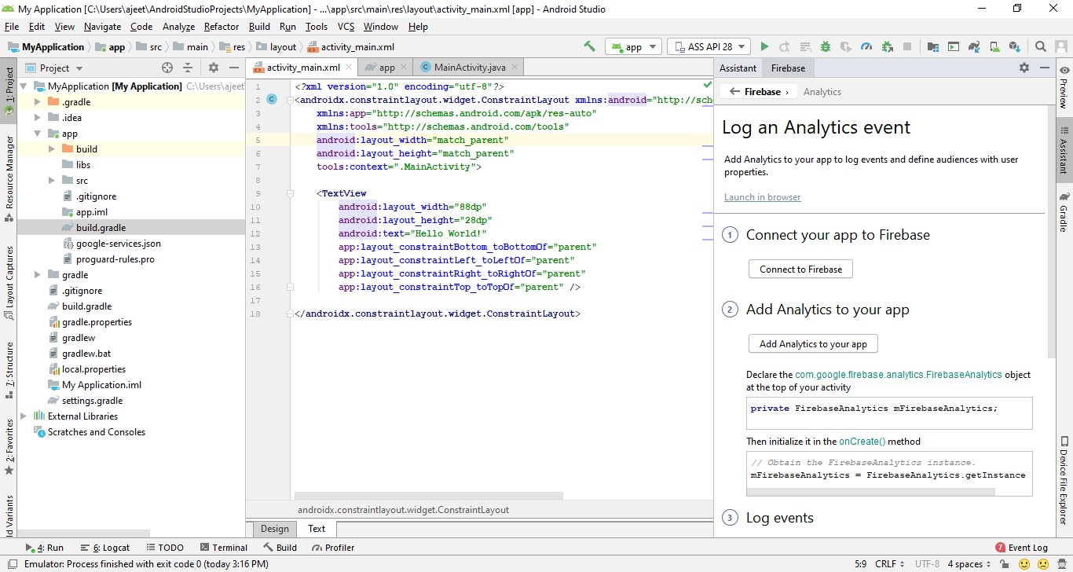

**Step 1:**

So, in the first step, we will connect to Firebase. When we click on connect to Firebase, it may bring up our browser, and we may have to log into our Google account. If we log in to our Google account, we may have to give access to Android Studio so that it can allow us to add stuff.

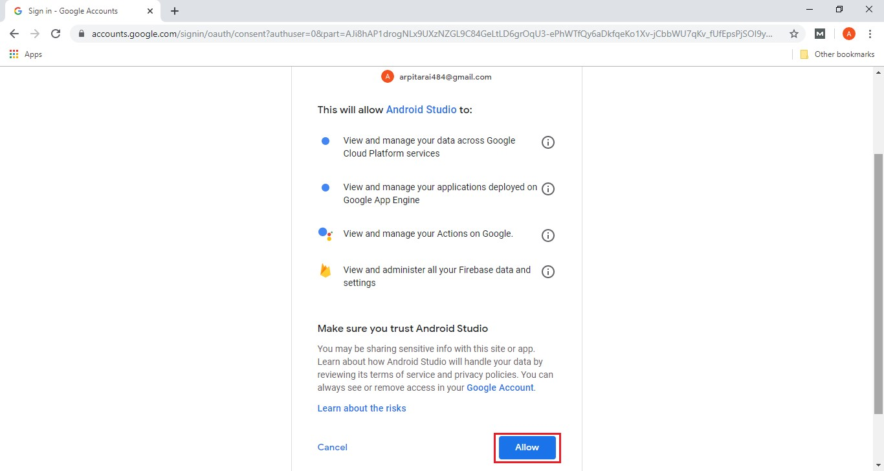

When we click on allow, it will take us back to Android Studio. Because our project is already connected with Firebase, it will pop up a message, i.e., Firebase already connected. But if our project is not connected with Firebase, it will show the following window.

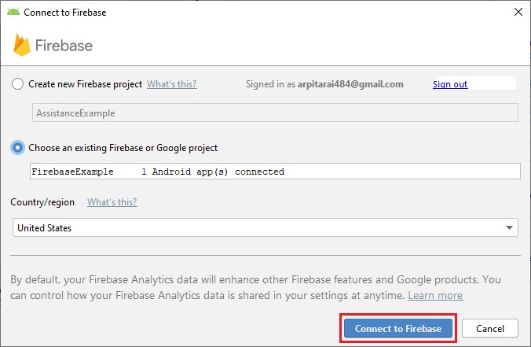

Here, we have to create a new Firebase project or choosing the existing Firebase project. It completely depends on us. When we click on **Connect to Firebase**, our project will connect with Firebase successfully.

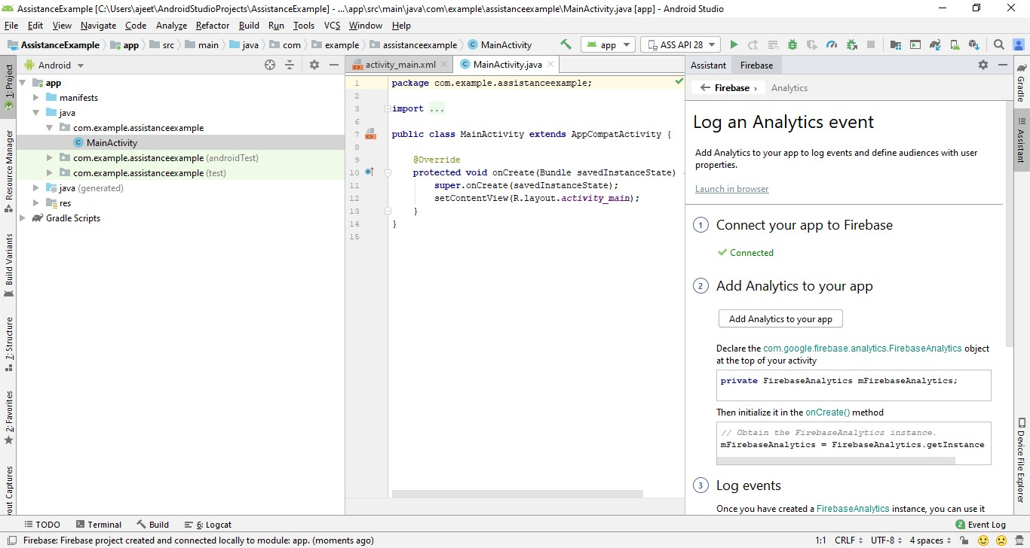

**Step 2:**

In the next step, we will add analytics to our app by clicking on **Add Analytics to your app**.

This will actually update our build.gradle files, which we did in the previous section.

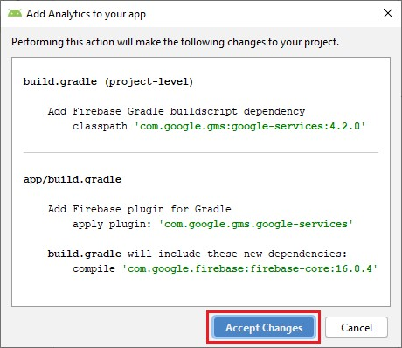

When we click on Accept Changes, it will update our Gradle files, which we can verify by going to build. Gradle files.

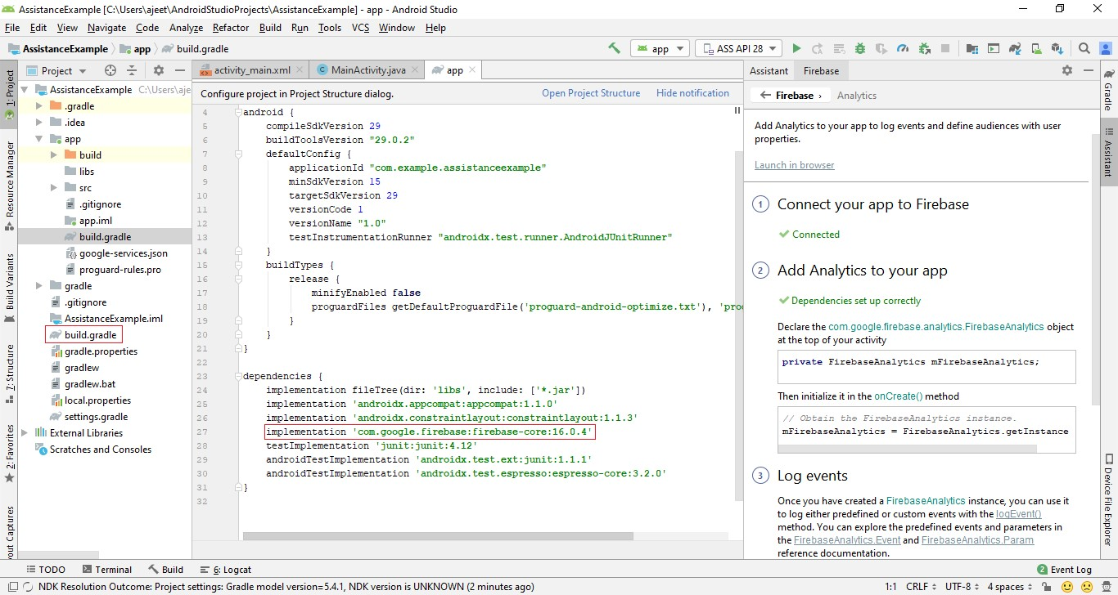

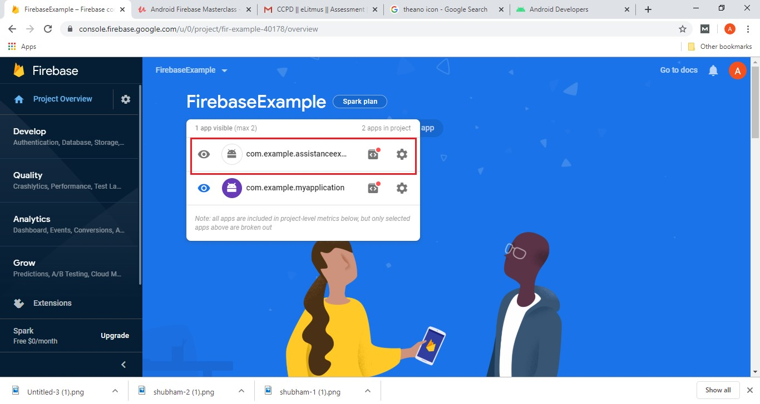

Firebase Authentication o Being able to authenticate our users securely, it offers a customized experience to them based on their interests and preferences. o We can ensure that they have no problems accessing their private data while using our app from multiple devices.

* Firebase Authentication provides all the server-side stuff for authenticating the user. o Firebase authentication supports authentication using a password, phone numbers, popular identity provider like Google, Facebook, and Twitter, etc.
* We can sign in users to our app by using the FirebaseUI.
* It handles the UI flows for signing in user with an email address and password, phone numbers, and popular providers, including Google sign-In and Facebook Login.
* It can also handle cases like account recovery. o It is not required to design a UI since it is already provided for us. It means we don't have to write the activities.
* We can also sign-in users using the Firebase Authentication SDK to integrate one or several sign-in methods into our app manually.

#### Firebase UI Authentication Method

Firebase UI Authentication is a way to add a complete sign-in system to our app, where Firebase provides user interface to them. Firebase UI provides a drop-in auth solution which is used to implement authentication on mobile devices and websites. There are the following steps to use Firebase UI Authentication:

* Set up sign-in methods:
* Enable authentication method in the firebase console.
* For email address and password, phone number sign-in, and any identity providers.
* Complete the configuration if anyone requires for identity providers.
* Setting OAuth redirect URL.
* Customize the sign-in UI.
* For customizing the sign-in and UI, we have to set some Firebase UI options or fork the code on GitHub.
* To perform the sign-in flow, use Firebase UI:
* Import the Firebase UI library. o Specify the sign-in method which we want to support. o Initiate the Firebase UI sign-in flow.

#### Firebase SDK Authentication Method

The Firebase SDK Authentication provides methods for creating and managing users who use their email addresses and password to sign in. SDK also handles sending password reset emails.

* We can also provide phone number authentication using SDK o We can authenticate users by integrating with identity providers.
* SDK provides methods which allow users to sign-in with their Google, Facebook, Twitter, and GitHub accounts.
* We can connect our app's existing sign-in system to the Firebase Authentication SDK and gain access to Firebase Real-time database and other Firebase services.

There are the following steps to use Firebase SDK Authentication:

* Set up sign-in methods:
* Enable the authentication method in the Firebase console for an email address and password or phone number sign-in and any identity providers.
* Complete the configuration if anyone is required for identity providers.
* Setting our OAuth redirect URL.
* Implementing UI flows for our sign-in methods:
* For email signing, add screens which prompt the user to type their email addresses
* For phone number sign-in, add screens which prompt users to type their phone number, and after that, for the code from the SMS message they receive.
* For identity sign-in, implement the flow required by each provider.
* Passing the user's credentials to the Firebase Authentication SDK:
* Pass the user's email address and password. o Pass the OAuth token, which was acquired from the identity provider.

**How Authentication Works?**

* First get authentication credentials from the user to sign a user into app.
* Credentials can be the user's email address and password.
* The credential can be an OAuth token from an identity provider.
* Then pass these credentials to the Firebase Authentication SDK. Backend services will then verify those credentials and return a response to the client.
* After a successful sign in we can:
* Access the user's access to data stored in other Firebase products.
* Access the user's basic profile information. o Use the provided authentication token to verify the identity of users in our own backend services.
* An authenticated user can read and write data to the Firebase Real-time Database and Cloud Storage. o We can control the access of those authenticated users by modifying the Firebase Database Rules and Storage Security Rules.

**Users** o A Firebase User object represents the account of a user who has signed up to the app in Firebase project. Apps have many registered users, and every app in a Firebase project shares a user data base. o AFirebase User instance is independent of a Firebase Auth instance. It means we can have several references to different users within the same context and still call any of their method

* A Firebase User has a fixed set of basic properties such as Unique ID, Primary email address, Name, and a photo URL.
* Firstly, a user signs up to the app. The user's profile data is populated with the primary email address if using email/password auth, account information available by the provider if using identity auth, and anything we want if using custom auth. o The user becomes the current user of the Auth instance when a user signs up or signs in.
* The Auth instance stops to keep a reference to the User object. And no longer persists it states when a user signs out:
* No current user
* The user instance continues to be completely functional o If we keep a reference to it, we can still access and update the user's data.
* Using listeners is the recommended way to track the current state of the Auth instance.
* An Auth listener gets notified any time when something relevant happens to the Auth object.

#### User Lifecycle

* An Auth listener gets notified in the following situation o The Auth object finishes initializing, and a user was already signed in from a previous session or has been redirected from an identity provider's sign-in flow
* A user signs in. o A user signs out.
* The current user's access token is refreshed:
* The access token expires. o The user changes their password. o The user re-authenticates

#### Firebase: Google Sign-In Authentication

Starting steps are the same as we have done with other authentication methods, which are as follows:

1. Creating an Android project.
2. Creating a Firebase project.
3. Adding Firebase to the Android project or application, either manually or Firebase Assistance.
4. Adding the required libraries and JSON files.

**Step 1:**

Apart from firebase auth and core libraries, add google play services auth in app.gradle file

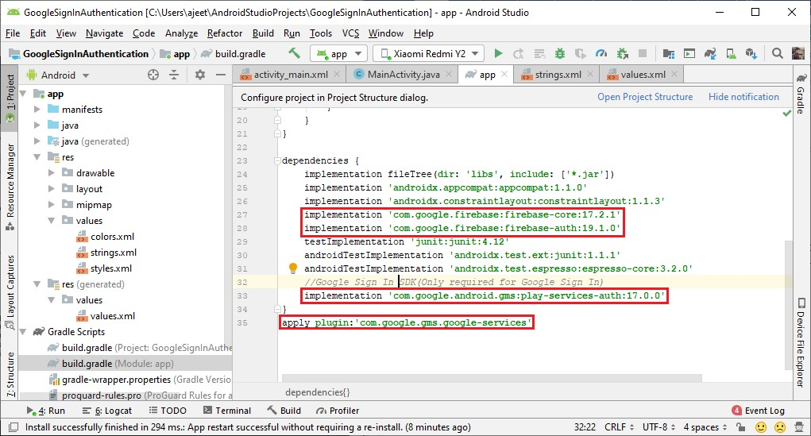

**Step 2:**

In the next step, enable the Google sign-in method in Firebase console. We also have to add a project supporting email.

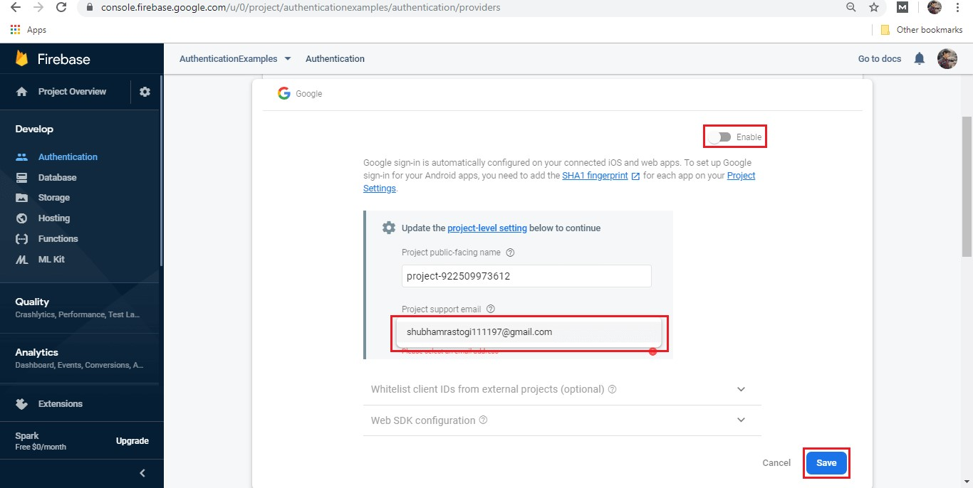

**Step 3:**

Just like our previous method, we have to set SHA-1 and SHA-256 keys.

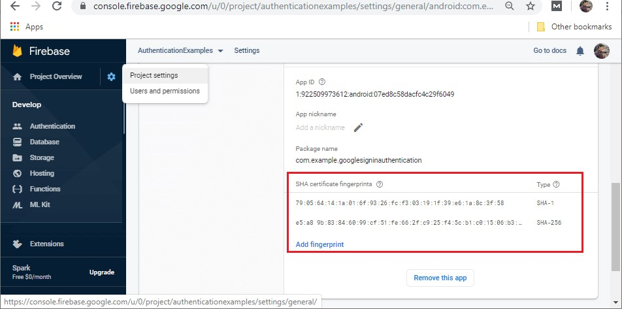

**Step 4:**

In the next step, create the layout file that contains three buttons Google sign-in, sign-out, and sign-out and disconnect. The activity layout will look like:

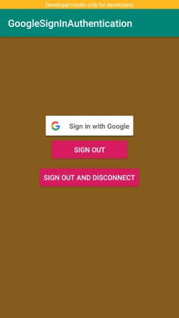

**Step 5:**

Now, modify our MainActivity.java file to perform the Google sign-in authentication in the following way:

**public** **class** MainActivity **extends** AppCompatActivity **implements** View.OnClickListener {

//Adding tag for logging and RC_SIGN_IN for an activity result **private** **static** **final** String TAG = "GoogleActivity"; **private** **static** **final** **int** RC_SIGN_IN = 9001;

// Adding Google sign-in client

GoogleSignInClient mGoogleSignInClient; //Creating member variable for FirebaseAuth **private** FirebaseAuth mAuth;

@Override **protected** **void** onCreate(Bundle savedInstanceState) { **super**.onCreate(savedInstanceState); setContentView(R.layout.activity_main); //Adding buttons to the OnClickListener findViewById(R.id.sign_in_button).setOnClickListener(**this**); findViewById(R.id.signOutButton).setOnClickListener(**this**); findViewById(R.id.disconnectButton).setOnClickListener(**this**); //Building Google sign-in and sign-up option.

// Configuring Google Sign In

GoogleSignInOptions gso = **new** GoogleSignInOptions.Builder(GoogleSignInOptions.DEFAULT_SIGN

_IN)

/* for the requestIdToken, use getString(R.string.default_web_client_id), this is in the values.xml file that is generated from your google-services.json file (data from your firebase project), uses the google-sign-in method web api key*/

.requestIdToken(getString(R.string.default_web_client_id))//Default_web_client_id will be matched with the .requestEmail() .build();

// Build a GoogleSignInClient with the options specified by gso.

mGoogleSignInClient = GoogleSignIn.getClient(**this**, gso); // Set the dimensions of the sign-in button.

SignInButton signInButton = findViewById(R.id.sign_in_button); signInButton.setSize(SignInButton.SIZE_WIDE);

// Initialize Firebase Auth mAuth = FirebaseAuth.getInstance();

}

//Creating onStart() method.

@Override **public** **void** onStart() { **super**.onStart();

// Checking if the user is signed in (non-null) and update UI accordingly. FirebaseUser currentUser = mAuth.getCurrentUser(); **if** (currentUser != **null**) {

Log.d(TAG, "Currently Signed in: " + currentUser.getEmail());

Toast.makeText(MainActivity.**this**, "Currently Logged in: " + currentUser.getEmail(), Toast.LEN GTH_LONG).show();

}

}

//Calling onActivityResult to use the information about the sign-in user contains in the object.

@Override **public** **void** onActivityResult(**int** requestCode, **int** resultCode, Intent data) { **super**.onActivityResult(requestCode, resultCode, data);

// Result returned from launching the Intent from GoogleSignInApi.getSignInIntent(...); **if** (requestCode == RC_SIGN_IN) {

Task<GoogleSignInAccount> task = GoogleSignIn.getSignedInAccountFromIntent(data);

**try** {

// Google Sign In was successful, authenticate with Firebase

GoogleSignInAccount account = task.getResult(ApiException.**class**);

Toast.makeText(**this**, "Google Sign in Succeeded", Toast.LENGTH_LONG).show(); firebaseAuthWithGoogle(account);

} **catch** (ApiException e) {

// Google Sign In failed, update UI appropriately

Log.w(TAG, "Google sign in failed", e);

Toast.makeText(**this**, "Google Sign in Failed " + e, Toast.LENGTH_LONG).show();

} } }

//Creating helper method FirebaseAuthWithGoogle().

**private** **void** firebaseAuthWithGoogle(GoogleSignInAccount acct) {

Log.d(TAG, "firebaseAuthWithGoogle:" + acct.getId());

//Calling get credential from the oogleAuthProviderG

AuthCredential credential = GoogleAuthProvider.getCredential(acct.getIdToken(), **null**); mAuth.signInWithCredential(credential)

.addOnCompleteListener(**this**, **new** OnCompleteListener<AuthResult>() { //Override th onComplete() to see we are successful or not.

@Override **public** **void** onComplete(@NonNull Task<AuthResult> task) { **if** (task.isSuccessful()) {

// Update UI with the sign-in user's information

FirebaseUser user = mAuth.getCurrentUser();

Log.d(TAG, "signInWithCredential:success: currentUser: " + user.getEmail());

Toast.makeText(MainActivity.**this**, "Firebase Authentication Succeeded ", Toast.LENGTH_LONG).sho w();

} **else** {

// If sign-in fails to display a message to the user.

Log.w(TAG, "signInWithCredential:failure", task.getException());

Toast.makeText(MainActivity.**this**, "Firebase Authentication failed:" + task.getException(), Toast.LENG TH_LONG).show();

}

}

});

}

**public** **void** signInToGoogle(){

//Calling Intent and call startActivityForResult() method Intent signInIntent = mGoogleSignInClient.getSignInIntent(); startActivityForResult(signInIntent, RC_SIGN_IN);

}

**private** **void** signOut() {

FirebaseAuth.getInstance().signOut(); // Firebase sign out

// Google sign out mGoogleSignInClient.signOut().addOnCompleteListener(**this**, **new** OnCompleteListener<Void>() {

@Override

**public** **void** onComplete(@NonNull Task<Void> task) {

// Google Sign In failed, update UI appropriately

Toast.makeText(getApplicationContext(),"Signed out of google",Toast.LENGTH_SHORT).show();

}

});

}

**private** **void** revokeAccess() {

FirebaseAuth.getInstance().signOut(); // Firebase sign out

// Google revoke access mGoogleSignInClient.revokeAccess().addOnCompleteListener(**this**, **new** OnCompleteListener<Void>() {

@Override

**public** **void** onComplete(@NonNull Task<Void> task) {

// Google Sign In failed, update UI appropriately

Log.w(TAG, "Revoked Access");

}

});

}

@Override **public** **void** onClick(View v) { **int** i = v.getId();

**if** (i == R.id.sign_in_button) { //Adding signInToGoogle() method signInToGoogle(); }

**else** **if** (i == R.id.signOutButton) { signOut(); } **else** **if** (i == R.id.disconnectButton) { revokeAccess(); }

}

@Override

**public** **void** onPointerCaptureChanged(**boolean** hasCapture) { }

}

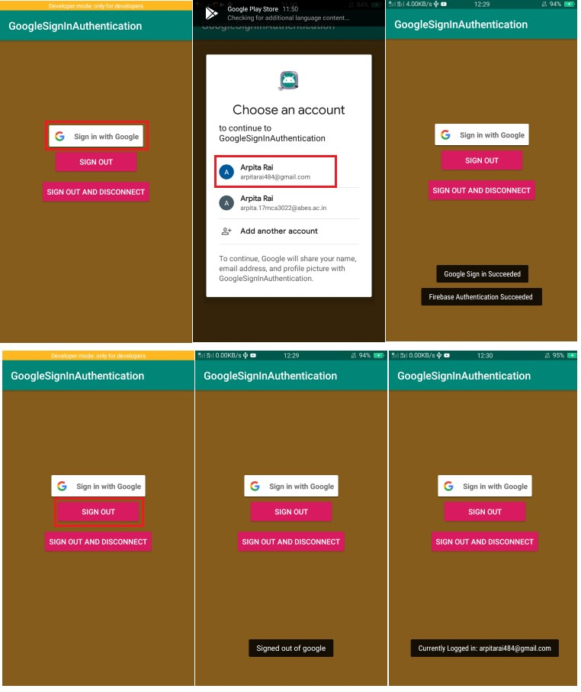

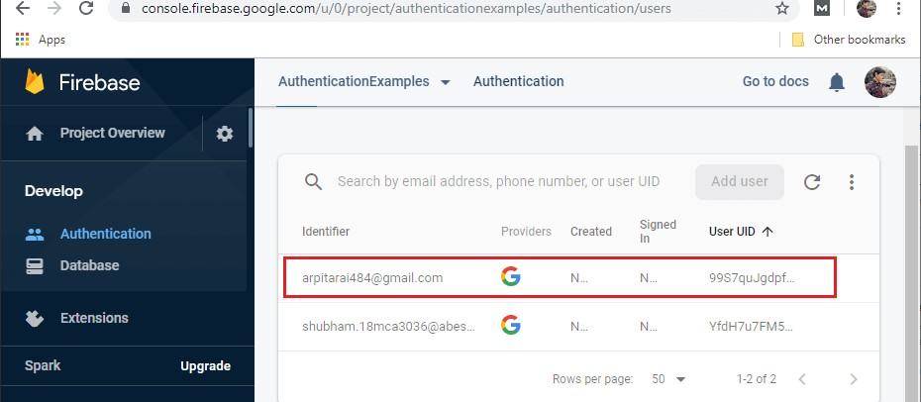

### Firebase: Realtime Database

The Firebase Realtime Database is a cloud-hosted database in which data is stored as JSON.

The data is synchronized in real-time to every connected client. All of our clients share one Realtime Database instances and automatically receive updates with the newest data, when we build cross-platform applications with our iOS, and JavaScript SDKs.

The Firebase Realtime Database is a NoSQL database from which we can store and sync the data between our users in real-time. It is a big JSON object which the developers can manage in real-time. By using a single API, the Firebase database provides the application with the current value of the data and updates to that data. Real-time syncing makes it easy for our users to access their data from any device, be it web or mobile.

The Realtime database helps our users collaborate with one another. It ships with mobile and web SDKs, which allow us to build our app without the need for servers. When our users go offline, the Real-time Database SDKs use local cache on the device for serving and storing changes. The local data is automatically synchronized, when the device comes online. **Key capabilities**

#### Real-time

The Firebase Real-time database uses data synchronization instead of using HTTP requests. Any connected device receives the updates within milliseconds. It doesn't think about network code and provides collaborative and immersive experiences.

#### Offline

The Firebase Database SDK persists our data to disk, and for this reason, Firebase apps remain responsive even when offline. The client device receives the missed changes, once connectivity is re-established.

#### Accessible from client devices

There is no need for an application server to access the Firebase Real-time database. We can access it directly from a mobile device or web browser. Data validation and security are available through the Firebase Real-time Database Security Rules, expression-based rules executed when data is read or written.

#### Scaling across multiple databases

With the Firebase Real-time Database on Blaze Pricing Plan, we can support the data needs of our app by splitting our data across multiple database instances in a single Firebase project. Streamline authentication with Firebase authentication on our project and authenticate users in our database instances. Controls access to data in each database with custom Firebase real-time database rules available for each database instance.

## Other Alternatives

Apart from Firebase's real-time database, there are several alternatives that are used.

### Cloud Firestore

Cloud Firestore is a scalable and flexible database used for server development, mobile, and web from Firebase and Google Cloud Platform.

### Firebase Remote Config

It stores developer specified key-value pairs to change the behavior and appearance of our app without requiring users to download an update.

### Firebase Hosting

It is used to hosts the HTML, CSS, and JavaScript of our website as well as other developerprovided assets like graphing, fonts, and icons.

### Cloud Storage

It is used to store images, videos, and audio as well as other user-generated content.

**Installation & Setup Realtime Database**

### Create a Database

1. Navigate to the **Realtime Database** section of the [Firebase console.](https://console.firebase.google.com/project/_/database) You'll be prompted to select an existing Firebase project. Follow the database creation workflow.
2. Select a starting mode for your Firebase Security Rules:

### Test mode

Good for getting started with the mobile and web client libraries, but allows anyone to read and overwrite your data. After testing, **make sure to review the** [**Understand Firebase Realtime Database Rules**](https://firebase.google.com/docs/database/security) **section.**

**Note:** If you create a database in Test mode and make no changes to the default world-readable and world-writeable Rules within a trial period, you will be alerted by email, then your database rules will deny all requests. Note the expiration date during the Firebase console setup flow.

To get started with the web, Apple, or Android SDK, select testmode.

### Locked mode

Denies all reads and writes from mobile and web clients. Your authenticated application servers can still access your database.

1. Choose a location for the database.

Depending on the [location of the database,](https://firebase.google.com/docs/projects/locations#rtdb-locations) the URL for the new database will be in one of the following forms:

* + *DATABASE_NAME*.firebaseio.com (for databases in us-central1)
  + *DATABASE_NAME*.*REGION*.firebasedatabase.app (for databases in all other locations)

1. Click **Done**.

When you enable Realtime Database, it also enables the API in the [Cloud API Manager.](https://console.cloud.google.com/projectselector/apis/api/firebasedatabase.googleapis.com/overview)

### Add the Realtime Database SDK to your app

Using the [Firebase Android BoM,](https://firebase.google.com/docs/android/learn-more#bom) declare the dependency for the Realtime Database Android library in your **module (app-level) Gradle file** (usually app/build.gradle).

dependencies {

**// Import the BoM for the Firebase platform implementation platform('com.google.firebase:firebase-bom:29.1.0')**

### // Declare the dependency for the Realtime Database library

// When using the BoM, you don't specify versions in Firebase library dependencies **implementation 'com.google.firebase:firebase-database'** }

By using the [Firebase Android BoM,](https://firebase.google.com/docs/android/learn-more#bom) your app will always use compatible versions of the Firebase Android libraries.

*(Alternative)* Declare Firebase library dependencies *without* using the BoM

### Configure Realtime Database Rules

The Realtime Database provides a declarative rules language that allows you to define how your data should be structured, how it should be indexed, and when your data can be read from and written to.

**Note:** By default, read and write access to your database is restricted so only authenticated users can read or write data. To get started without setting up [Authentication,](https://firebase.google.com/docs/auth) you can [configure your rules for public access.](https://firebase.google.com/docs/rules/basics#default_rules_locked_mode) This does make your database open to anyone, even people not using your app, so be sure to restrict your database again when you set up authentication.

### Write to your database

Retrieve an instance of your database using getInstance() and reference the location you want to write to.

**Important**: To get a reference to a database other than a **us-central1** default database, you must pass the database URL to **getInstance()**. For a **us-central1** default database, you can call **getInstance()** (or **database**) without arguments.

You can find your Realtime Database URL in the *Realtime Database* section of the [Firebase console.](https://console.firebase.google.com/) Depending on the [location of the database,](https://firebase.google.com/docs/projects/locations#rtdb-locations) the database URL will be in one of the following forms:

### • https://*DATABASE_NAME*.firebaseio.com (for databases in us-central1)

• **https://*DATABASE_NAME*.*REGION*.firebasedatabase.app** (for databases in all other locations)

// Write a message to the database

FirebaseDatabase database = FirebaseDatabase.getInstance();

DatabaseReference myRef = database.getReference("message");

myRef.setValue("Hello, World!");

You can save a range of data types to the database this way, including Java objects. When you save an object the responses from any getters will be saved as children of this location.

### Read from your database

To make your app data update in realtime, you should add a [ValueEventListener](https://firebase.google.com/docs/reference/android/com/google/firebase/database/ValueEventListener) to the reference you just created.

The onDataChange() method in this class is triggered once when the listener is attached and again every time the data changes, including the children.

// Read from the database

myRef.addValueEventListener(new ValueEventListener() {

@Override public void onDataChange(DataSnapshot dataSnapshot) { // This method is called once with the initial value and again // whenever data at this location is updated.

String value = dataSnapshot.getValue(String.class);

Log.d(TAG, "Value is: " + value);

}

@Override

public void onCancelled(DatabaseError error) {

// Failed to read value

Log.w(TAG, "Failed to read value.", error.toException());

}

});

8.4.2.Structure Your Database

This guide covers some of the key concepts in data architecture and best practices for structuring the JSON data in your Firebase Realtime Database. Building a properly structured database requires quite a bit of forethought. Most importantly, you need to plan for how data is going to be saved and later retrieved to make that process as easy as possible.

### How data is structured: it's a JSON tree

All Firebase Realtime Database data is stored as JSON objects. You can think of the database as a cloud-hosted JSON tree. Unlike a SQL database, there are no tables or records. When you add data to the JSON tree, it becomes a node in the existing JSON structure with an associated key. You can provide your own keys, such as user IDs or semantic names, or they can be provided for you using [push().](https://firebase.google.com/docs/reference/android/com/google/firebase/database/DatabaseReference#push())

If you create your own keys, they must be UTF-8 encoded, can be a maximum of 768 bytes, and cannot contain **.**, **$**, **#**, **[**, **]**, **/**, or ASCII control characters 0-31 or 127. You cannot use ASCII control characters in the values themselves, either.

For example, consider a chat application that allows users to store a basic profile and contact list. A typical user profile is located at a path, such as /users/$uid. The user alovelace might have a database entry that looks something like this:

{

"users": {

"alovelace": {

"name": "Ada Lovelace",

"contacts": { "ghopper": true },

},

"ghopper": { ... },

"eclarke": { ... }

}

}

Although the database uses a JSON tree, data stored in the database can be represented as certain native types that correspond to available JSON types to help you write more maintainable code.

### Best practices for data structure

*Avoid nesting data*

Because the Firebase Realtime Database allows nesting data up to 32 levels deep, you might be tempted to think that this should be the default structure. However, when you fetch data at a location in your database, you also retrieve all of its child nodes. In addition, when you grant someone read or write access at a node in your database, you also grant them access to all data under that node. Therefore, in practice, it's best to keep your data structure as flat as possible.

*Flatten data structures*

If the data is instead split into separate paths, also called denormalization, it can be efficiently downloaded in separate calls, as it is needed. It's now possible to iterate through the list of rooms by downloading only a few bytes per conversation, quickly fetching metadata for listing or displaying rooms in a UI. Messages can be fetched separately and displayed as they arrive, allowing the UI to stay responsive and fast.

*Create data that scales*

When building apps, it's often better to download a subset of a list. This is particularly common if the list contains thousands of records. When this relationship is static and onedirectional, you can simply nest the child objects under the parent. Sometimes, this relationship is more dynamic, or it may be necessary to denormalize this data. Many times you can denormalize the data by using a query to retrieve a subset of the data, as discussed in [Retrieve Data.](https://firebase.google.com/docs/database/android/retrieve-data)

But even this may be insufficient. Consider, for example, a two-way relationship between users and groups. Users can belong to a group, and groups comprise a list of users. When it comes time to decide which groups a user belongs to, things get complicated.

What's needed is an elegant way to list the groups a user belongs to and fetch only data for those groups.

### Read and Write Data on Android

Firebase data is written to a FirebaseDatabase reference and retrieved by attaching an asynchronous listener to the reference. The listener is triggered once for the initial state of the data and again anytime the data changes.

**Note:** By default, read and write access to your database is restricted so only authenticated users can read or write data. To get started without setting up [Authentication,](https://firebase.google.com/docs/auth) you can [configure your rules for public access.](https://firebase.google.com/docs/rules/basics#default_rules_locked_mode) This does make your database open to anyone, even people not using your app, so be sure to restrict your database again when you set up authentication.

#### (Optional) Prototype and test with Firebase Local Emulator Suite

Before talking about how your app reads from and writes to Realtime Database, let's introduce a set of tools you can use to prototype and test Realtime Database functionality: Firebase Local Emulator Suite. If you're trying out different data models, optimizing your security rules, or working to find the most cost-effective way to interact with the back-end, being able to work locally without deploying live services can be a great idea.

A Realtime Database emulator is part of the Local Emulator Suite, which enables your app to interact with your emulated database content and config, as well as optionally your emulated project resources (functions, other databases, and security rules).

Using the Realtime Database emulator involves just a few steps:

1. Adding a line of code to your app's test config to connect to the emulator.
2. From the root of your local project directory, running firebase emulators:start.
3. Making calls from your app's prototype code using a Realtime Database platform SDK as usual, or using the Realtime Database REST API.

A detailed [walkthrough involving Realtime Database and Cloud Functions](https://firebase.google.com/docs/emulator-suite/connect_and_prototype?database=RTDB) is available. You should also have a look at the [Local Emulator Suite introduction.](https://firebase.google.com/docs/emulator-suite)

#### Get a DatabaseReference

To read or write data from the database, you need an instance of DatabaseReference: private DatabaseReference mDatabase = FirebaseDatabase.getInstance().getReference();

#### Write data

*Basic write operations*

For basic write operations, you can use setValue() to save data to a specified reference, replacing any existing data at that path. You can use this method to:

* Pass types that correspond to the available JSON types as follows:
* String
* Long
* Double
* Boolean
* Map<String, Object>
* List<Object>
* Pass a custom Java object, if the class that defines it has a default constructor that takes no arguments and has public getters for the properties to be assigned.

If you use a Java object, the contents of your object are automatically mapped to child locations in a nested fashion. Using a Java object also typically makes your code more readable and easier to maintain. For example, if you have an app with a basic user profile, your User object might look as follows:

@IgnoreExtraProperties

public class User { public String username;

public String email;

public User() {

// Default constructor required for calls to DataSnapshot.getValue(User.class)

}

public User(String username, String email) {

this.username = username;

this.email = email;

}

}

You can add a user with setValue() as follows:

public void writeNewUser(String userId, String name, String email) {

User user = new User(name,

email); mDatabase.child("users").child(userId).setValue(user);

}

Using setValue() in this way overwrites data at the specified location, including any child nodes. However, you can still update a child without rewriting the entire object. If you want to allow users to update their profiles you could update the username as follows:

mDatabase.child("users").child(userId).child("username").setValue(name);

#### Read data

Read data with persistent listeners

To read data at a path and listen for changes, use the addValueEventListener() method to add a ValueEventListener to a DatabaseReference.

|  |  |  |
| --- | --- | --- |
| **Listener** | **Event callback** | **Typical usage** |
| ValueEventListener | onDataChange() | Read and listen for changes to the entire contents of a path. |

You can use the onDataChange() method to read a static snapshot of the contents at a given path, as they existed at the time of the event. This method is triggered once when the listener is attached and again every time the data, including children, changes. The event callback is passed a snapshot containing all data at that location, including child data. If there is no data, the snapshot will return false when you call exists() and null when you call getValue() on it.

**Important:** The **onDataChange()** method is called every time data is changed at the specified database reference, including changes to children. To limit the size of your snapshots, attach only at the highest level needed for watching changes. For example, attaching a listener to the root of your database is not recommended.

The following example demonstrates a social blogging application retrieving the details of a post from the database:

ValueEventListener postListener = new ValueEventListener() {

@Override

public void onDataChange(DataSnapshot dataSnapshot) {

// Get Post object and use the values to update the UI

Post post = dataSnapshot.getValue(Post.class);

// ..

}

@Override

public void onCancelled(DatabaseError databaseError) {

// Getting Post failed, log a message

Log.w(TAG, "loadPost:onCancelled", databaseError.toException());

}

};

mPostReference.addValueEventListener(postListener);

The listener receives a DataSnapshot that contains the data at the specified location in the database at the time of the event. Calling getValue() on a snapshot returns the Java object representation of the data. If no data exists at the location, calling getValue() returns null.

In this example, ValueEventListener also defines the onCancelled() method that is called if the read is canceled. For example, a read can be canceled if the client doesn't have permission to read from a Firebase database location. This method is passed a DatabaseError object indicating why the failure occurred.

*Read data once*

*Read once using get()*

The SDK is designed to manage interactions with database servers whether your app is online or offline. Generally, you should use the ValueEventListener techniques described above to read data to get notified of updates to the data from the backend. The listener techniques reduce your usage and billing, and are optimized to give your users the best experience as they go online and offline.

If you need the data only once, you can use get() to get a snapshot of the data from the database. If for any reason get() is unable to return the server value, the client will probe the local storage cache and return an error if the value is still not found.

Unnecessary use of get() can increase use of bandwidth and lead to loss of performance, which can be prevented by using a realtime listener as shown above.

mDatabase.child("users").child(userId).get().addOnCompleteListener(new

OnCompleteListener<DataSnapshot>() {

@Override

public void onComplete(@NonNull Task<DataSnapshot> task) {

if (!task.isSuccessful()) {

Log.e("firebase", "Error getting data", task.getException());

}

else {

Log.d("firebase", String.valueOf(task.getResult().getValue()));

}

}

});

##### Read once using a listener

In some cases you may want the value from the local cache to be returned immediately, instead of checking for an updated value on the server. In those cases you can use addListenerForSingleValueEvent to get the data from the local disk cache immediately.

This is useful for data that only needs to be loaded once and isn't expected to change frequently or require active listening. For instance, the blogging app in the previous examples uses this method to load a user's profile when they begin authoring a new post.

##### Updating or deleting data

*Update specific fields*

To simultaneously write to specific children of a node without overwriting other child nodes, use the updateChildren() method.

When calling updateChildren(), you can update lower-level child values by specifying a path for the key. If data is stored in multiple locations to scale better, you can update all instances of that data using [data fan-out.](https://firebase.google.com/docs/database/android/structure-data#fanout) For example, a social blogging app might have a Post class like this:

@IgnoreExtraProperties

public class Post {

public String uid;

public String author;

public String title;

public String body;

public int starCount = 0;

public Map<String, Boolean> stars = new HashMap<>();

public Post() {

// Default constructor required for calls to DataSnapshot.getValue(Post.class)

}

public Post(String uid, String author, String title, String body) {

this.uid = uid;

this.author = author;

this.title = title;

this.body = body;

}

@Exclude

public Map<String, Object> toMap() {

HashMap<String, Object> result = new HashMap<>();

result.put("uid", uid);

result.put("author", author);

result.put("title", title);

result.put("body", body);

result.put("starCount", starCount);

result.put("stars", stars);

return result;

}

}

To create a post and simultaneously update it to the recent activity feed and the posting user's activity feed, the blogging application uses code like this:

private void writeNewPost(String userId, String username, String title, String body) {

// Create new post at /user-posts/$userid/$postid and at

// /posts/$postid simultaneously

String key = mDatabase.child("posts").push().getKey();

Post post = new Post(userId, username, title, body);

Map<String, Object> postValues = post.toMap();

Map<String, Object> childUpdates = new HashMap<>();

childUpdates.put("/posts/" + key, postValues);

childUpdates.put("/user-posts/" + userId + "/" + key, postValues); mDatabase.updateChildren(childUpdates);

}

This example uses push() to create a post in the node containing posts for all users at /posts/$postid and simultaneously retrieve the key with getKey(). The key can then be used to create a second entry in the user's posts at /user-posts/$userid/$postid.

Using these paths, you can perform simultaneous updates to multiple locations in the JSON tree with a single call to updateChildren(), such as how this example creates the new post in both locations. Simultaneous updates made this way are atomic: either all updates succeed or all updates fail.

*Add a Completion Callback*

If you want to know when your data has been committed, you can add a completion listener.

Both setValue() and updateChildren() take an optional completion listener that is called when the write has been successfully committed to the database. If the call was unsuccessful, the listener is passed an error object indicating why the failure occurred.

mDatabase.child("users").child(userId).setValue(user)

.addOnSuccessListener(new OnSuccessListener<Void>() {

@Override

public void onSuccess(Void aVoid) {

// Write was successful!

// ...

}

})

.addOnFailureListener(new OnFailureListener() {

@Override

public void onFailure(@NonNull Exception e) {

// Write failed

// ...

}

});

*Delete data*

The simplest way to delete data is to call removeValue() on a reference to the location of that data. You can also delete by specifying null as the value for another write operation such as setValue() or updateChildren(). You can use this technique with updateChildren() to delete multiple children in a single API call.

##### Detach listeners

Callbacks are removed by calling the removeEventListener() method on your Firebase database reference. If a listener has been added multiple times to a data location, it is called multiple times for each event, and you must detach it the same number of times to remove it completely.

Calling removeEventListener() on a parent listener does not automatically remove listeners registered on its child nodes; removeEventListener() must also be called on any child listeners to remove the callback.

#### Save data as transactions

When working with data that could be corrupted by concurrent modifications, such as incremental counters, you can use a [transaction operation.](https://firebase.google.com/docs/reference/android/com/google/firebase/database/Transaction.Handler) You give this operation two arguments: an update function and an optional completion callback. The update function takes the current state of the data as an argument and returns the new desired state you would like to write. If another client writes to the location before your new value is successfully written, your update function is called again with the new current value, and the write is retried.

For instance, in the example social blogging app, you could allow users to star and unstar posts and keep track of how many stars a post has received as follows:

private void onStarClicked(DatabaseReference postRef) {

postRef.runTransaction(new Transaction.Handler() {

@Override

public Transaction.Result doTransaction(MutableData mutableData) {

Post p = mutableData.getValue(Post.class);

if (p == null) {

return Transaction.success(mutableData);

}

if (p.stars.containsKey(getUid())) {

// Unstar the post and remove self from stars

p.starCount = p.starCount - 1;

p.stars.remove(getUid());

} else {

// Star the post and add self to stars

p.starCount = p.starCount + 1;

p.stars.put(getUid(), true);

}

// Set value and report transaction success

mutableData.setValue(p);

return Transaction.success(mutableData);

}

@Override

public void onComplete(DatabaseError databaseError, boolean committed,

DataSnapshot currentData) {

// Transaction completed

Log.d(TAG, "postTransaction:onComplete:" + databaseError);

}

});

}

Using a transaction prevents star counts from being incorrect if multiple users star the same post at the same time or the client had stale data. If the transaction is rejected, the server returns the current value to the client, which runs the transaction again with the updated value. This repeats until the transaction is accepted or too many attempts have been made.

**Note:** Because **doTransaction()** is called multiple times, it must be able to handle **null** data. Even if there is existing data in your remote database, it may not be locally cached when the transaction function is run, resulting in **null** for the initial value.

*Atomic server-side increments*

In the above use case we're writing two values to the database: the ID of the user who stars/unstars the post, and the incremented star count. If we already know that user is starring the post, we can use an atomic increment operation instead of a transaction.

private void onStarClicked(String uid, String key) {

Map<String, Object> updates = new HashMap<>();

updates.put("posts/"+key+"/stars/"+uid, true);

updates.put("posts/"+key+"/starCount", ServerValue.increment(1));

updates.put("user-posts/"+uid+"/"+key+"/stars/"+uid, true);

updates.put("user-posts/"+uid+"/"+key+"/starCount", ServerValue.increment(1));

mDatabase.updateChildren(updates);

}

This code does not use a transaction operation, so it does not automatically get re-run if there is a conflicting update. However, since the increment operation happens directly on the database server, there is no chance of a conflict.

If you want to detect and reject application-specific conflicts, such as a user starring a post that they already starred before, you should write custom security rules for that use case.

#### Work with data offline

If a client loses its network connection, your app will continue functioning correctly. Every client connected to a Firebase database maintains its own internal version of any data on which listeners are being used or which is flagged to be kept in sync with the server. When data is read or written, this local version of the data is used first. The Firebase client then synchronizes that data with the remote database servers and with other clients on a "best-effort" basis.

As a result, all writes to the database trigger local events immediately, before any interaction with the server. This means your app remains responsive regardless of network latency or connectivity. Once connectivity is reestablished, your app receives the appropriate set of events so that the client syncs with the current server state, without having to write any custom code.

### Publish app on play store

No one can doubt the popularity and dominance of the Google Play Store account in the domain of mobile applications and software. The domain gets all the more solidified by the [Play Store statistics](https://appinventiv.com/blog/google-play-store-statistics/) that there are approximately 2.8 million apps on Play Store and that almost 3739 apps get released on it daily. Numbers like these solidify how Play Store for Android is an excellent option to upload your application on.

**Step-by-Step Process to Upload App To Google Play Store**

1. *Google Play Developer Console*

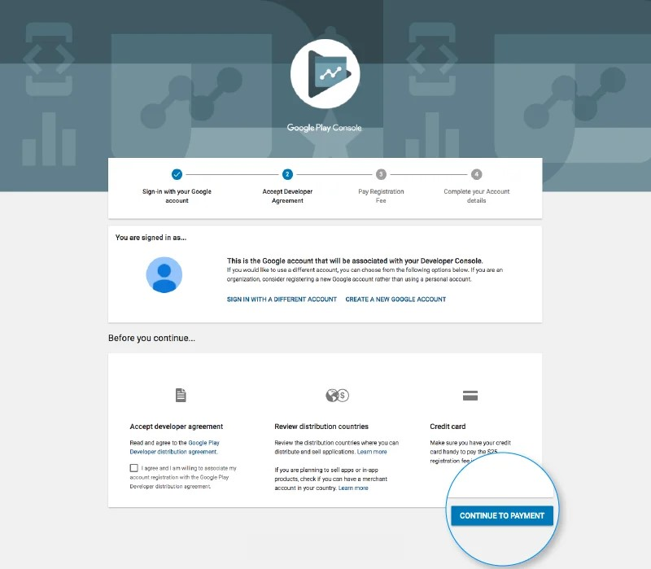

In order to upload an Android play store app, a developer dashboard is imperative. Google

Play console is kind of a backend controlling center, from where developers submit Play Store apps for Android. There is a one-time fee of $25 by which a developer can open an account, loaded with functions and control features. After paying this one-time fee, you can upload Google Store Play apps for free.

You need to fill out all the credentials asked while creating the account, such as your name, country and more. Once you submit your account it will take upto 48 hours to get approved.

1. *Link Developer Account with Google Wallet Merchant Account*

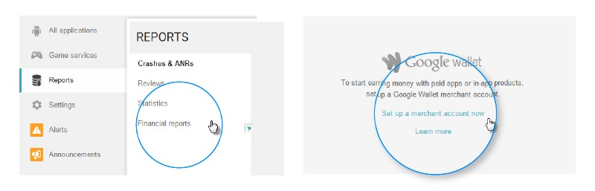

If the app getting uploaded to Play Store supports in-app purchases, then you will need a merchant account. To create one you can sign in to your Google Play Console account and click on **‘Reports’** followed by **‘Financial Reports’** option. After this, you may select the **‘Set up a merchant account now’** option and simply fill out your details. The merchant account will automatically get linked to your Google Play Console account and will allow you to manage and examine app sales.

1. *Create Application*

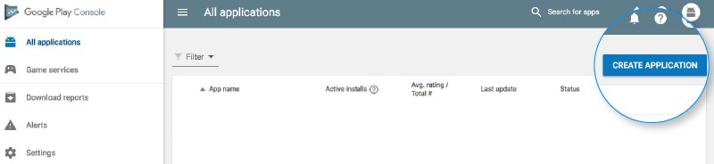

This is yet another step towards how to publish an app on play store.

Once you are logged into your developer or publisher account, here are a few steps you need to take to publish app to google play:

* 1. In the menu, go to the ‘All applications’ tab
  2. You will see an option ‘Create Application’ – select it
  3. From the drop-down menu, choose the application’s default language
  4. Enter your application’s title (it can be changed later)

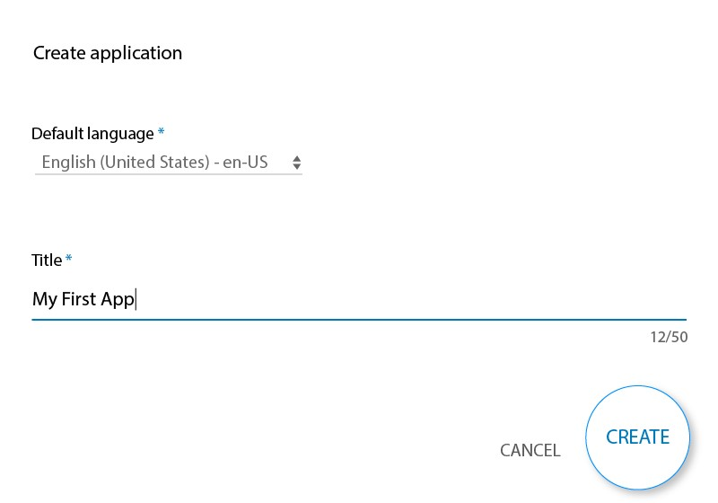

• Now, click on “Create”

1. *App Store Listing*

It is at this point of Google Play uploads, your preparations will come handy.

In this step around how to upload an app to the play store, you are required to fill out all the information and details you have already prepared with caution before. The table below shows what information you need to fill in the app listing-

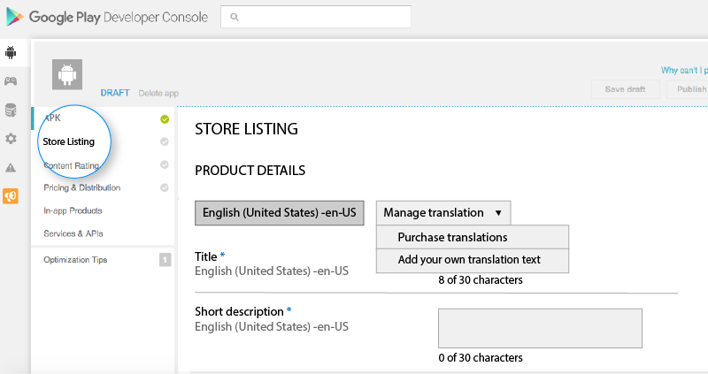

Make sure to use appropriate keywords in your [app description](https://appinventiv.com/blog/write-mobile-app-development-brief/) to increase the chances of your app showing up in searches. Along with this, make sure to use all the data we have talked about in the prerequisite section for app listing.

1. *Upload App Bundles or APK To Google Play*

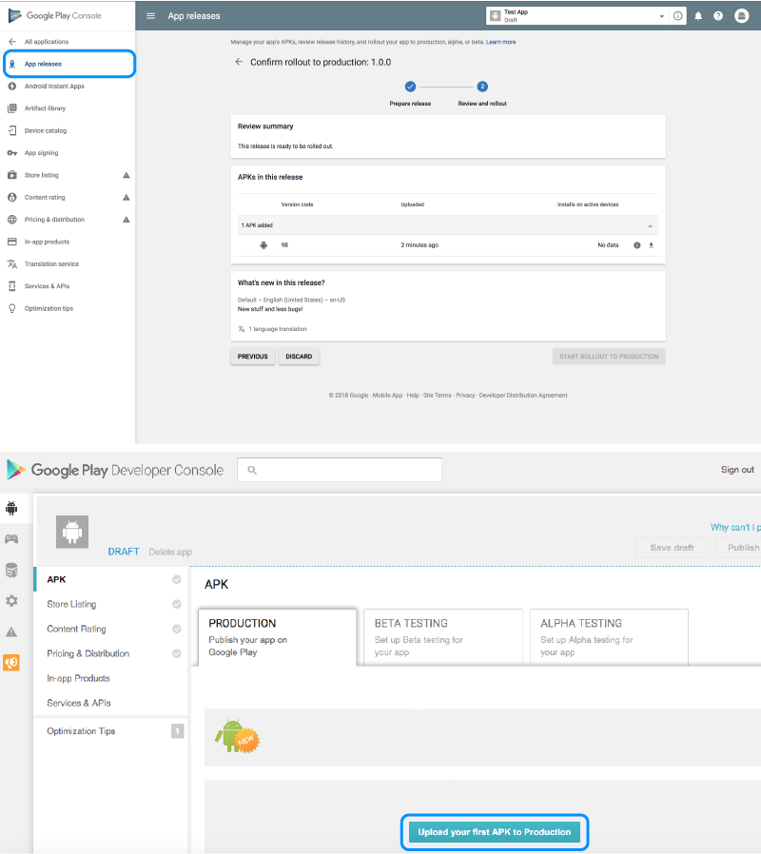

Now, you are required to use the files such as App bundle or APK and signed app release and upload them into your application. This is how you do it: Navigate to the **‘Release Management’** and then **‘App Release’** tab in the menu. After this, you will be asked to choose any one type of release from four options- internal test, close test, production release, and an open test. Once, you have made a decision regarding which type of release you want, you may select **‘Create Release’**.

At this point, you will be redirected to the New release to the production page. Here, you are again required to make another decision- to opt for Google Play apps store signing on the app or not. If you choose the latter, then simply click on the ‘OPT-OUT’ option. Now, select ‘Browse files’ and then look into how to upload apk to google apps store while naming and describing your release through on-screen instructions. You can also click on ‘Review’ to confirm the information. When everything is taken care of, press ‘Save’.

1. *Time For Content Rating*

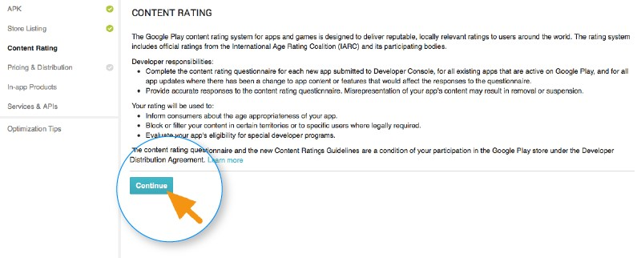

The next step regarding how to publish Android apps on the Play Store is to rate your app. This is crucial because it is listed as ‘Unrated’, it might get removed altogether from the store, so it is imperative to rate the application. For Content Rating, you must again navigate to the menu on the left side of the screen and then select the same. By clicking on **‘Continue’** you can move forward and then type your email address in the respective field and then **‘Confirm’** it. Now, you may fill the questionnaire for your app rating. Follow this by selecting the **‘Save Questionnaire’** and then choose the **‘Calculate Rating’** option to see your app rating on the Play Store. The last thing to finalize your app’s content rating is to click on **‘Apply’**.

1. Fix App Pricing and Distribution

Now, you have to be clear about what countries your app is going to be available in. The point to note here is that Google doesn’t support publishing an app for all regions. The app will be published in selected countries instead of world-wide.

Moreover, [assigning a price to your app](https://appinventiv.com/blog/how-to-choose-right-app-pricing-strategy/) is crucial. If you want your app to be free, make sure that this decision is permanent, as Google does not allow you to convert free apps into paid ones. Although, the price of the app can be altered.

To do all this, go to the **Pricing and Distribution** tab in the menu, and then make a choice whether your app is going to be **Free or Paid**. You may now select the countries you want your app to be released. Additionally, if your application is suited for children under the age of 13, you may select the option of **‘Yes’** for Primary Child-Detected. If otherwise is the case, simply select **‘No’**. Similarly, select the options for allowing ads into your application.

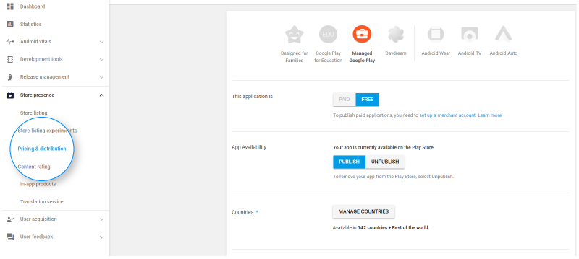

1. *Finally, Publish the Application*

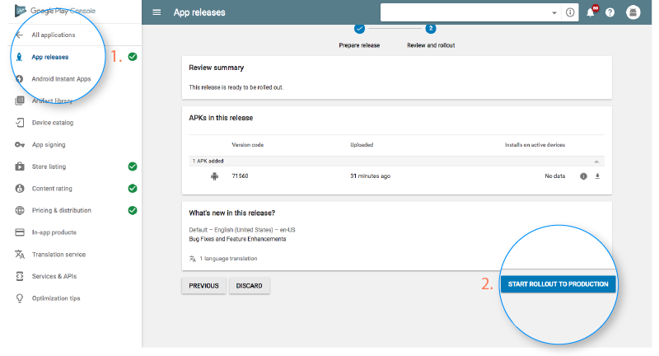

Once you are confirmed about everything being correct, take the last step of this guide on how to upload android app to Play Store, i.e, add the application to the platform. You need to go back to the ‘App Releases’ tab and then select ‘Manage Production’ followed by ‘Edit Release’. After this, click on ‘Review’ and then choose ‘Start rollout to production’ option. To bring this process to an end select the ‘Confirm’ option and Voila! You have successfully uploaded the app to the Google Play Store apk account for free.

Once you upload app to google play store free, all there is left to do now is to just wait for your application to get approved. It generally took about two hours for your application to get reviewed. But with apps store Google Play’s updated privacy policy, it will now take hours and even days for the same, encouraging [mobile app development companies](https://appinventiv.com/) to create even more flawless applications that get selected instantly. So, hold your excitement in the place and just wait.

**AIM:** Create a signup app to insert data in real time database using firebase.

**Procedure:**

**Step 1:** Create an empty activity to design an registration page.

*<?***xml version="1.0" encoding="utf-8"***?>*

<**androidx.constraintlayout.widget.ConstraintLayout xmlns:android="http://schemas.android.com/apk/res/android" xmlns:app="http://schemas.android.com/apk/res-auto" xmlns:tools="http://schemas.android.com/tools" android:layout_width="match_parent" android:layout_height="match_parent" tools:context=".MainActivity"**>

<**TextView**

**android:id="@+id/textView" android:layout_width="wrap_content" android:layout_height="wrap_content" android:text="SIGNUP PAGE" android:textSize="15pt" android:textColor="@color/black"**

**app:layout_constraintBottom_toBottomOf="parent" app:layout_constraintEnd_toEndOf="parent" app:layout_constraintLeft_toLeftOf="parent" app:layout_constraintRight_toRightOf="parent" app:layout_constraintStart_toStartOf="parent" app:layout_constraintTop_toTopOf="parent" app:layout_constraintVertical_bias="0.116"** />

<**EditText**

**android:id="@+id/editTextTextPersonName" android:layout_width="wrap_content" android:layout_height="wrap_content" android:ems="10" android:inputType="textPersonName" android:hint="Enter Name"**

**app:layout_constraintBottom_toBottomOf="parent" app:layout_constraintEnd_toEndOf="parent" app:layout_constraintHorizontal_bias="0.497" app:layout_constraintStart_toStartOf="parent" app:layout_constraintTop_toTopOf="parent" app:layout_constraintVertical_bias="0.246"** />

<**EditText**

**android:id="@+id/editTextTextEmailAddress" android:layout_width="wrap_content" android:layout_height="wrap_content" android:ems="10" android:hint="Email" android:inputType="textEmailAddress" app:layout_constraintBottom_toBottomOf="parent" app:layout_constraintEnd_toEndOf="parent" app:layout_constraintHorizontal_bias="0.497" app:layout_constraintStart_toStartOf="parent" app:layout_constraintTop_toTopOf="parent" app:layout_constraintVertical_bias="0.456"** />

<**EditText**

**android:id="@+id/editTextNumber" android:layout_width="wrap_content" android:layout_height="wrap_content" android:ems="10" android:hint="Phone number" android:inputType="number"**

**app:layout_constraintBottom_toBottomOf="parent" app:layout_constraintEnd_toEndOf="parent" app:layout_constraintHorizontal_bias="0.497" app:layout_constraintStart_toStartOf="parent" app:layout_constraintTop_toTopOf="parent" app:layout_constraintVertical_bias="0.568"** />

<**EditText**

**android:id="@+id/editTextTextPassword" android:layout_width="wrap_content" android:layout_height="wrap_content" android:ems="10" android:hint="Password" android:inputType="textPassword" app:layout_constraintEnd_toEndOf="parent" app:layout_constraintHorizontal_bias="0.497" app:layout_constraintStart_toStartOf="parent" tools:layout_editor_absoluteY="233dp" tools:ignore="MissingConstraints"** />

<**Button**

**android:id="@+id/signup" android:layout_width="wrap_content" android:layout_height="wrap_content" android:text="SIGNUP"**

**app:layout_constraintBottom_toBottomOf="parent" app:layout_constraintEnd_toEndOf="parent" app:layout_constraintHorizontal_bias="0.476" app:layout_constraintStart_toStartOf="parent" app:layout_constraintTop_toTopOf="parent" app:layout_constraintVertical_bias="0.696"** />

</**androidx.constraintlayout.widget.ConstraintLayout**>

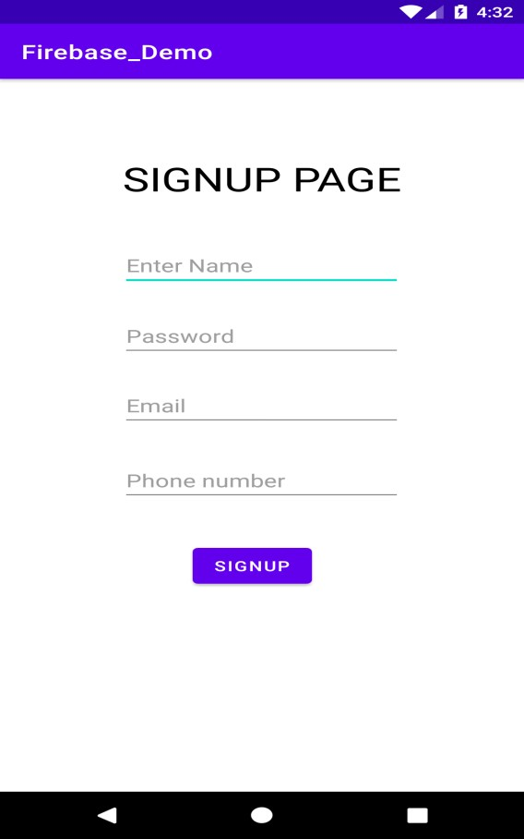

**Step 2:** Steps for creating/connecting to firebase through android studio.

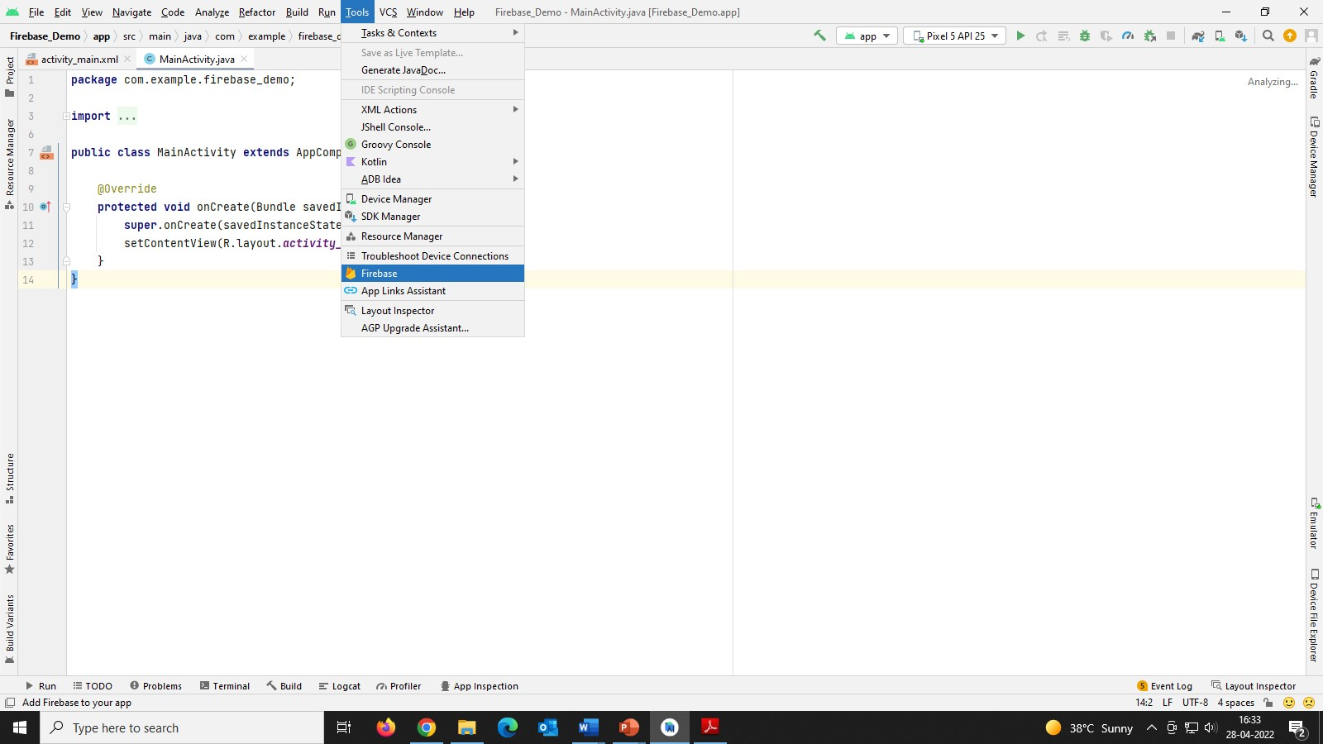

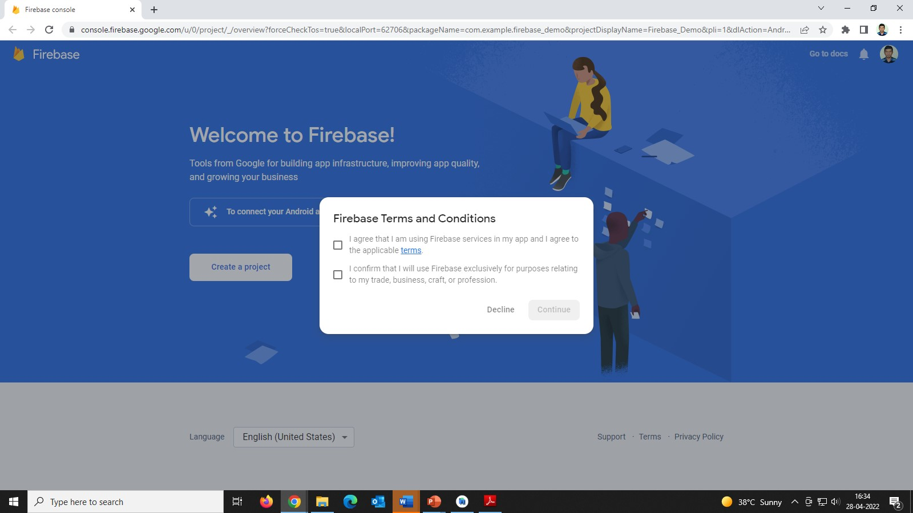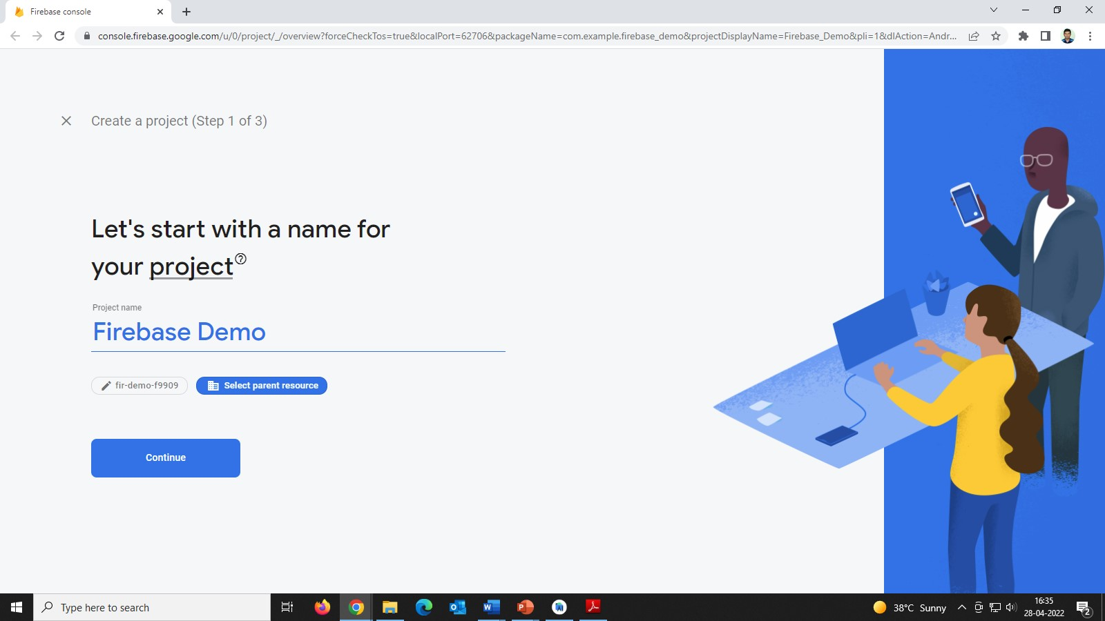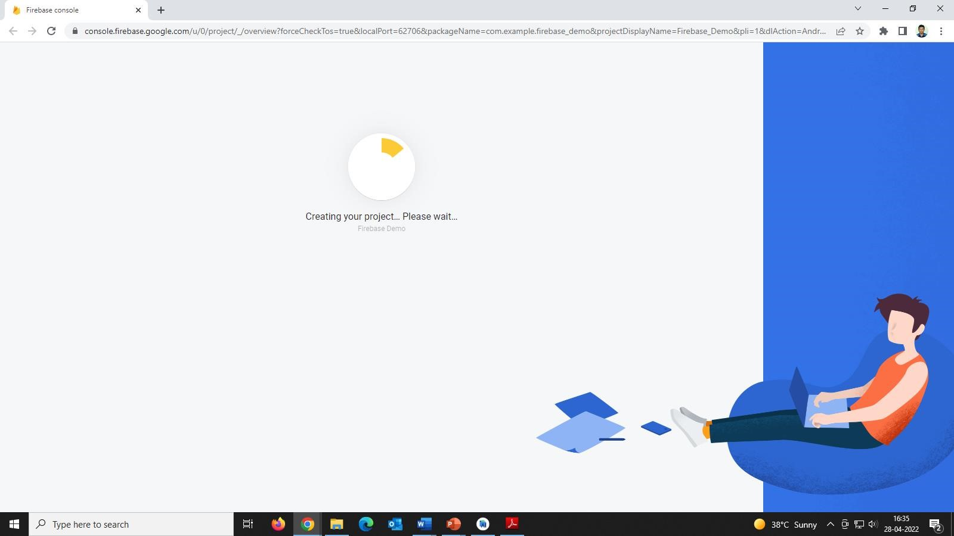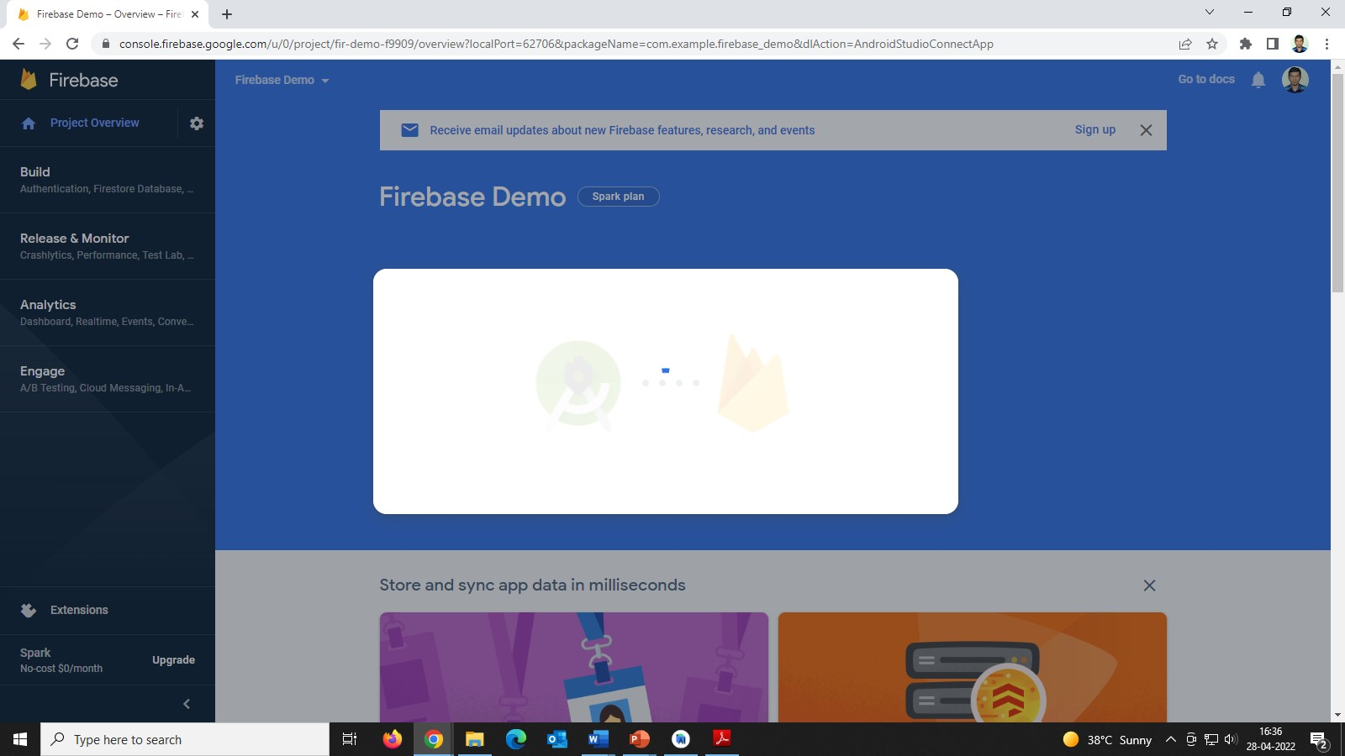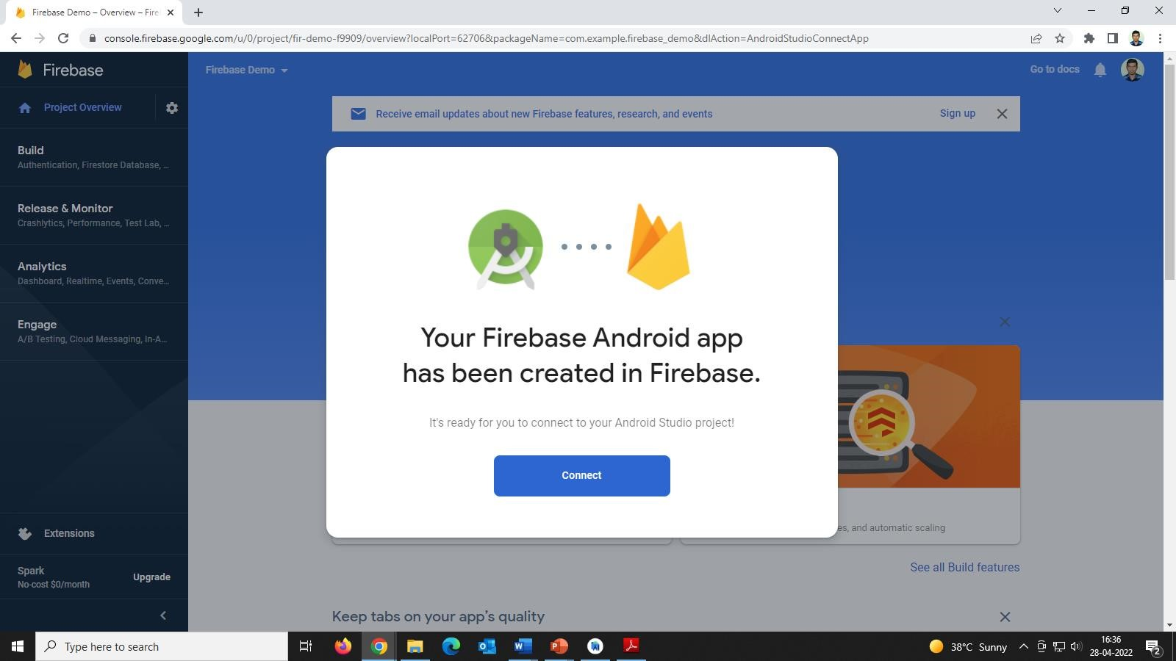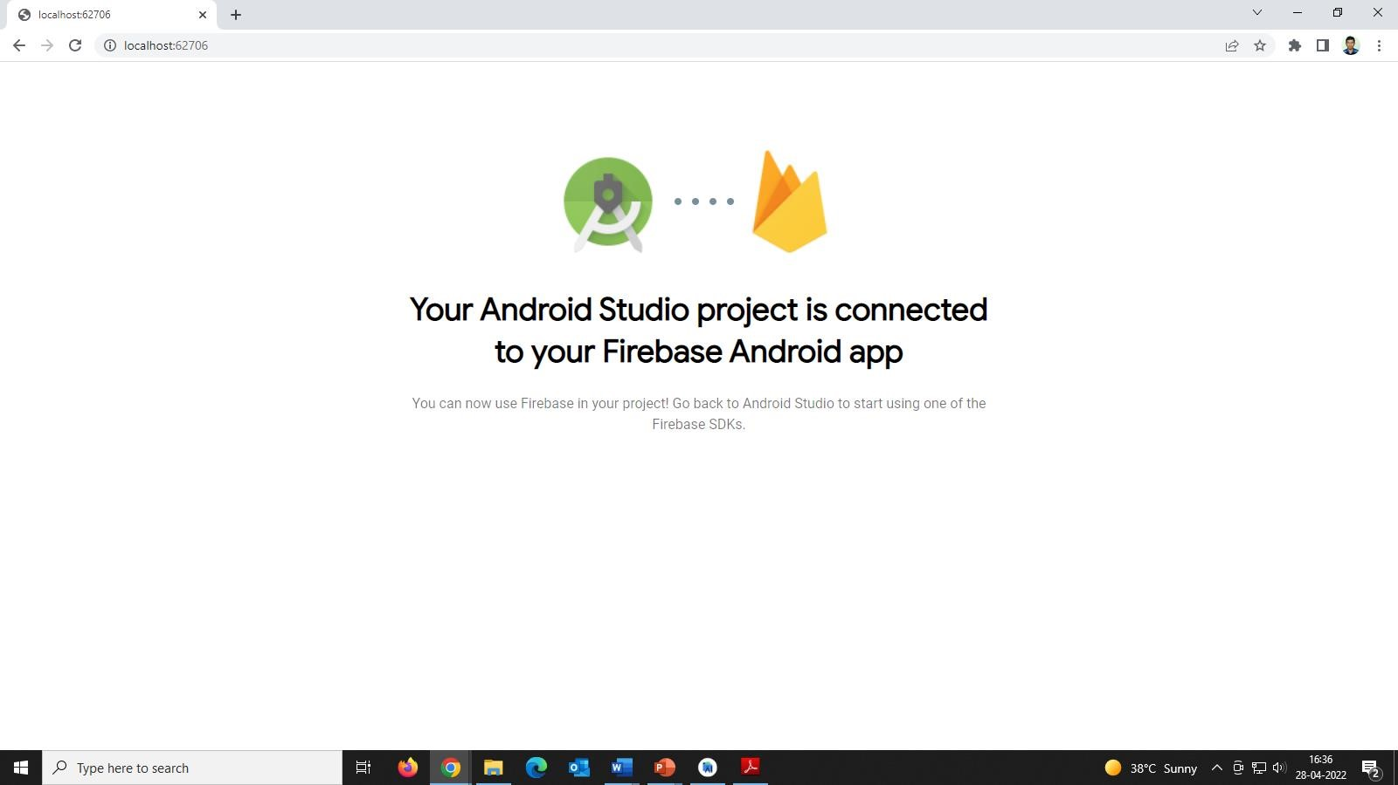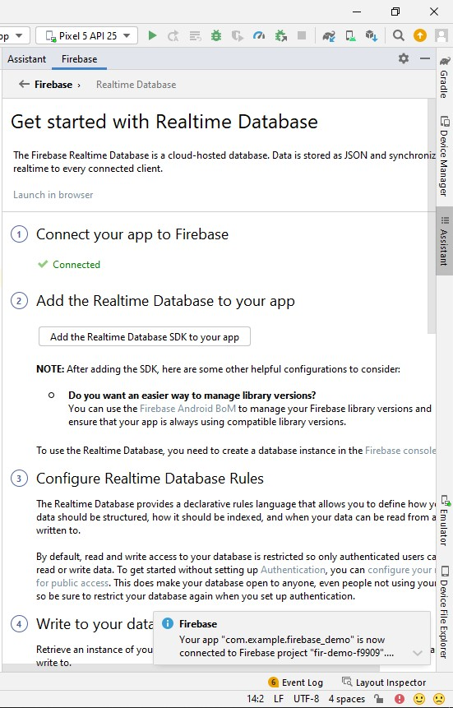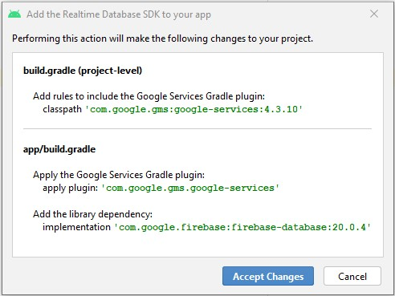

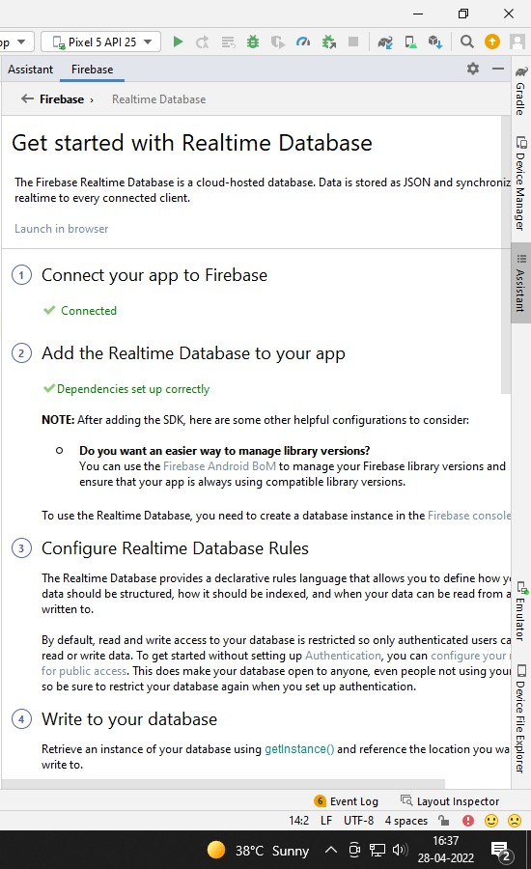

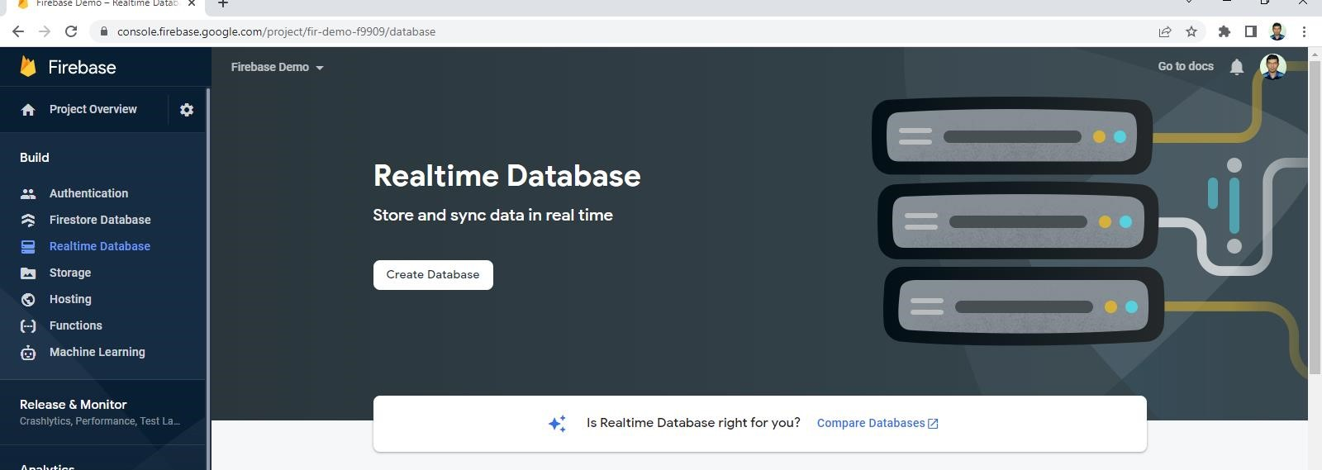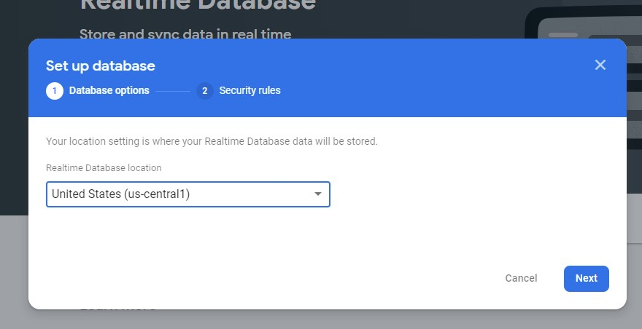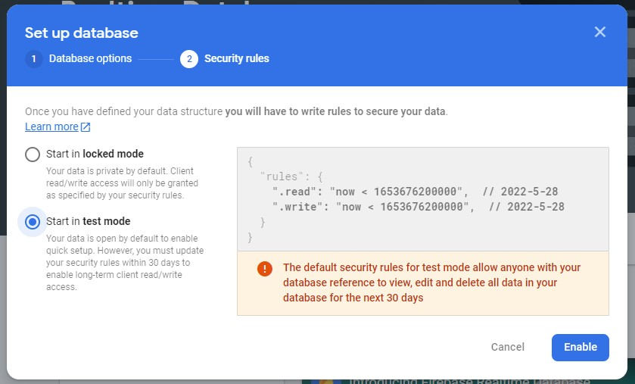

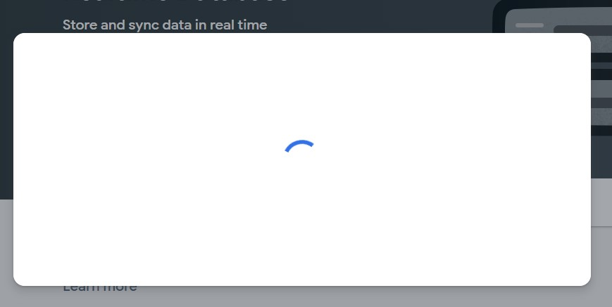

**package** com.example.firebase_demo;

**import** androidx.appcompat.app.AppCompatActivity;

**import** android.os.Bundle; **import** android.view.View; **import** android.widget.Button; **import** android.widget.EditText; **import** android.widget.TextView;

**import** com.google.firebase.database.DatabaseReference; **import** com.google.firebase.database.FirebaseDatabase;

**public class** MainActivity **extends** AppCompatActivity {

**private** DatabaseReference **mDatabase**;

@Override

**protected void** onCreate(Bundle savedInstanceState) { **super**.onCreate(savedInstanceState); setContentView(R.layout.***activity_main***);

EditText t1=(EditText)findViewById(R.id.***editTextTextPersonName***);

EditText t2=(EditText)findViewById(R.id.***editTextTextPassword***);

EditText t3=(EditText) findViewById(R.id.***editTextTextEmailAddress***);

EditText t4=(EditText)findViewById(R.id.***editTextNumber***);

Button b=(Button)findViewById(R.id.***signup***);

b.setOnClickListener(**new** View.OnClickListener() {

@Override

**public void** onClick(View view) {

String s1=t1.getText().toString();

String s2=t2.getText().toString();

String s3=t3.getText().toString();

String s4=t4.getText().toString();

System.***out***.println(s1+**"\n"**);

System.***out***.println(s2+**"\n"**); System.***out***.println(s3+**"\n"**); writeNewUser(s1,s2,s3,s4);

}

});

**mDatabase** = FirebaseDatabase.*getInstance*().getReference();

}

**public void** writeNewUser(String username, String password, String email,String phonenumber) {

User user = **new** User(username,password,email,phonenumber); **mDatabase**.child(**"EMP"**).child(username).setValue(user);

}

}

**package** com.example.firebase_demo;

**public class** User { **public** String **username**; **public** String **email**; **public** String **password**; **public** String **phonenumer**;

**public** User() {

*// Default constructor required for calls to*

*DataSnapshot.getValue(User.class)*

}

**public** User(String username, String password, String email, String phonenumber) {

**this**.**username** = username; **this**.**email** = email; **this**.**password**=password; **this**.**phonenumer**=phonenumber;

}

**public** String getPhonenumer() { **return phonenumer**;

}

**public** String getEmail() { **return email**;

}

**public** String getPassword() { **return password**;

} **public** String getUsername() { **return username**;

} **public void** setEmail(String email) { **this**.**email** = email;

}

**public void** setPassword(String password) { **this**.**password** = password;

} **public void** setPhonenumer(String phonenumer) { **this**.**phonenumer** = phonenumer;

}

**public void** setUsername(String username) { **this**.**username** = username;

}

}

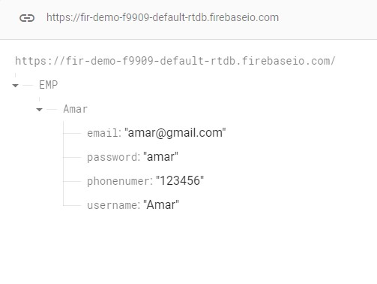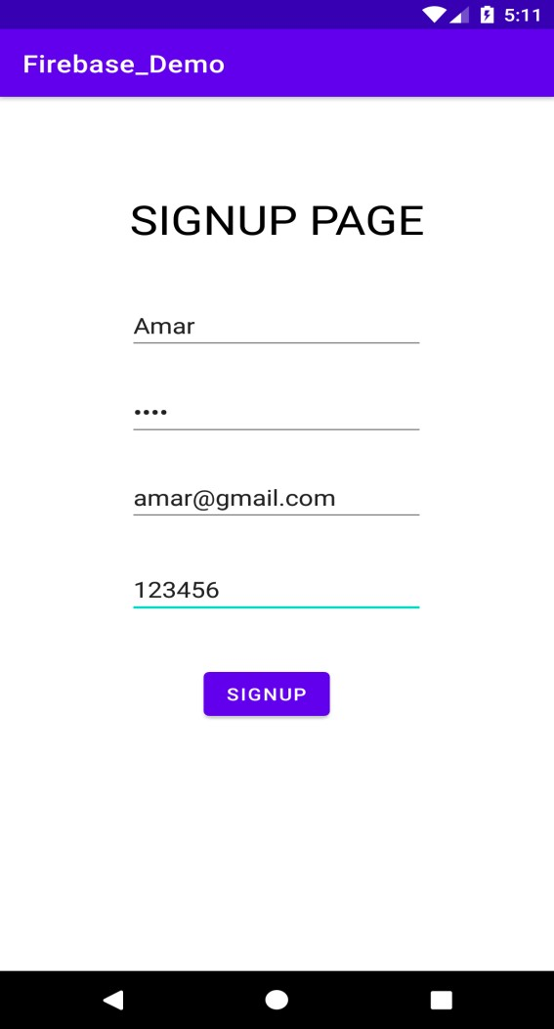

#### Exercise to be done in Lab

1. Create an application with an activity to perform google sign in authentication
2. Create another activity to get student basic details from user and store into Firebase

Realtime database and retrieve the same and display in new activity

1. publish the app in google play store.